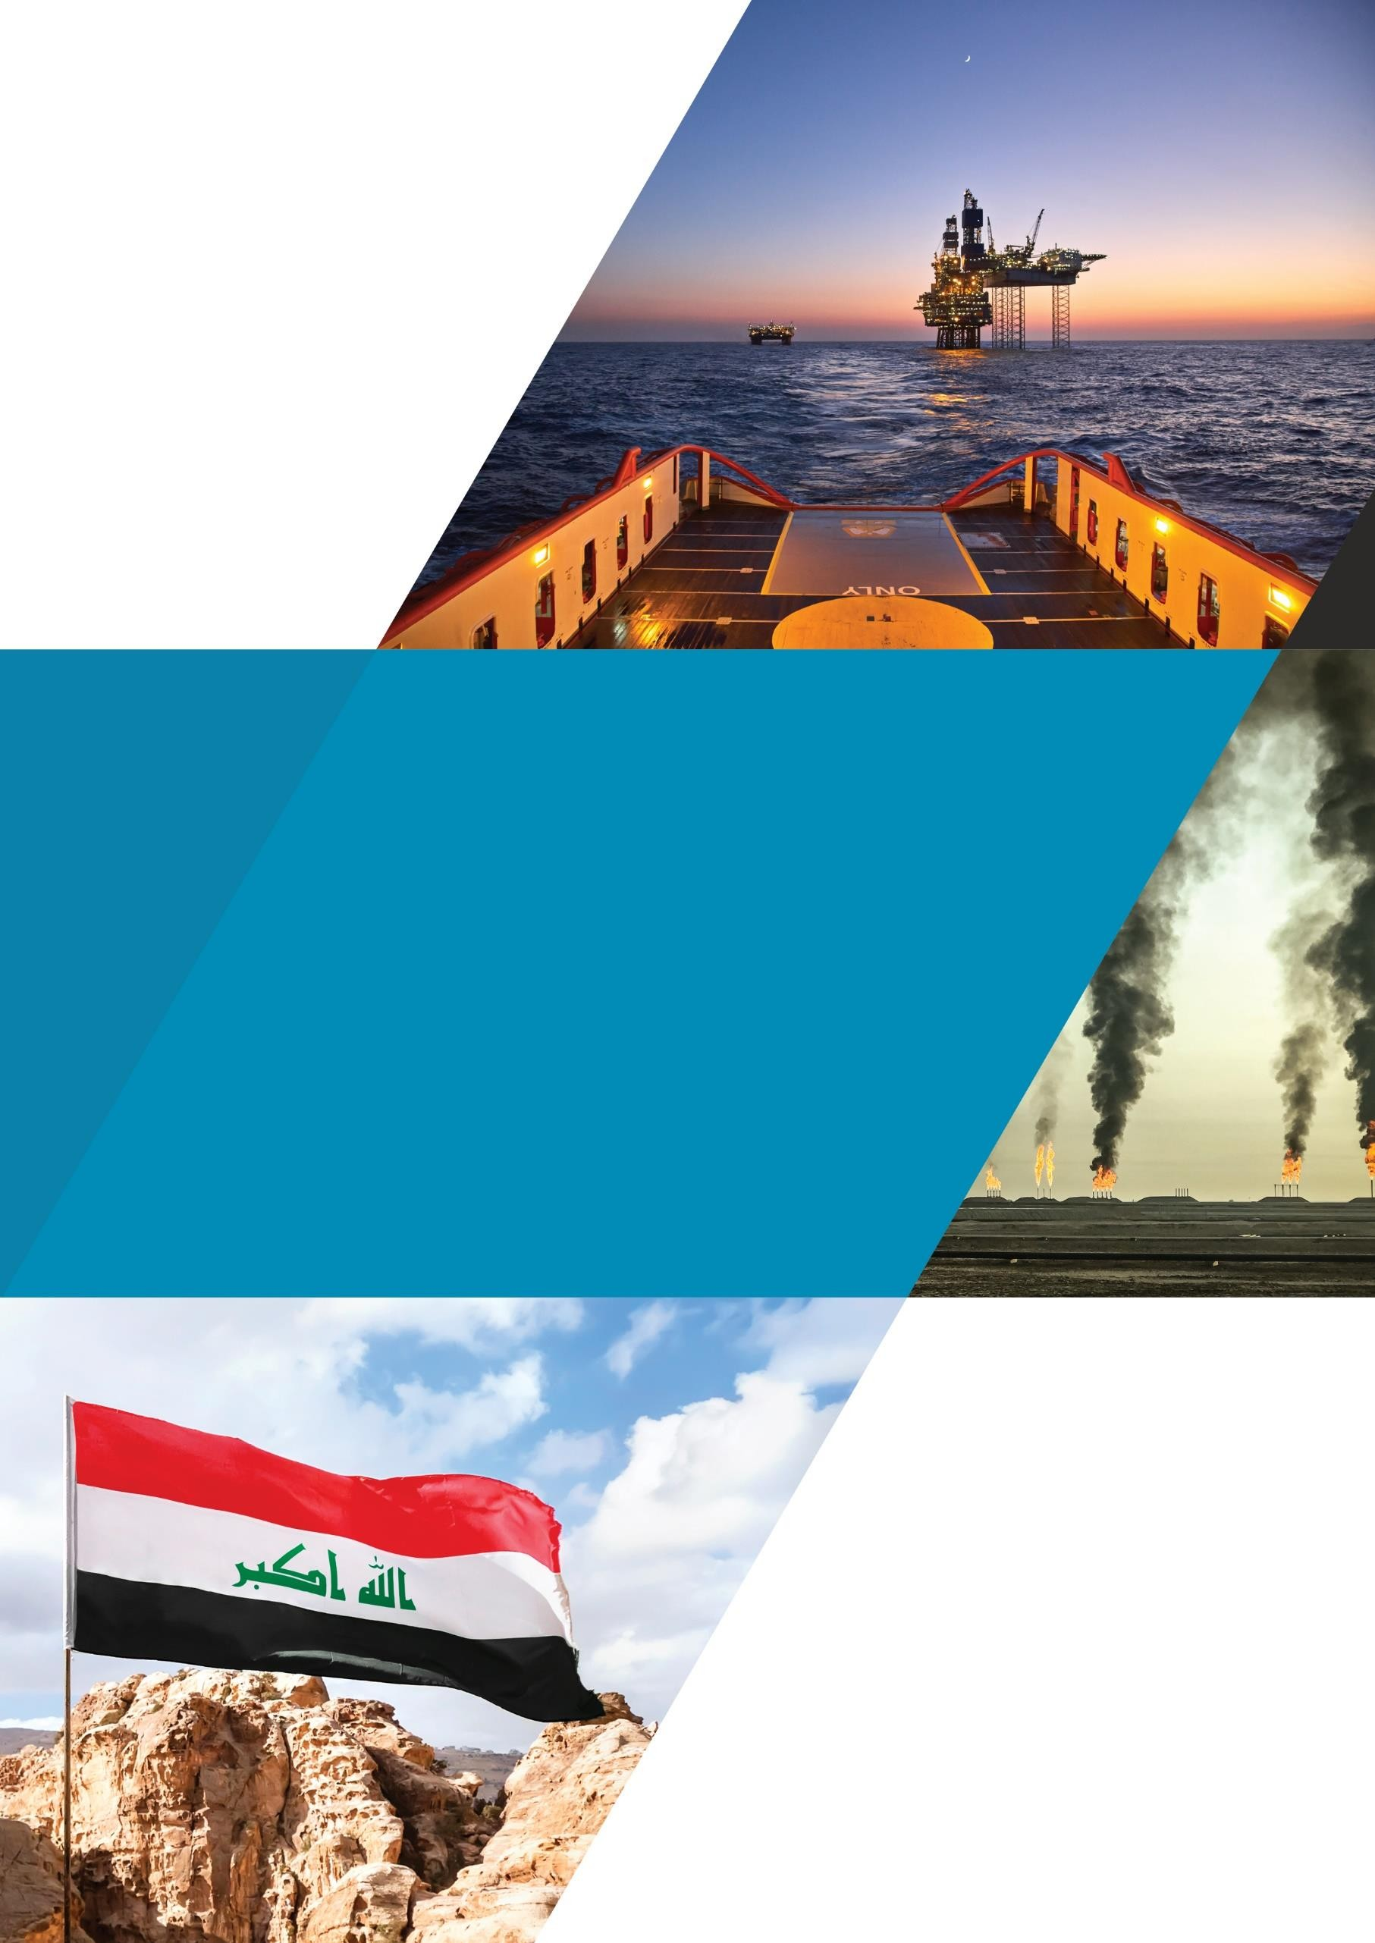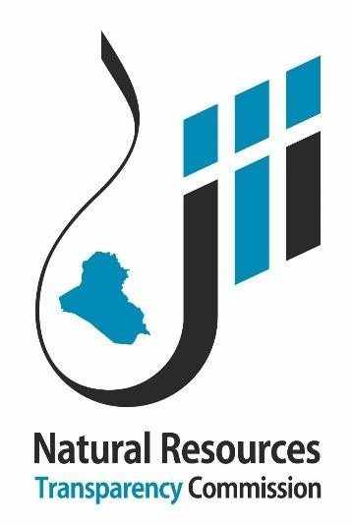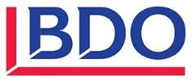
NRTC Initial Reconciliation Report for 2021

Initial Reconciliation Report 2021
December 2023

This report has been prepared at the request of the Multi-Stakeholder Group (MSG) in charge of the implementation of the Extractive Industries Transparency Initiative in Iraq. The opinions expressed in the report are those of the Independent Administrator and the report has been approved by the MSG. This report has been prepared exclusively for use by the NRTC and must not be used by other parties, nor for any purposes other than those for which it is intended.

TABLE OF CONTENTS
- BUYER COMPANIES 6
  - Crude oil buyers 6
  - Petroleum products buyers 8
- INTERNATIONAL OIL COMPANIES 10
  - Crude oil lifted 10
  - Tax receipts 12

LIST OF TABLES

Table 1: Summary of initial discrepancies (Crude oil Sales) 6
Table 2: Initial Discrepancies by Crude Oil Buyer 6
Table 3: Summary of Initial Discrepancies (Petroleum Products) 8
Table 4: Initial Discrepancies by Petroleum Products Buyer 8
Table 5: Summary of Initial Discrepancies (Crude oil lifted In-Kind) 10
Table 6: Oil Lifted by IOCs initial differences by Company 10
Table 7: Detail of IOCs’ Taxes by Revenue Stream 12
Table 8: Detail of IOCs’ Taxes by Oil Field 12
Table 9: Detail of IOCs’ Taxes by Province 12

LIST OF ABBREVIATIONS

bbl | Barrel
CIT | Corporate income tax
IOC | International oil company
MoF | Ministry of Finance
NRTC | Natural Resources Transparency Commission
PIT | Personal income tax
RT | Reporting template
SOMO | State Oil Marketing Company
SS | Social security
WHT | Withholding tax
WP | Work permit

BUYER COMPANIES
We present below the reconciliation between the State Oil Marketing Company (SOMO) and companies that bought crude oil and petroleum products during 2021.

Crude oil buyers
The table below summarises the initial discrepancies of crude oil sales between SOMO and buyer companies.
TABLE 1: SUMMARY OF INITIAL DISCREPANCIES (CRUDE OIL SALES)

Initial reconciliation | SOMO |  | Crude oil buyers |  | Discrepancies
Initial reconciliation | Quantity (bbl) | Amount (USD) | Quantity (bbl) | Amount (USD) | Quantity (bbl) | % | Amount (USD) | %
Crude oil buyers that submitted their RTs | 128,547,183 | 8,788,748,510 | 127,641,760 | 8,652,226,206 | 905,423 | 0.71% | 136,522,304 | 1.58%
Crude oil buyers that did not submit their RTs yet | 822,051,065 | 56,536,116,889 | - | - | 822,051,065 | 100.00% | 56,536,116,889 | 100.00%
Total | 950,598,248 | 65,324,865,400 | 127,641,760 | 8,652,226,206 | 822,956,488.00 | 644.74% | 56,672,639,194 | 655.01%

Details of the initial discrepancies are presented below by crude oil buyer:
TABLE 2: INITIAL DISCREPANCIES BY CRUDE OIL BUYER

N° | Crude oil buyer | SOMO |  | Crude oil buyers |  | Discrepancies
N° | Crude oil buyer | Quantity (bbl) | Amount (USD) | Quantity (bbl) | Amount (USD) | Quantity (bbl) | Amount (USD)
Crude Oil buyers that submitted their RTs |  | 128,547,183 | 8,788,748,510 | 127,641,760 | 8,652,226,206 | 905,423 | 136,522,304
1 | GS CALTEX SINGAPORE PTE. LTD | 42,842,797 | 2,916,156,771 | 42,902,655 | 2,852,346,189 | (59,858) | 63,810,583
2 | NAYARA ENERGY LIMITED | 28,469,567 | 1,933,690,606 | 28,469,567 | 1,933,690,606 | - | -
3 | CHEVRON | 23,445,425 | 1,589,127,080 | 23,445,425 | 1,589,127,080 | - | -
4 | HPCL-MITTAL ENERGY LIMITED | 13,894,182 | 975,781,795 | 13,894,182 | 975,781,795 | - | -
5 | The Egyptian General Petroleum Corporation (EGPC) | 9,876,066 | 690,288,237 | 9,876,066 | 690,288,237 | - | -
6 | REPSOL TRADING S.A | 10,019,146 | 683,704,021 | 9,053,865 | 610,992,299 | 965,281 | 72,711,722
Crude oil buyers that did not submit their RTs yet |  | 822,051,065 | 56,536,116,889 | - | - | 822,051,065 | 56,536,116,889
7 | INDIAN OIL (CHENNAI PETROLEUM CORPORATION LTD) | 135,320,200 | 9,331,566,455 | - | - | 135,320,200 | 9,331,566,455
8 | China International United Petroleum and Chemicals Co. Ltd. (UNIPEC) | 130,914,735 | 9,128,936,067 | - | - | 130,914,735 | 9,128,936,067

N° | Crude oil buyer | SOMO |  | Crude oil buyers |  | Discrepancies
N° | Crude oil buyer | Quantity (bbl) | Amount (USD) | Quantity (bbl) | Amount (USD) | Quantity (bbl) | Amount (USD)
9 | SINOCHEM | 105,237,087 | 7,252,900,474 | - | - | 105,237,087 | 7,252,900,474
10 | RELIANCE INDUSTRIES LIMITED(RIL) | 82,945,203 | 5,591,328,789 | - | - | 82,945,203 | 5,591,328,789
11 | Turkish Petroleum Refineries Corp. (TUPRAS) TURKEY | 58,917,068 | 4,020,622,475 | - | - | 58,917,068 | 4,020,622,475
12 | CHINA ZHENHUA OIL CO. LTD (SINOSURE) | 47,725,895 | 3,314,150,177 | - | - | 47,725,895 | 3,314,150,177
13 | MOTOR OIL HELLAS CORINTH REFINERIES S.A | 30,146,184 | 2,023,498,536 | - | - | 30,146,184 | 2,023,498,536
14 | SHELL | 28,456,135 | 1,998,820,430 | - | - | 28,456,135 | 1,998,820,430
15 | BHARAT PETROLEUM CORPORATION LTD. | 28,543,750 | 1,957,670,240 | - | - | 28,543,750 | 1,957,670,240
16 | MANGALORE REFINERY & PETROCHEMICALS LIMITED. | 17,677,143 | 1,244,358,924 | - | - | 17,677,143 | 1,244,358,924
17 | VALERO MARKETING & SUPPLY COMPANY | 19,037,203 | 1,231,820,651 | - | - | 19,037,203 | 1,231,820,651
18 | HINDUSTAN PETROLEUM CORPORATION LIMITED | 17,454,785 | 1,195,429,643 | - | - | 17,454,785 | 1,195,429,643
19 | PETROCHINA INTERNATIONAL CO. | 16,589,273 | 1,172,046,042 | - | - | 16,589,273 | 1,172,046,042
20 | MARATHON PETROLEUM SUPPLY LLC | 14,627,382 | 1,012,305,037 | - | - | 14,627,382 | 1,012,305,037
21 | ExxonMobil Sales And Supply Corporation Gallows | 14,385,335 | 960,441,097 | - | - | 14,385,335 | 960,441,097
22 | SK ENERGY CO. LTD | 11,714,526 | 782,323,540 | - | - | 11,714,526 | 782,323,540
23 | BHARAT OMAN REFINERIES LIMITED | 10,698,785 | 747,241,945 | - | - | 10,698,785 | 747,241,945
24 | China Offshore Oil (Singapore) International PTE. LTD. | 10,334,729 | 736,168,805 | - | - | 10,334,729 | 736,168,805
25 | SARAS TRADING SA | 8,232,710 | 579,640,845 | - | - | 8,232,710 | 579,640,845
26 | HELLENIC PETROLEUM S.A. | 8,003,789 | 547,871,819 | - | - | 8,003,789 | 547,871,819
27 | ENI TRADING & SHIPPING SPA - ITALY | 7,026,023 | 461,761,438 | - | - | 7,026,023 | 461,761,438
28 | TOTSA TOTAL OIL TRADING SA | 4,916,150 | 321,489,787 | - | - | 4,916,150 | 321,489,787
29 | FORMOSA PETROCHEMICAL CORPORATION (FPCC) | 2,913,051 | 206,415,291 | - | - | 2,913,051 | 206,415,291
30 | IPLOM INERNATIONAL SA | 2,960,752 | 191,596,707 | - | - | 2,960,752 | 191,596,707
31 | HENGLI | 1,926,475 | 154,570,722 | - | - | 1,926,475 | 154,570,722
32 | SHANDONG DONGMING | 1,921,878 | 136,589,791 | - | - | 1,921,878 | 136,589,791
33 | RONGSHENG PETROCHEMICAL | 1,550,000 | 115,671,850 | - | - | 1,550,000 | 115,671,850
34 | PETROBRAS GLOBAL TRADING B.V. | 990,520 | 65,173,244 | - | - | 990,520 | 65,173,244
35 | JORDAN PETROLEUM REFINERY CO. LTD. | 884,299 | 53,706,069 | - | - | 884,299 | 53,706,069
Total |  | 950,598,248 | 65,324,865,400 | 127,641,760 | 8,652,226,206 | 822,956,488 | 56,672,639,194

Petroleum products buyers
The table below summarises the initial discrepancies of petroleum products sales between SOMO and buyer companies.
TABLE 3: SUMMARY OF INITIAL DISCREPANCIES (PETROLEUM PRODUCTS)

Initial reconciliation | SOMO |  | Petroleum products buyers |  | Discrepancies
Initial reconciliation | Quantity (bbl) | Amount (USD) | Quantity (bbl) | Amount (USD) | Quantity (bbl) | % | Amount (USD) | %
Petroleum products buyers that submitted their RTs | 205,813 | 124,782,874 | 205,813 | 124,782,874 | - | 0.00% | - | 0.00%
Petroleum products buyers that did not submit their RTs yet | 9,179,676 | 3,987,805,922 | - | - | 9,179,676 | 100.00% | 3,987,805,922 | 100.00%
Total | 9,385,489 | 4,112,588,796 | 205,813 | 124,782,874 | 9,179,675.53 | 4460.20%. | 3,987,805,922 | 3195.80%

Details of the initial discrepancies are presented below by petroleum products buyer:
TABLE 4: INITIAL DISCREPANCIES BY PETROLEUM PRODUCTS BUYER

N° | Petroleum Products Buyer | SOMO |  | Petroleum products buyers |  | Discrepancies
N° | Petroleum Products Buyer | Quantity (bbl) | Amount (USD) | Quantity (bbl) | Amount (USD) | Quantity (bbl) | Amount (USD)
Crude oil buyers submitting their RTs |  | 205,813 | 124,782,874 | 205,813 | 124,782,874 | - | -
1 | EnlIL Energy | 205,813 | 124,782,874 | 205,813 | 124,782,874 | - | -
Crude oil buyers not submitting their RTs |  | 9,179,676 | 3,987,805,922 | - | - | 9,179,676 | 3,987,805,922
2 | RELIANCE Industries Company | 2,123,868 | 838,868,692 | - | - | 2,123,868 | 838,868,692
3 | Shuaa taqa Petrol services Company | 1,681,305 | 821,037,916 | - | - | 1,681,305 | 821,037,916
4 | Chevron AL KHALIJ | 1,898,534 | 771,818,080 | - | - | 1,898,534 | 771,818,080
5 | Manabaa wassit Company | 908,842 | 424,548,142 | - | - | 908,842 | 424,548,142
6 | PTT International Trading | 542,655 | 289,695,702 | - | - | 542,655 | 289,695,702
7 | LITASCO middle East | 599,975 | 223,198,753 | - | - | 599,975 | 223,198,753
8 | Shoroq Al Anouar Company | 333,062 | 142,563,992 | - | - | 333,062 | 142,563,992
9 | Ministry of Energy and Water Lebanon | 290,468 | 136,547,821 | - | - | 290,468 | 136,547,821
10 | VENANDI Global company | 283,341 | 122,771,313 | - | - | 283,341 | 122,771,313
11 | LARAAK OIL trading | 144,379 | 71,993,099 | - | - | 144,379 | 71,993,099
12 | Aramco Trading Fujairah | 146,534 | 70,311,532 | - | - | 146,534 | 70,311,532
13 | Layali Sahab Company | 70,786 | 33,407,446 | - | - | 70,786 | 33,407,446

N° | Petroleum Products Buyer | SOMO |  | Petroleum products buyers |  | Discrepancies
N° | Petroleum Products Buyer | Quantity (bbl) | Amount (USD) | Quantity (bbl) | Amount (USD) | Quantity (bbl) | Amount (USD)
14 | Djabal Asoued Company | 78,881 | 16,294,769 | - | - | 78,881 | 16,294,769
15 | GUNVOR | 25,785 | 14,324,796 | - | - | 25,785 | 14,324,796
16 | Nassim Brari Company | 48,879 | 10,046,638 | - | - | 48,879 | 10,046,638
17 | Wadi Company Ltd | 2,383 | 377,231 | - | - | 2,383 | 377,231
Total |  | 9,385,489 | 4,112,588,796 | 205,813 | 124,782,874 | 9,179,676 | 3,987,805,922

INTERNATIONAL OIL COMPANIES

Crude oil lifted
The table below summarises the initial discrepancies between SOMO and international oil companies (IOCs) in crude oil lifted in lieu of cost recovery and remuneration fees.
TABLE 5: SUMMARY OF INITIAL DISCREPANCIES (CRUDE OIL LIFTED IN-KIND)

Initial reconciliation | SOMO |  | IOCs |  | Discrepancies
Initial reconciliation | Quantity (bbl) | Amount (USD) | Quantity (bbl) | Amount (USD) | Quantity (bbl) | % | Amount (USD) | %
IOCs that submitted their RTs | 94,757,385 | 6,425,233,165 | 89,631,040 | 6,056,859,535 | 5,126,345 | 5.72% | 368,373,630 | 6.08%
IOCs that did not submit their RTs yet | 55,442,888 | 3,789,554,373 | - | - | 55,442,888 | 100.00% | 3,789,554,373 | 100%
Total | 150,200,273 | 10,214,787,538 | 89,631,040 | 6,056,859,535 | 60,569,233 | 67.58% | 4,157,928,003 | 68.65%

Details of the initial discrepancies are presented below by IOC:
TABLE 6: OIL LIFTED BY IOCS INITIAL DIFFERENCES BY COMPANY

N° | IOC | SOMO |  | IOCs |  | Discrepancies
N° | IOC | Quantity (bbl) | Amount (USD) | Quantity (bbl) | Amount (USD) | Quantity (bbl) | Amount (USD)
IOCs that submitted their RTs |  | 94,757,385 | 6,425,233,165 | 89,631,040 | 6,056,859,535 | 5,126,345 | 368,373,630
1 | PETROCHINA IRAQ OPERATIONS | 26,347,936 | 1,777,657,985 | 26,347,936 | 1,777,657,985 | - | -
2 | BP | 16,669,423 | 1,102,467,883 | 16,669,423 | 1,102,467,883 | - | -
3 | TURKISH PETROLEUM OVERSEAS COMPANY LIMITED | 4,008,391 | 273,853,761 | 4,008,391 | 273,853,761 | - | -
4 | ITOCHU OIL EXPLONATION IRAQ (B.V.) | 2,929,256 | 208,790,652 | 2,929,256 | 208,790,652 | - | -
5 | EXXON MOBIL IRAQ LIMITED | 2,922,007 | 202,946,423 | 2,922,007 | 202,946,423 | - | -
6 | ENI IRAQ B.V. | 12,843,960 | 908,638,137 | 7,717,615 | 541,017,831 | 5,126,345 | 367,620,306
7 | CNOOC IRAQ LIMITED | 11,349,773 | 776,998,967 | 11,349,773 | 776,245,644 | - | 753,324
8 | PETRONAS | 10,017,984 | 659,537,502 | 10,017,984 | 659,537,502 | - | -
9 | KUWAIT ENERGY IRAQ OPERATIONS | 2,794,157 | 201,204,136 | 2,794,157 | 201,204,136 | - | -
10 | JAPEX GARRAF LTD | 2,913,984 | 179,430,526 | 2,913,984 | 179,430,526 | - | -

N° | IOC | SOMO |  | IOCs |  | Discrepancies
N° | IOC | Quantity (bbl) | Amount (USD) | Quantity (bbl) | Amount (USD) | Quantity (bbl) | Amount (USD)
11 | DRAGON OIL (BLOCK 9) LIMITED | 1,001,885 | 71,329,203 | 1,001,885 | 71,329,203 | - | -
12 | PT PERTAMINA IRAK | 958,629 | 62,377,989 | 958,629 | 62,377,989 | - | -
IOCs that did not submit their RTs yet |  | 55,442,888 | 3,789,554,373 | - | - | 55,442,888 | 3,789,554,373
13 | LUKOIL MID - EAST LIMITED | 13,786,512 | 938,778,017 | - | - | 13,786,512 | 938,778,017
14 | BOC | 8,499,434 | 527,533,759 | - | - | 8,499,434 | 527,533,759
15 | AL WAHA PETROLEUM CO. LTD. | 6,289,317 | 435,504,505 | - | - | 6,289,317 | 435,504,505
16 | Korea Gas Corporation (KOGAS) | 5,013,347 | 335,130,308 | - | - | 5,013,347 | 335,130,308
17 | TOTAL E & P IRAQ | 4,348,144 | 303,476,444 | - | - | 4,348,144 | 303,476,444
18 | CHINA INTERNATIONAL UNITED PETROLEUM AND CHEMICALS CO. LTD. (UNIPEC) | 3,719,383 | 287,457,570 | - | - | 3,719,383 | 287,457,570
19 | GAZPROM NEFT BADRA B.V. | 3,564,669 | 237,608,698 | - | - | 3,564,669 | 237,608,698
20 | PETROCHINA INTERNATIONAL CO. | 2,884,481 | 202,189,289 | - | - | 2,884,481 | 202,189,289
21 | EBS PETROLEUM COMPANY LIMITED | 2,244,235 | 160,268,988 | - | - | 2,244,235 | 160,268,988
22 | SINOCHEM | 1,940,639 | 154,523,380 | - | - | 1,940,639 | 154,523,380
23 | Kuwait Energy Iraq Limited (SIBA and Mansuriya) | 1,157,695 | 82,320,674 | - | - | 1,157,695 | 82,320,674
24 | SOCAR TRADING | 1,041,090 | 65,817,710 | - | - | 1,041,090 | 65,817,710
25 | THE EGYPTIAN GENERAL PETROLEUM CORPORATION (EGPC) | 953,942 | 58,945,030 | - | - | 953,942 | 58,945,030
Total |  | 150,200,273 | 10,214,787,538 | 89,631,040 | 6,056,859,535 | 60,569,233 | 4,157,928,003

NRTC Initial Reconciliation Report for 2021

Tax receipts
The Ministry of Finance (MoF) did not yet provide the taxes collected from extractive companies. The tables below show the payments disclosed by IOCs detailed by revenue stream, oil field and province:
TABLE 7: DETAIL OF IOCS’ TAXES BY REVENUE STREAM

IOC | CIT | PIT | SS | WHT | WP fees | Total | %
PetroChina International Iraq FZE-Iraq Branch | 150,710,918 |  |  |  |  | 150,710,918 | 32.39%
BP Iraq NV | 92,788,286 | 9,264,608 |  |  |  | 102,052,894 | 21.93%
Eni Iraq B.V. | 31,482,937 | 5,364,289 | 151,505 | 31,831,550 |  | 68,830,282 | 14.79%
CNOOC Iraq Limited | 11,554,750 | 10,137,789 |  | 39,147,966 |  | 60,840,505 | 13.08%
Kuwait Energy Basra Limited Iraq Branch | 5,281,254 | 9,539,015 | 1,620,818 | 10,144,597 |  | 26,585,684 | 5.71%
PETRONAS Carigali Iraq Holding B.V. | 10,168,283 | 8,831,767 | 4,383,990 |  | 37,483 | 23,421,523 | 5.03%
ExxonMobil Iraq Limited | 15,610,528 |  |  |  |  | 15,610,528 | 3.36%
ITOCHU Oil Exploration (Iraq) B.V. | 7,712,655 |  |  | 5,618 |  | 7,718,273 | 1.66%
PT. Pertamina Irak Eksplorasi Produksi | 5,762,165 |  |  |  |  | 5,762,165 | 1.24%
Turkish Petroleum Overseas Company Limited | 1,986,374 |  |  |  |  | 1,986,374 | 0.43%
LUKOIL Overseas Iraq Exploration B.V. |  | 816,866 |  | 920,784 |  | 1,737,650 | 0.37%
Japex Garraf Ltd. |  | 12,708 | 6,498 | 1,412 |  | 20,618 | 0.00%
Total | 333,058,149 | 43,967,041 | 6,162,811 | 82,051,927 | 37,483 | 465,277,412 | 100%
% | 71.58% | 9.45% | 1.32% | 17.64% | 0.01% | 100.00%

TABLE 8: DETAIL OF IOCS’ TAXES BY OIL FIELD

Field | Total taxes (USD) | %
Halfaya, Rumaila, WQ1 oil fields | 281,854,778 | 60.58%
Zubair oil field | 68,830,282 | 14.79%
Missan oil fields | 62,826,879 | 13.50%
Block-9 oil field | 26,585,684 | 5.71%
Garraf oil field | 23,442,140 | 5.04%
Block-10 oil field | 1,737,650 | 0.37%
Total | 465,277,412 | 100.00%

TABLE 9: DETAIL OF IOCS’ TAXES BY PROVINCE

Province | Total taxes (USD) | %
Basra | 377,270,743 | 81.09%
Missan | 62,826,879 | 13.50%
Thi-Qar and Muthanna | 25,179,790 | 5.41%
Total | 465,277,412 | 100.00%

NRTC Initial Reconciliation Report for 2021

BDO LLP, a UK limited liability partnership registered in England and Wales under number OC305127, is a member of BDO International Limited, a UK company limited by guarantee, and forms part of the international BDO network of independent member firms. A list of members' names is open to inspection at our registered office, 55 Baker Street, London W1U 7EU. BDO LLP is authorised and regulated by the Financial Conduct Authority to conduct investment business.

BDO is the brand name of the BDO network and for each of the BDO member firms.

BDO Northern Ireland, a partnership formed in and under the laws of Northern Ireland, is licenced to operate within the international BDO network of independent member firms.

Copyright © January 2019 BDO LLP. All rights reserved. Published in the UK

www.bdo.co.uk

