
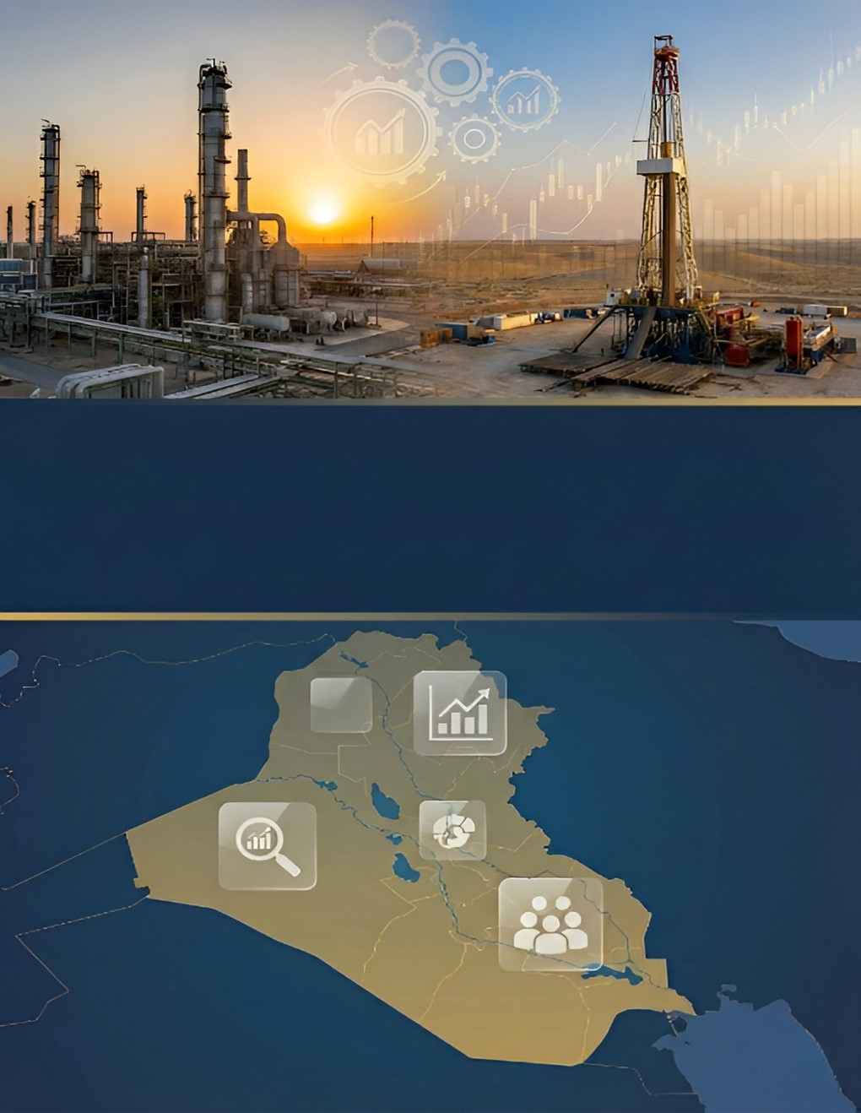

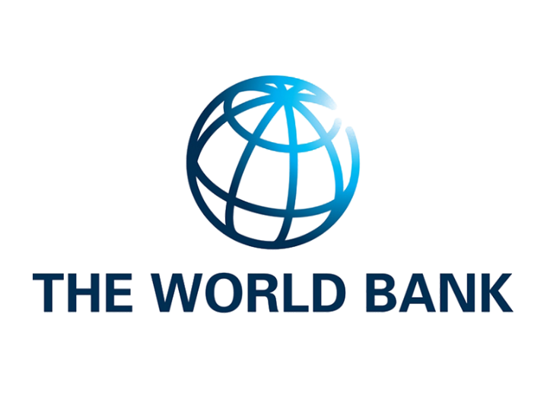

Transparency Authority for Natural Resources
Annual Report 2023

December 31, 2025

Report Contents

the chapter | Page
Overview | 3
Executive Summary | 7
Chapter One: The Legal and Financial Framework | 12
Chapter Two: Exploration and Production | 35
Chapter Three: Exports | 49
Chapter Four: Revenue Collection | 65
Chapter Five: Revenue Distribution | 92
Chapter Six: Benefits of the Extractive Sector | 107
Chapter Seven: Indicators and RecommendationsFollow-up | 120

Overview
It is initiative Transparency in Industries Extractive(EITI)standard Internationally It aims to Consolidation administration open and responsible For resources natural, from during Strengthening systems Governance I have governments and companies, and support Dialogue The year, Building trust between various Parties.And It was presented The initiative First time during summit the earth For development Sustainable in Johannesburg general2002, To release officially in London general2003.And it is applied The initiative inside all nation member via partnership pool governments and companies sector Extractive and organizations the society Civilian.

And in March2009, Announced government Iraq Her desire in Join to The initiative Strengthening principles Transparency and accountability in administration Resources natural.And it was formed first council For owners Interest multiple(MSG)in September2010, And became Iraq country Candidate in February from Year same, then He obtained characteristic Compliance For standards The initiative in Canon the first2012.

Includes to implement The initiative in Iraq sectoral oil gas Mining, And Issued Administrative Independent For the initiative several Reports Cover period from1Canon the second2009Even31Canon the first 2022, In addition to Report present that It deals Data general 2023.
Overview -appearance 1
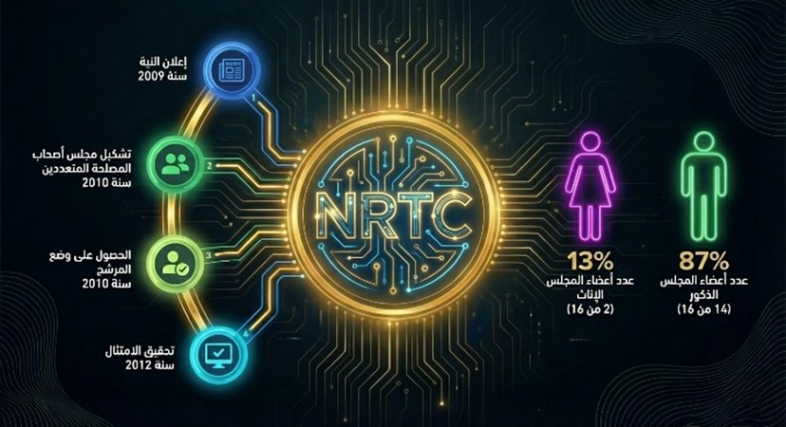

The main objectives of Iraq's accession to the Extractive Industries Transparency Initiative (EITI) are to promote the principles of transparency and accountability, combat corruption, build trust with citizens, support international investment, and improve Iraq's international image..
The justifications Iraq cites for its membership and compliance with the initiative's requirements include its near-total dependence on the oil and gas sectors, the need to benefit from international technical support, and the strengthening of dialogue channels between various stakeholders..
The main reasons for Iraq's continued membership in the initiative are due to several considerations, including:
- Economic: TerTransparency is key to attracting investments..
- Political: THussein emphasized Iraq's international standing and the importance of promoting internal dialogue..
- development: Linking the oil and gas sector to reform efforts and sustainable governance.
Formation and governance of the Natural Resources Transparency Authority
The Extractive Industries Transparency Initiative (EITI) in Iraq was established in 2010 and has continued its work since then. On December 11, 2024, the initiative was reorganized by Decree No. 86 issued by the General Secretariat of the Council of Ministers. Pursuant to paragraph two of this decree, the Natural Resources Transparency Authority was established as an independent body, unaffiliated with any government entity, tasked with implementing the Republic of Iraq’s commitments under the EITI.(EITI), and ensuring compliance with its principles, requirements, and international standards. The Authority's tasks include promoting transparency in the management of the oil, gas, and mining sectors, reducing corruption and poverty, supporting economic development, and raising living standards.
In addition, as stated in paragraphs five and seven of the decree, the body consists of:
- council Trustees, It includes group Owners Interest multiple And he supervises on to implement Standards The initiative And determines Goals that Reflect Priorities Nationalism Management sectors oil gas and miningThis council consists ofpresident Council Deputy President Six ten Member They choose For four years midwife For extension or Renewal with Consideration Balance qualitative between Both genders, And as Clear in Below:
- naming Mr. minister oil President Council Trustees.
- naming the boss Executive Deputy President addition to His position.
- six Members They represent Entities Government degree boss general So what above Their nomination Ministries(Planning and oil and industry minerals), And honesty public Council Ministers, and the bank Central Iraqi.
- five Members They represent Industry Extractive(sectors oil gas and mining), on that It represents companies International oil companies operating in Republic Iraq Two members degree boss regional or boss The branch, And represents companies public Owned public Owned State Ministry oil Two members degree boss general And represents companies public Owned Ministry Industry minerals Member one degree boss general.
- five Members They represent ingredients the society Civilian on that It represents Organizations not Government three Members degree(president The organization)They choose from between My candidates Organizations The permission Fundamentally Under law Organizations not Government(12For the year2010)And represents Unions and unions Professional Registered officially Under the law Two members degree Captain or president Union.
- be Approval on My candidates Entities Government in council Trustees from Honesty public Council Ministers.

- Honesty Nationalism, And it works under Supervision Daily Live For the manager Executive And it costs Implementation Business Daily GodAة It consists of from:
- angel Job:It consists from group from employees Those Determine them Entities that Represents the government in council Trustees.
- a team The chains of transmission:It consists from number from Owners Experience and specialization Those Their nomination Entities The actress in Council and the authorities The other The relationship And they cost With appreciation Support For the council from during meetings patrol Determine building on Requirements the job.
- Consultants Those Contract With them Council.
He takes overcouncilStakeholdersmultiple(MSG) Developing policies and programs in line with the initiative's standards and Iraq's national priorities, overseeing the reporting process, approving work plans, and implementing necessary awareness activities.,As for herATransparencyinwealthnatural(NRTC),It undertakes the implementation of activities approved by the MSG work plan and initiative standards..
Overview -appearance2
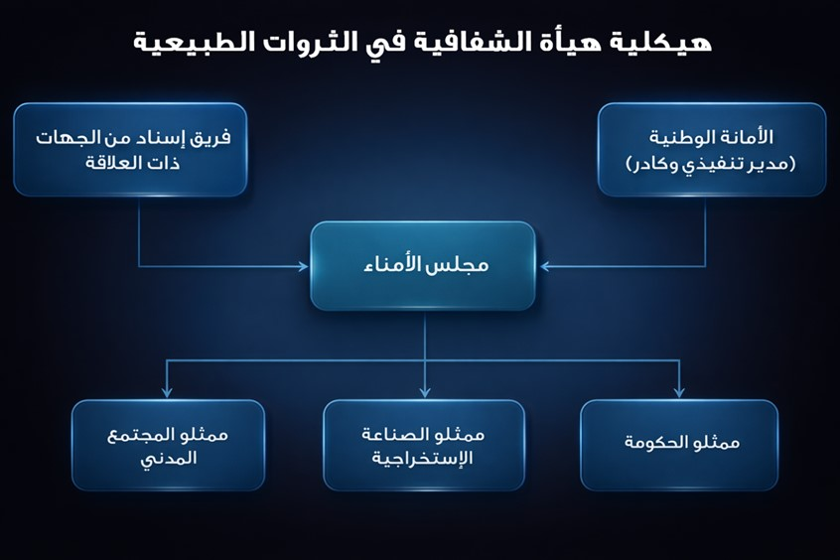
The following figure represents the components of the current Transparency Authority's Multi-Stakeholder Council.
Overview -appearance 3
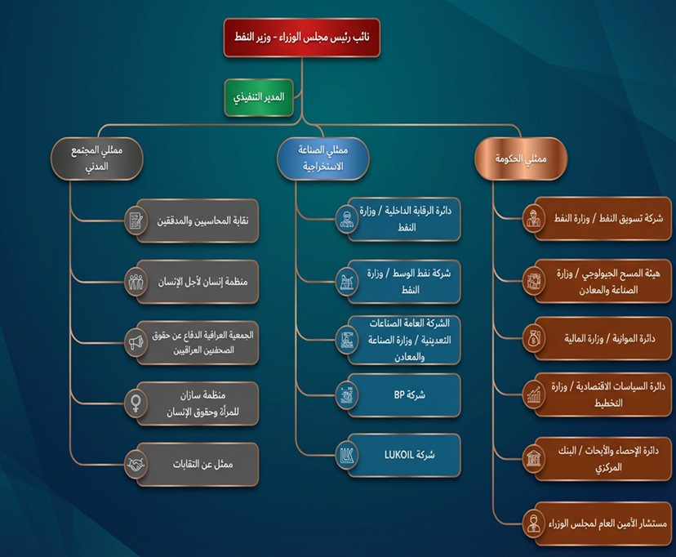


Executive Summary

Executive Summary

Key developmentsEconomicIn Iraq during the year 2023
The Iraqi economy witnessed a number of fundamental developments during 2023, reflecting the interplay of oil, financial, and monetary factors, alongside structural reform efforts in several vital sectors. The year was characterized by a clear duality: significant fiscal expansion on the one hand, and monetary and oil-related pressures on the other..

At the beginning of 2023, the Iraqi economy faced significant challenges regarding the exchange rate of the Iraqi dinar against the US dollar. Markets experienced sharp fluctuations due to tightened foreign exchange procedures and enhanced compliance and oversight requirements for banking operations. This led to higher prices for imported goods and increased inflation rates, directly impacting citizens' purchasing power before corrective measures were implemented.By changing the official exchange rate of the US dollar to 1,300 Iraqi dinars per dollar, instead of the previous 1,450 Iraqi dinars per dollar, the value of the Iraqi dinar improved by approximately 10%.%.

In the oil sector, the international arbitration ruling issued in March 2023 concerning Kurdistan Region oil exports via the Turkish port of Ceyhan marked a pivotal moment in the trajectory of the Iraqi economy. The ruling halted oil exports from the region, resulting in a temporary decline in oil revenues, while simultaneously reinforcing the principle of state sovereignty over the management of natural resources and the regulation of oil exports within the constitutional and legal framework..

As part of efforts to enhance local capabilities in the energy sector, April 2023 saw the opening of the Karbala refinery with a large refining capacity, representing a strategic step to reduce dependence on imported oil derivatives, support self-sufficiency, improve the balance of payments, and provide direct and indirect employment opportunities..

The year also witnessed the launch of the sixth round of gas licensing rounds, in line with a clear government direction towards investing in associated and non-associated gas, reducing flaring rates, and enhancing energy security, in accordance with environmental commitments and the requirements of sustainable development..

In June 2023, the House of Representatives approved the Federal General Budget Law for the years2023-2024-2025This is the first three-year budget in Iraq's history, with one of the largest expenditures ever recorded. This approval reflects an expansionary fiscal policy, with a significant increase in operational and investment spending, coupled with a rise in the planned deficit, posing future challenges related to fiscal sustainability and spending efficiency..
andIn May ofIn the same year, Iraq began implementing its commitments under the OPEC+ oil production cut agreements, which contributed to limiting GDP growth despite a relative improvement in global oil prices, and highlighted once again the sensitivity of the Iraqi economy to fluctuations in global energy markets..

In general, 2023 can be described as a transitional year for the Iraqi economy, characterized by immediate challenges and structural pressures, met by a gradual drive towards reform, strengthening economic governance, and improving the management of public resources, particularly in the oil sector and public finance..
Executive Summary -appearance 4
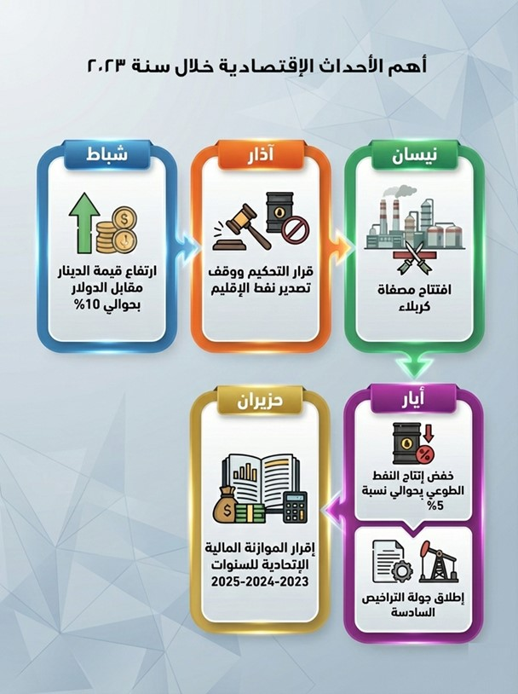
Most importantIndicators Oil and economicIn Iraq during the year 2023
First: Oil production and export indicators
Data indicates a slight improvement in oil activity levels during 2023 compared to 2022, with crude oil production increasing by 2% to reach approximately 1.57 billion barrels, and crude oil exports rising by roughly the same percentage. This increase reflects the stability of production and export capacity, despite challenges related to global markets and production commitments within the OPEC+ alliance.+.

However, this quantitative improvement did not translate into increased revenues, as the total value of crude oil exports decreased by 16%, primarily due to a 17% drop in the average price per barrel of exported oil, from $95.6 to $79.2. This indicator highlights the sensitivity of public revenues to fluctuations in global prices, even when export volumes remain stable or increase..
Executive Summary -table 1
Index | 2022 | 2023 | percentage change
Crude oil production (barrels) | 1,536,410,781 | 1,571,158,878 | 2%
Total quantity of crude oil exported (barrels) | 1208,531,119 | 1,232,170,145 | 2%
Total value of crude oil exported (US dollars) | 115,568,593,468 | 97,573,545,001 | -16%
Average price per barrel of exported crude oil (US dollars) | 95.6 | 79.2 | -17%

secondly:Indicators export Products oil
Export volumes of petroleum products recorded a notable growth of 10% during 2023, a positive development reflecting improved refining capacity and the country's increased focus on maximizing local value-added. However, the total value of petroleum product exports decreased by 10% due to declining global prices, further highlighting the impact of price factors on export revenues, even with increased volumes..

Executive Summary -table 2
Index | 2022 | 2023 | percentage change
Total quantity of exported petroleum products (tons) | 9,213,173 | 10,150,934 | 10%
Total value of exported petroleum products (US dollars) | 5,003,144,571 | 4,510,082,301 | -10%

Third:Indicators Economic College
The gross domestic product (GDP) at current prices showed a sharp decline of 20% during 2023, affected by the drop in oil prices, given that the oil sector is the main component of GDP. This decline reflects the high degree of dependence of the national economy on the extractive sector and the limited contribution of non-oil sectors in offsetting price shocks..
Executive Summary -table 3
Index | 2022 | 2023 | percentage change
Gross Domestic Product at current prices (billion Iraqi dinars) | 417,686 | 332,175 | -20%

Fourth:Indicators Finance public and transfers
Total actual general budget revenues declined by (16%), in line with the decrease in oil revenues, which places additional pressure on fiscal sustainability and public spending management..
In contrast, petrodollar transfers witnessed a decrease of (8%), affected by the decline in the value of oil exports, while transfers for the development of regions and governorates recorded a significant jump of (98%), a remarkable development that reflects a financial trend that supports local development and compensates the governorates for the economic impact of the decline in revenues, especially in the producing governorates..

Executive Summary -table 4
Index | 2022 | 2023 | percentage change
Total revenues of the state's general budget - actual (billion Iraqi dinars) | 161,697 | 135,681 | -16%
Total petrodollar transfers (Iraqi dinars) | 1,326,325,013,753 | 1,216,195,494,232 | -8%
Total regional and provincial development transfers (Iraqi Dinars) | 2,591,634,828,370 | 5,143,488,420,828 | 98%

General summary of indicators
In general, indicators show that 2023 was characterized by:
- Relative stability in the quantities produced and exported.
- In contrast to a noticeable decline in values ​​and revenues as a result of falling global prices,
- With a direct impact on GDP and public revenues,
- Meanwhile, a significant increase in regional and provincial development transfers has emerged as a financial tool to mitigate the economic impact and support regional development..
These findings underscore the need to diversify the economic base, strengthen manufacturing industries, and improve the management of oil revenues to mitigate the impact of oil price volatility on the economy and public finances..

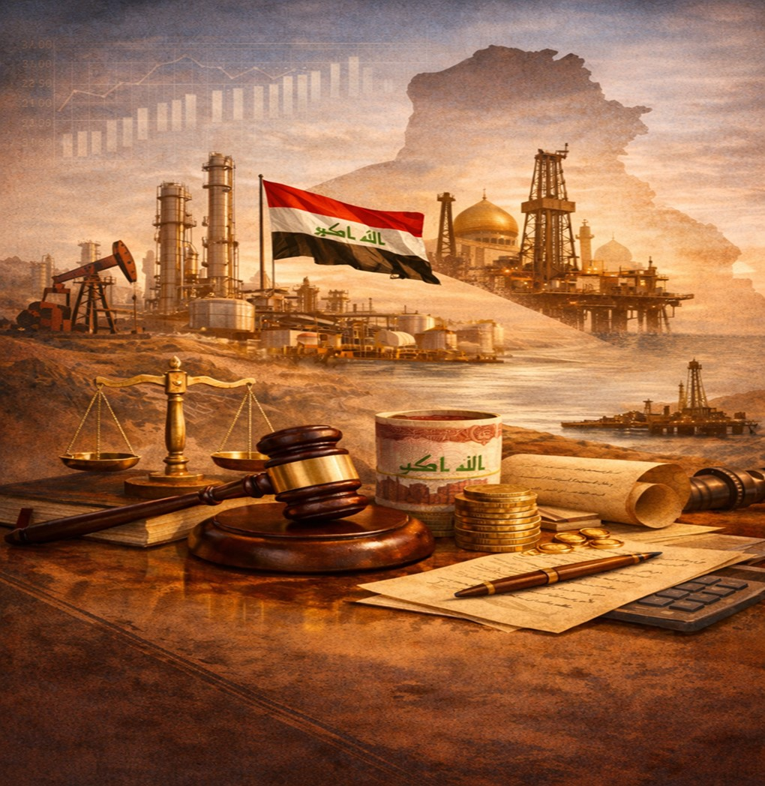
Chapter One: The Legal and Financial Framework

- frameworkLegal and the system Financial

  - The legal aspects of extractive industries

It is considered Industries Extractive One Supports President For the economy Iraqi, Given when It represents Its revenues from importance pivotal in finance Budget public For the state, so form in some years more from(90%)from total Revenue.And it depends This is amazing Industries on to exploit Resources natural extracted from inner the earth, And treating it and strengthening Its value Added, In what Contributes in supply Economy With materials Primary Basic To support Activities yield and development.
And he owns Iraq reserves large and diverse from Resources natural, In what It qualifies him To support Paths Development Economic and development Services public.And singled out Constitution Iraqi For the year2005Number from Its materials To determine ownership oil gas and mechanisms Their management, in when did not It deals issue wealth mineral In picture Explicit.as Eat Constitution topic Investment, Confirmed importance Encouraging him, And text on group from rulings The Connection The organization For this Field.
AHis approach someTexts rulings or Materials The Connection from Constitution:
Material(25): Guarantee State repair Economy Iraqi according to Foundations Economic Modern And with Guarantees investment complete Its resources and diversification confiscation and encouragement sector private and its development.
Material(26): Guarantee State to encourage Investments in Sectors different And organizes that By law.
Material (111): oil gas he king all The people Iraqi in all Regions and the governorates.

In addition, the oil sector is subject to lawInvestment private in filtering oil raw number64For the year2007(https://oil.gov.iq/?article=183).
As for the mining sector, it is primarily governed by the Mineral Investment Regulation Law No. 91 of 1988, as amended (https://iraqld.e-sjc-services.iq/legislations/showlegislation?lawbookid=12560).

Issued province Kurdistan law oil gas number(22)For the year2007, that income space Access in9dad from Year same.unless that this the law Cancelled Under resolution The court Federal Upper number(59/Federal/2012)And the monotheist with decision number(110/Federal/2019), Issued on the date15February2022, so She ruled The court Not Its constitutionality and its invalidation.

as Obligation decision government province Kurdistan By delivery complete production oil from Fields The incident inside region and areas The other to the government Federalism, And granted ministry oil Federal Validity Exclusive in administration Operations Exploration and extraction Export.And according to decision same, It was considered all Contracts oil that I concluded it government region with countries or companies foreign Invalid, with Obliging her By enabling ministry oil Diwan censorship Finance Federal from review that Contracts and scrutinize it.
And in context This link, Decided Iraq on the date23March2023dispute arbitration international long The term with Türkiye about exports oil province Kurdistan For the period from2014to2018, Which She was It is transferred via line pipes from crossing Fishkhabur to harbor Jihan Turkish Don consent the government Federal.And Issued body arbitration in Paris decision It is required Türkiye By paying compensation It is estimated Approximately1.5one billion dollar In favor of Iraq, According to when I confirmed it sources Media International.And on effect this decision, It happened Stop export oil Product in region via harbor Jihan As of from25March2023.

And in25September2025, It was announced Reaching to deal between ministry oil Federal Ministry wealth natural in province Kurdistan, With the participation majority companies oil International The worker in The region It states on delivery about190one thousand barrel daily from oil region to a company marketing oil Nationalism(Sumo), addition to Allocation50one thousand barrel daily To cover Consumption Local in region.And it is marketed Quantities allocated For export via The system Nationalism For pipes and line"Iraq – Türkiye", on that Deposit Revenue Verified in Treasury public State.

And on the date27September2025, It was announced officially appeal Operations export oil raw from province Kurdistan via line pipes Iraqi–Turkish.


  - sideFinancial economic For industries Extractive
It represents export oil raw Source Main For revenues sector Extractive in Iraq, where It is pumping oil raw Either to outlets a company marketing oil(Sumo)For the purpose Export, or to refineries and stations generation electricity To meet Consumption Local.And she takes over ministry Finance transformation Revenue Verified to ministry oil To pay Costs Production due For companies The contractor That's according to Tables Time patrol, And with He takes into account flows Cash Private With all a company.

register Revenue resulting from sale oil gas For consumption Local As an income In favor of companies Nationalism, Which It commits By converting rate60%from net Its profits Annual to Treasury public State.As for returns exports oil to markets International, It is transformed directly to account ministry Finance I have Bank the reserve Federal in New York.

He explains The drawing The graph Below The mechanism The process For deposit returns sales exports oil in the accounts that retains In it the government Iraqi, Which Return Her ownership to ministry Finance And it is managed from before Bank Central Iraqi, That's during general2023, before that It is Its distribution Later according to following:
Chapter One (Legal and Financial Framework) -appearance 5
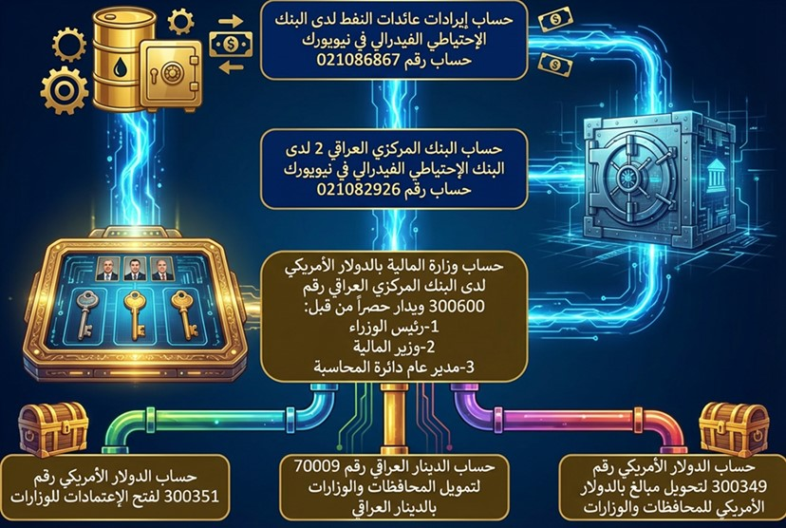
And according to contracts Tours Licenses, Get companies foreign on wages Profitability and costs Mustard, Pay in Most Eyes.as Takes over circle Contracts and licenses petroleum in ministry oil deduction Taxes due on This is amazing Companies, and conversion Its value to ministry Finance according to Frameworks Legal Approved.

And it does ministry oil By converting Rewards the signature, addition to a class Partner Government from wages Profitability, to ministry Finance, that undertakes In turn Distribution This is amazing Revenue on Ministries and the governorates within Budget Federal State.

He explains The drawing The graph Below nature Relations and flows Finance between the government Federalism, Actress Ministry Finance, and companies Extractive The worker in sector oil And gas, whether Nationalism Owned State or companies foreign.
Chapter One (Legal and Financial Framework) -appearance 6
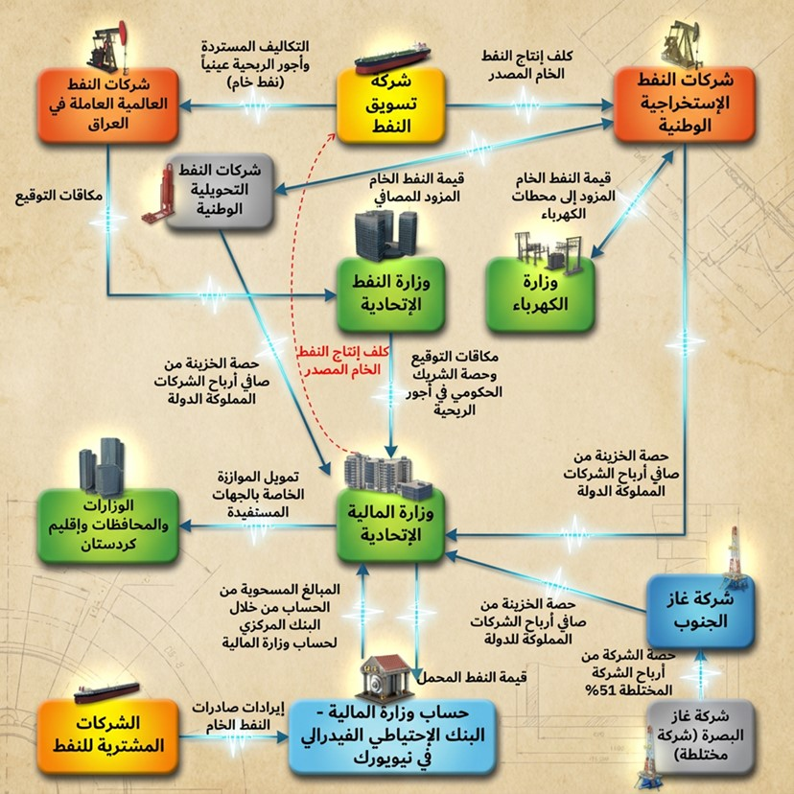
The financial relationship between the federal government (Ministry of Finance) and extractive companies in the mining sector, including state-owned public companies in Iraq, is based on the following principles.:
- The revenue generated from the sale of minerals is recorded in the accounts of the relevant extractive companies to cover their expenses as self-financing companies..
- Based on the amended Public Companies Law No. (22) of 1997, specifically Article (11), the percentage (60% of net distributable profits annually to the Ministry of Finance under the item "Treasury Share""
- This share is included in the state revenues, to be redistributed later by the Ministry of Finance to ministries and governorates according to the allocations approved in the Federal General Budget Law..

    - Federal General Authority for Monitoring the Allocation of Imports

FoundedFederal General Authority for Monitoring the Allocation of ImportsBy law issued by the Iraqi Parliament under number 55 of 2017,Its establishment came in response to the need to create an independent federal body to manage sovereign revenues and monitor the fairness and transparency of their distribution between the federal government, the regions, and the provinces not organized into a region., andIt is considered This is amazing The Authority device Regulatory And executively in that one.
One of the most important tasks of this body is:

Firstly- To verify the fairness of the distribution of federal revenues when preparing the draft federal general budget and the accuracy of calculating the distribution of allocations of federal revenues, grants, aid and international loans in accordance with the bases, standards and indicators that are determined by system and submit its final reports to the House of Representatives.
secondly- Monitoring the process of financing the allocation amounts from the Ministry of Finance and the executive procedures taken to calculate the share of each region or governorate not organized into a region from international grants, aid and loans.
Third- Contacting the relevant authorities to provide the Authority with any books, correspondence and endorsements related to the Authority’s functions and to answer all questions related to allocations and funding.
Fourth- Investigating and examining the imports coming to the federal government, the details of their components and sources.
Fifth- Hosting a representative of any ministry whose presence is needed for the purpose of consultation and seeking his opinion.

    - The tax aspect of extractive industries
Each of the licensing round companies is subject to a tax of (35%) of the calculated profit wages after deducting the government partner’s share, as shown in its annual financial statements organized in accordance with the unified Iraqi accounting system, in accordance with Instruction No. (5) of 2010 emanating from the Petroleum Tax Law No. (19) of 2010.
The standard service contract of the Ministry of Oil included tax provisions that regulate the financial and tax relationship of foreign companies contracting with the Ministry of Oil, represented by its national companies, on the one hand, and with the General Authority for Taxes on the other hand.

In 2024, the General Secretariat of the Council of Ministers issued Resolution No. 24074 dated January 23, 2024, which cancels Diwani Order No. 499 of 2016, whereby 35% (income tax) is deducted from the profit-sharing wages received byLicensing Tour CompaniesThe amounts related to 2023 are included in the first quarter account statement for 2024 (instead of being paid by)Licensing Tour Companies(For the General Authority for Taxes). In practice, if the wages are profitableLicensing Tour CompaniesThe revenue for the first quarter of 2024 is insufficient to cover all tax dues related to 2023. The remaining tax dues are to be paid from petroleum costs for the same quarter.

Chapter One (Legal and Financial Framework) -appearance 7
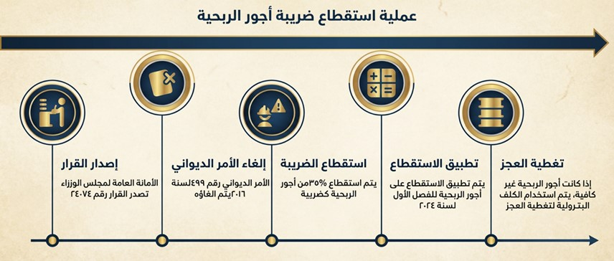

  - Petroleum licensing rounds
According to the Ministry of Oil Organization Law No. 101 of 1976 (Article 5), and the incorporation certificates of national oil companies (for example, the certificate of Dhi Qar Oil Company, which authorizes it to conduct tenders and auctions, enter into various contracts with other Iraqi and foreign economic and financial sectors, accept agencies, conclude contracts, and conduct all transactions, whether independently, on its own behalf, or jointly with others, and to undertake all actions it deems appropriate to achieve its objectives and under the conditions it considers), the Ministry of Oil has conducted six oil and gas licensing rounds. Under these service contracts, the winning consortium or company becomes a "contractor" to the national oil company, which varies according to the field/exploration block. The national oil company is referred to as a regional oil company.(ROC) in service contracts is contractually defined as the Iraqi State Oil and Gas Company, exclusively entrusted and authorized to drill, evaluate, develop, and produce within the contract area, in accordance with the law (Law Regulating the Work of the Ministry of Oil No. 101 of 1976 - as amended). Geographical areas (fields/exploration blocks) were originally allocated to national oil companies.
It is noted thatIt is created According to For decades Tours Licenses entity operational subscriber, independent Administratively financially on a company oil Regional(ROC),And it is allocated Exclusively For work K"Operator".
Here we must address the most important reasons that prompted the Iraqi government, represented by the Ministry of Oil, to resort to oil licensing contracts, which are:
- Production in the producing fields in southern and northern Iraq has deteriorated, necessitating urgent action to halt this decline.
- The limited funds provided by the government for field development or redevelopment projects.
- The need to explore new oil and gas fields to manage and enhance oil and gas reserves.

    - Oil service contracts
Service contracts are a type of oil contract that grants countries that own resources more powers and rights to manage their resources and revenues. According to this type of contract, the Ministry of Oil contracted with foreign oil companies for the purpose of providing a specific service by rehabilitating fields or carrying out new explorations in exchange for service fees paid to these companies. In this type of contract, the state bears all the fees and risks, and in return, all the quantities produced and petroleum resources are at the disposal of the state, and the companies do not have a right to them. This is considered to be in line with what is stated in Article (111) of the Constitution.
The Ministry of Oil has divided the fields and geographical areas into categories in order to launch licensing rounds for them, as shown below:
- productive fields
- Discovered fields that are not producing, or producing but have not reached commercial production.
- Gas fields.
- Exploratory geographical areas.

Some standard contracts were published in a file attached to the annual report appendices.2023Under the title "Some Standard Contracts for Licensing Rounds," tables containing the names of companies that submitted bids in each licensing round were also published in a file attached to the annual report.2023Under the name " names companies the introduction For tenders in Tours Licenses The six"

    - Granting licenses
The following diagram summarizes the stages of granting petroleum licenses.Through licensing roundsin generalIt should be noted that petroleum licenses may be granted without conducting a licensing round for fields that were offered in previous licensing rounds but were not awarded.:
Chapter One (Legal and Financial Framework) -appearance 8
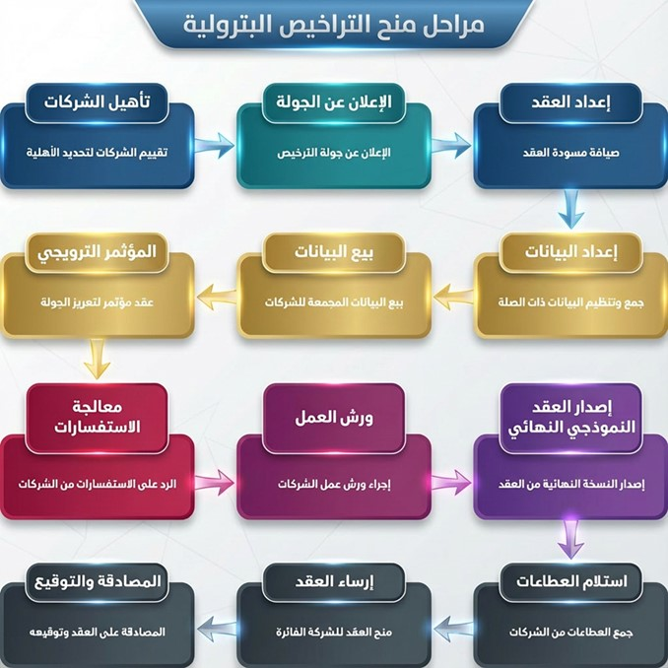

The transfer of ownership in licensing round contracts is carried out through the full or partial assignment of rights and obligations, in accordance with Article 28 of the service contracts in general. This article stipulates, in short, that companies may not assign their rights or obligations under the contract, in whole or in part, without the prior written consent of the national or regional oil company. If the assignment is to a wholly-owned subsidiary qualified by the Ministry of Oil, approval is granted on the condition that the original company continues to share responsibility with the assignee. Assignment to a third party or a company not wholly owned requires an application supported by proof of technical and financial competence, approval from the regional oil company within three months, and the provision of acceptable guarantees before the assignment is finalized, thus releasing the assigning company from its obligations.

    - Petroleum licensing register
The Extractive Industries Transparency Initiative (EITI) has organized a register of petroleum licenses and their amendments from data provided to it by the Department of Petroleum Contracts and Licenses. This register includes basic information for these licenses, and updates related to them in terms of amending participation ratios or adding/withdrawing partners from the consortium.

The tables below show the licenses in place in Iraq as of the date of this report.

Chapter One (Legal and Financial Framework) -table 5
Outside of licensing rounds (oil and gas fields)
The field | The national contracting company (first party) | Coalition | Participation rates % | Government partner (participation percentage %) | Operator | Date of signing the contract | Contract activation date | Contract duration | Initial production rateIPR (barrels per day) | Initial production target (10%) (barrels per day) | First commercial production (barrels per day) | Profitability per barrel produced (US dollars)
hunchback | Middle Oil Company | Oasis Oil Company Limited | 75% | Oil Marketing Company (25%) | Oasis Oil Company Limited | September 1, 2008 | November 10, 2008 | 20 years | nothing | nothing | 25,000 | 6
East Baghdad (southern part) | Middle Oil Company | China Zhenhua | 90% | North Oil Company (10%) | China Zhenhua | May 23, 2018 | May 23, 2018 | 25 years old | nothing | nothing | 1,500 | 6
Artawi | Basra Oil Company | Total Energy, the French company | 45% | There is no government partner (the field depends on revenue for the state). | Total Energy, the French company | August 16, 2023 | August 16, 2024 | 30 years | nothing | nothing | 60,000 | There is no fixed profit margin
Artawi | Basra Oil Company | Qatar Energy Company | 25%
Artawi | Basra Oil Company | Basra Oil Company | 30%
Mansouriya | Middle Oil Company | Middle Oil Company | 51.0% | There is no government partner | Middle Oil Company | October 31, 2024 | December 31, 2024 | 20 years | nothing | nothing | nothing | 7%
Mansouriya | Middle Oil Company | neighbor | 34.3%
Mansouriya | Middle Oil Company | Petro Iraq | 14.7%
Sinbad | Basra Oil Company | United Energy Group | 100% | nothing | United Energy Group | In the preparation stage

Chapter One (Legal and Financial Framework) -table 6
First round (oil fields)
The field | The national contracting company (first party) | Coalition | Participation rates % | Government partner (participation percentage %) | Operator | Date of signing the contract | Contract activation date | Contract duration | Initial production rateIPR (barrels per day) | Initial production target (10%) (barrels per day) | First commercial production (barrels per day) | Profitability fees per additional barrel produced (US dollars)
Al-Rumaila* | Basra Oil Company | British Petroleum (BP) | 47.63% | Oil Marketing Company (6%) | British Petroleum (BP) | November 3, 2009 | December 17, 2009 | 25 years old | 1,066,000 | 1,172,600 | 1,172,600 | 2
Al-Rumaila* | Basra Oil Company | PetroChina | 46.37%
Al-Zubair | Basra Oil Company | Eni (B.V.) | 41.56% | Missan Oil Company (5%) | Eni (B.V.) | January 22, 2010 | February 18, 2010 | 25 years old | 182,775 | 201,053 | 201,053 | 2
Al-Zubair | Basra Oil Company | Basra Oil Company | 29.69%
Al-Zubair | Basra Oil Company | Kogaz | 23.75%
West Qurna (Phase 1) | Basra Oil Company | ExxonMobil sold its stake in the company to Basra Oil Company on 6/11/2023, and the shareholding percentages between the partners changed. | 32.692% The company withdrew completely (no participation percentage) | Oil Exploration Company (5%) | ExxonMobil changed operator to PetroChina after the sale of its stake. | January 25, 2010 | March 1, 2018 | 20 years (extendable to 30 years) | 244,000 | 268,400 | 268,400 | Al-Mushrif reservoir = 1.9 / Al-Zubair reservoir = 2
West Qurna (Phase 1) | Basra Oil Company | Shell (This stake was sold to the Japanese company Itochu on May 27, 2018) | The new participation rate after the sale is 19.61%, and 19.62%.
West Qurna (Phase 1) | Basra Oil Company | Basra Oil Company | Basra Oil Company joined the contractor consortium with a 22.69% participation rate.
West Qurna (Phase 1) | Basra Oil Company | PetroChina | The company retained its 32.692% share, remaining the field operator.
West Qurna (Phase 1) | Basra Oil Company | Pertamina | The new participation rate after the sale is 20%.
Maysan oil fields (Abu Gharb, Buzurkan, Fakkah) | Missan Oil Company | China National Offshore Oil Corporation (CNOOC Iraq) | 63.75% | Iraqi Drilling Company (25%) | Sinok Iraq | May 17, 2010 | December 20, 2010 | 20 years | 88,000 | 96,800 | 96,800 | 2.3
Maysan oil fields (Abu Gharb, Buzurkan, Fakkah) | Missan Oil Company | Turkish Petroleum Corporation (TPAO) | 11.25%
* British Petroleum and CompanyPetroChina establishedBasra Energy Company Limited, a joint venture as of June 1, 2022,Where you ownBasra Energy Company Limited manages its interests in the Rumaila field, including enhancing access to external financing. The Iraqi Cabinet, in its session of August 24, 2021, approved the restructuring of BP and PetroChina’s participation in the Rumaila oil field service contract.

Chapter One (Legal and Financial Framework) -table 7
Round Two (Non-Producing Oil Fields)
The field | The national contracting company (first party) | Coalition | Participation rates % | Government partner (participation percentage %) | Operator | Date of signing the contract | Contract activation date | Contract duration | Initial production rateIPR (barrels per day) | Initial production target (10%) (barrels per day) | First commercial production (barrels per day) | Profitability per barrel produced (US dollars)
West Qurna (Phase 2) | Basra Oil Company | Lukoil Middle East Limited | 75% | North Oil Company (5%) | Lockwell Middle East Limited | January 31, 2010 | February 10, 2010 | 25 years old | nothing | nothing | 120,000 | Al-Mushrif reservoir = 1.15 / Al-Yamamah reservoir = 3.65
Crazy (This license was withdrawn and production is currently being carried out through national effort) | Basra Oil Company | Shell | 45% | Missan Oil Company (25%) | Shell | January 17, 2010 | March 1, 2010 | 20 years | 45900 | nothing | 175,000 | 1.39
 | Basra Oil Company | Petronas | 30%
Al-Halfaya | North Oil Company | PetroChina | 45% | Basra Oil Company (10%) | PetroChina | January 27, 2010 | March 1, 2010 | 30 years | 3100 | nothing | 70,000 | 1.4
Al-Halfaya | North Oil Company | Petronas | 22.5%
Al-Halfaya | North Oil Company | Total | 22.5%
The croaker | Dhi Qar Oil Company | Petronas | 45% | North Oil Company (5%) | Petronas | January 18, 2010 | February 10, 2010 | 20 years | nothing | nothing | 35,000 | 1.49
The croaker | Dhi Qar Oil Company | Japex | 30%
Badra | Middle Oil Company | Gazprom Neft | 30% | Oil Exploration Company (25%) | Gazprom Neft | January 28, 2010 | February 18, 2010 | 20 years | nothing | nothing | 15,000 | 5.5
Badra | Middle Oil Company | Korea Gas Corporation (KOGAS) | 22.5%
Badra | Middle Oil Company | Petronas | 15%
Badra | Middle Oil Company | Turkish Petroleum Corporation (TPAO) | 7.5%
Qayyarah | North Oil Company | Sonangol | 75% | Basra Oil Company (25%) | Sonangol | January 26, 2010 | February 18, 2010 | 20 years | nothing | nothing | 30,000 | 5
a star | North Oil Company | Sonangol | 75% | Iraqi Drilling Company (25%) | Sonangol | January 26, 2010 | February 18, 2010 | 20 years | nothing | nothing | 20,000 | 6

Chapter One (Legal and Financial Framework) -table 8
Third round (gas fields)
The field | The national contracting company (first party) | Coalition | Participation rates % | Government partner (participation percentage %) | Operator | Date of signing the contract | Contract activation date | Contract duration | Initial production rateIPR (million standard cubic feet per day) | Initial production target (10%) (1 million standard cubic feet per day) | First commercial production (1 million standard cubic feet per day) | Profitability per barrel of produced equivalent (US dollars)
Akkas * | Middle Oil Company | Korea Gas Corporation (KOGAS) | 75% | North Oil Company (5%) | Kogaz Akkas | October 13, 2011 | November 15, 2011 | 20 years | nothing | nothing | 100 | 5.5
Al-Mansouriya ** | Middle Oil Company | Turkish Petroleum Corporation (TPAO) | 37.5% | Oil Exploration Company (25%) | Tibao | June 5, 2011 | July 18, 2011 | 20 years | nothing | nothing | 80 | 7
Al-Mansouriya ** | Middle Oil Company | Kuwait Energy | 22.5%
Al-Mansouriya ** | Middle Oil Company | Kogaz | 15%
The chaos | Basra Oil Company | Kuwait Energy | 30% | Missan Oil Company (25%) | Kuwait Energy | June 5, 2011 | July 1, 2011 | 20 years | nothing | nothing | 25 mqmq | 7.5
The chaos | Basra Oil Company | Turkish Petroleum Corporation (TPAO) | 30%
The chaos | Basra Oil Company | Egyptian General Petroleum Corporation | 15%
*The company was unable to complete its work due to the terrorist activities of ISIS, and a series of negotiations led to the company's withdrawal in 2019. The Ministry of Oil is in contact with several reputable regional and international companies in order to reach an agreement that achieves the planned objectives for developing the field and producing gas, but no agreement or contract has been reached with any of these companies as of the date of this report.
**This license was suspended on September 5, 2018, due to the consortium's delay in commencing field development because of the security situation. Subsequently, on January 20, 2022, a contract was signed for the development of the Mansouriya gas field, with a profit-sharing arrangement between the Central Oil Company and the Central Oil Company. The winning Chinese company, Sinopec, holds a 49% share, while the Central Oil Company retains a 51% share. This is a preliminary agreement, requiring approval from the Ministerial Energy Committee and the Cabinet. Following approval, the final agreement will be signed by the Central Oil Company and Sinopec to activate the contract and commence development operations..

Chapter One (Legal and Financial Framework) -table 9
Round Four (Exploration Patches)
The field | The national contracting company (first party) | Coalition | Participation rates % | Government partner (participation percentage %) | Operator | Date of signing the contract | Contract activation date | Contract duration | Initial production rateIPR (barrels per day) | Initial production target (10%) (barrels per day) | First commercial production (barrels per day) | Profitability per barrel produced (US dollars)
Exploration Area 8 * | Middle Oil Company | Pakistan Petroleum | 100% | nothing | Pakistan Petroleum | November 5, 2012 | December 5, 2012 | 30 years for an oil field and 40 years for a gas field | Not applicable (exploratory patches) |  |  | 5.38
Exploration Block 9 (Al-Fayha) | Basra Oil Company | Kuwait Energy | 60% | nothing | Kuwait Energy | January 27, 2013 | February 3, 2013 | 30 years |  |  |  | 6.24
Exploration Block 9 (Al-Fayha) | Basra Oil Company | Dragon Oil | 30%
Exploration Block 9 (Al-Fayha) | Basra Oil Company | Egyptian General Petroleum Corporation | 10%
Exploration Block 10 | Dhi Qar Oil Company | Lukoil Overseas Exploration Iraq | 60% | nothing | Lukoil Overseas Exploration Iraq | November 7, 2012 | December 3, 2012 | 30 years |  |  |  | 5.99
Exploration Block 10 | Dhi Qar Oil Company | Inpex | 40%
Exploration Block 12 | Basra Oil Company | Bashanft | 100% | nothing | Bashanft | November 8, 2012 | January 1, 2013 | 30 years |  |  |  | 5
*It was completed withdrawal Contractor from The field And procedures settlement between a company oil Middle and the company Pakistani.

Chapter One (Legal and Financial Framework) -table 10
Fifth round (border fields)
The field | The national contracting company (first party) | Coalition | Participation rates % | Government partner (participation percentage %) | Operator | Date of signing the contract | Contract activation date | Contract duration | The maximum profit margin that can be granted to the company (determined by the Ministry of Oil) is % | Profit margin offered by the company %
Oil Khana | Middle Oil Company | Geo–Jade | 100% | nothing | Geo–Jade | February 21, 2023 | June 1, 2023 | 34 | 24.45% | 14.67%
Al-Hawizeh | Missan Oil Company | Geo–Jade | 100% | nothing | Geo–Jade | February 21, 2023 | April 6, 2023 | 20 | 7.16% | 7.15%
Khader Al-Mai | Basra Oil Company | Crescent Petroleum | 100% | nothing | Crescent Petroleum | February 21, 2023 | December 15, 2023 | 34 | 13.76% | 13.75%
Claws–Camel | Middle Oil Company | Crescent Petroleum | 100% | nothing | Crescent Petroleum | February 21, 2023 | November 15, 2023 | 20 | 16.65% | 9.21%
Anjana - Khashm al-Ahmar | Middle Oil Company | Crescent Petroleum | 100% | nothing | Crescent Petroleum | February 21, 2023 | October 15, 2023 | 20 | 20.00% | 19.99%

Chapter One (Legal and Financial Framework) -table 11
Continuation of round five and round six
The field | The national contracting company (first party) | Coalition | Participation rates % | Government partner (participation percentage %) | Operator | Date of signing the contract | Contract activation date | Contract duration | The maximum profit margin that can be granted to the company (determined by the Ministry of Oil) is % | Profit margin offered by the company %
East Baghdad, northern extension | Middle Oil Company | Zbak -ZPEC | 100% | nothing | Zbak -ZPEC | October 27, 2024 | November 18, 2024 | 20 years |  | 6.67%
Middle Euphrates | Middle Oil Company | Zbak -ZPEC | 100% | nothing | Zbak -ZPEC | October 27, 2024 | November 18, 2024 | 20 years |  | 9.35%
Dima | Missan Oil Company | Car | 100% | nothing | Car | October 27, 2024 | February 18, 2025 | 20 years |  | 6.20%
Ann/Sasan | North Oil Company | Car | 100% | nothing | Car | October 27, 2024 | March 11, 2025 | 34 years old |  | 17.25%
Khalisiyah | Middle Oil Company | Car | 100% | nothing | Car | October 27, 2024 | February 17, 2025 | 34 years old |  | 32.00%
FAO | Basra Oil Company | United Energy Group | 100% | nothing | United Energy Group | October 27, 2024 | January 1, 2025 | 34 years old |  | 25.16%
Zarbatia | Middle Oil Company | Geo–Jade | 100% | nothing | Geo–Jade | October 27, 2024 | February 12, 2025 | 34 years old |  | 7.65%
Mount Sanam | Basra Oil Company | Geo–Jade | 100% | nothing | Geo–Jade | October 27, 2024 | January 20, 2025 | 34 years old |  | 30.90%
Exploration Block 7 | Middle Oil Company | China National Offshore Oil Corporation (CNOOC Iraq) | 100% | nothing | China National Offshore Oil Corporation (CNOOC Iraq) | October 29, 2024 | February 24, 2025 | 34 years old |  | 25.88%
Zafariyah | Middle Oil Company | Anton O'Leary | 100% | nothing | Anton O'Leary | October 27, 2024 | November 18, 2024 | 34 years old |  | 29.16%
Sumer | Dhi Qar Oil Company | Sinopec | 100% | nothing | Sinopec | October 27, 2024 | December 15, 2024 | 34 years old |  | 17.85%
Adan | Dhi Qar Oil Company | Sinopec | 100% | nothing | Sinopec | October 27, 2024 | December 15, 2024 | 34 years old |  | 15.80%
Abu Khayma | Dhi Qar Oil Company | China Zhenhua | 100% | nothing | China Zhenhua | October 27, 2024 | December 15, 2024 | 34 years old |  | 9.10%
Two horns | Middle Oil Company | China Zhenhua | 100% | nothing | China Zhenhua | October 27, 2024 | November 18, 2024 | 34 years old |  | 17.30%

    - Transparency of licensing round contracts
In his letter dated January 10, 2021, addressed to all national companies affiliated with the Ministry of Oil and the Contracts and Licensing Department, the Undersecretary of the Ministry of Oil for Extraction Affairs stressed the necessity of adhering to the Ministry of Oil's policy of contract transparency and considering this asAn ongoing policy encompasses licensing round contracts and other related agreements, which are updated in coordination with the Extractive Industries Transparency Initiative (EITI) in Iraq. Although the aforementioned contracts have not yet been published as of the date of this report, the Petroleum Contracts and Licensing Department had previously published all standard contract templates on the Ministry of Oil's website.

    - Licensing round contracts with amendments
The following table includes contracts in federal Iraq, in addition to their amendments:
Chapter One (Legal and Financial Framework) -table 12
Petroleum contracts in federal Iraq and their amendments
Licensing round | Contract area | Date of signing the contract | Amendments | Date of modification
First | Al-Rumaila | November 3, 2009 | Amendment No. 1 | September 4, 2014
First | Al-Zubair | January 22, 2010 | Amendment No. 1 | September 15, 2010
First | Al-Zubair | January 22, 2010 | Amendment No. 2 | July 15, 2013
First | Al-Zubair | January 22, 2010 | Amendment No. 3 | May 28, 2017
First | Al-Zubair | January 22, 2010 | Amendment No. 4 | February 18, 2020
First | West Qurna (Phase 1) | January 25, 2010 | Amendment No. 1 | August 18, 2010
First | West Qurna (Phase 1) | January 25, 2010 | Amendment No. 2 | August 18, 2010
First | West Qurna (Phase 1) | January 25, 2010 | Amendment No. 3 | November 28, 2013
First | West Qurna (Phase 1) | January 25, 2010 | Amendment No. 4 | February 19, 2014
First | West Qurna (Phase 1) | January 25, 2010 | Amendment No. 5 | May 27, 2018
First | Maysan fields | May 15, 2010 | nothing
Second | West Qurna (Phase 2) | January 31, 2010 | Amendment No. 1 | January 17, 2013
Second | West Qurna (Phase 2) | January 31, 2010 | Amendment No. 2 | November 28, 2013
Second | West Qurna (Phase 2) | January 31, 2010 | Amendment No. 3 | April 19, 2018
Second | West Qurna (Phase 2) | January 31, 2010 | Amendment No. 4 | November 1, 2023
Second | crazy | January 17, 2010 | nothing
Second | Halfaya | January 18, 2010 | Amendment No. 1 | September 4, 2014
Second | Graph | January 26, 2010 | nothing
Second | Badra | January 17, 2010 | Amendment No. 1 | May 22, 2025
Second | Qayyarah | January 26, 2010 | nothing
Second | a star | January 26, 2010 | nothing
Third | hard up | October 13, 2011 | nothing
Third | Mansouriya | June 5, 2011 | nothing
Third | Seba | June 5, 2011 | Amendment No. 1 | May 23, 2017
Third | Seba | June 5, 2011 | Amendment No. 2 | July 29, 2025
Fourth | Patch 8 | November 5, 2012 | Amendment No. 1 | 2015
Fourth | Patch 8 | November 5, 2012 | Amendment No. 2 | October 26, 2017
Fourth | Patch 9 (Al-Fayha) | January 27, 2013 | Amendment No. 1 | July 2015
Fourth | Patch 9 (Al-Fayha) | January 27, 2013 | Amendment No. 2 | September 30, 2015
Fourth | Patch 10 | November 7, 2012 | Amendment No. 1 | December 17, 2018
Fourth | Patch 12 | November 8, 2012 | Amendment No. 1 | August 2, 2017
Outside of licensing rounds | hunchback | September 1, 2008 | Amendment No. 1 | June 5, 2011
Outside of licensing rounds | East Baghdad, southern part | May 24, 2018 | Amendment No. 1 | April 30, 2025
Outside of licensing rounds | Artawi | August 16, 2023 | nothing

    - Petroleum cost recovery mechanism

in general,It is to push melasma petroleum The one who suffered from before Contractor during the chapter The appointed By amount no Exceeds amount Limit top To recover melasma petroleum Wages Profitability, And in Current She was melasma The one who suffered higher from amount Limit top For refund Turns amount residual(that did not It is Spend it For lack of adequacy roof recovery)to Chapters The subsequent And it is Calculation amount Limit top For refund as follows:-
Revenue supposed= (Production net*price oil Export Advertiser from before a company marketing oil).
Limit top To recover melasma petroleum Wages Profitability= (Revenue supposed* (50%)."

A detailed file on the mechanism for recovering petroleum costs for each of the first four petroleum licensing rounds (the mechanism is somewhat similar), in addition to the mechanism for calculating profitability for the six rounds, was prepared within a file attached to the appendices of the 2023 annual report under the name " Mechanism recovery melasma in Tours Licenses"

  - usufruct ownership
Beneficial ownership refers to the natural person who effectively owns or controls, directly or indirectly, a company operating in the extractive industries sector, or has significant rights in its management or profits, regardless of the legal form of registered ownership..
As part of the Extractive Industries Transparency Initiative(EITI)Disclosures regarding beneficial ownership are a fundamental requirement for enhancing transparency and combating corruption, as they aim to reveal the true owners of oil and mining companies and prevent the use of shell companies or complex structures to conceal interests or conflicts of interest..
Disclosing ownership of the benefit contributes to:
- Enhancing accountability and public trust in natural resource management.
- Supporting efforts to combat money laundering and corruption financing.
- Enabling regulatory bodies and civil society to track genuine economic interests.
- Improving the investment environment and governance in the extractive industries sector.

Work is underway to prepare a register of beneficial ownership for holders of petroleum licenses, which will be published on the website of the Natural Resources Transparency Authority.

  - Systematic disclosure
It is Disclosure systematic tool Basic To commit With requirements and standards initiative Transparency in Industries Extractive(EITI), And reflects maturity framework institutional State.Where systematic disclosure indicates,In the context of the Extractive Industries Transparency Initiative, toRegular, automatic, and direct publication by the government of data required underInternational Initiative(EITI) Through existing government and corporate systems, rather than relying on reportsseparate.
The Natural Resources Transparency Authority has prepared a policy for systematic disclosure, in cooperation with international experts. This policy aims to establish a national framework for data collection and systematic disclosure in the extractive industries sector in Iraq, ensuring compliance with the Extractive Industries Transparency Initiative (EITI) standard.(EITI) and relevant international best practices. The policy seeks to achieve the following objectives:
- Ensuring the automatic and systematic publication of data related to the extractive sector, in open, machine-readable formats..
- Enhancing transparency and public accountability through the regular and accessible disclosure of essential information..
- Supporting anti-corruption efforts by disclosing financial flows, contracts, and beneficial ownership statements..
- Building on existing government commitments to establish disclosure as part of institutional work, without the need for new additional legislation..
This policy defines the types and categories of data that stakeholders are required to disclose systematically and regularly, and includes in particular:
- Financial, contractual, and operational dataThis includes financial flows related to the extractive sector, whether tax-related or non-tax-related, in addition to data on contracts, licenses, and operating budgets.
- Exploration, production and export dataThis includes the quantities and types of resources produced and exported, classified by company, project, geographical location, and time period.
- Corporate governance and beneficial ownershipData relating to the legal structures of companies, the names of beneficial owners, and patterns of control, which enhances transparency in corporate structures.
- Environmental, social and governance dataThis includes social spending, environmental impact assessments, carbon emissions, and other indicators related to sustainability and social responsibility.
- contextual dataThis includes economic and regulatory information that contributes to a deeper understanding of the extractive sector’s role in the national economy, in line with the requirements of the Extractive Industries Transparency Initiative (EITI)..
The systematic disclosure policy was published in a file attached to the 2023 annual report under the name "Politics Nationalism For disclosure Methodological on Data sector Industries Extractive in Iraq"

  - Energy transition
In 2021, it was launchedFor the initiative Nationalism To support Energy and reduce emissionsIn Iraq, through the General Secretariat of the Council of Ministers, one of the main objectives of this initiative is as follows:

- Reducing harmful emissions by increasing reliance on renewable energy sources and improving energy efficiency..
- Diversifying the national energy mix from fossil fuels to cleaner and renewable sources such as solar and wind power.
- Improving energy efficiency in various sectors (industrial, buildings, transportation where possible) through more efficient equipment, better energy management, and supportive legislation..
- Promoting environmental awareness among citizens and institutions about the importance of reducing emissions and addressing climate change.
- International partnerships and cooperation to leverage expertise, technology, and funding.

Iraq participated in the climate summit(COP 30)Which was held in Brazil in November 2025, during which several key pledges and commitments were made Based on to"document Contributions Specific nationally"and strategy Transformation GreenNote that this document can be viewed in a file named " document Contributions Specific nationally"Included in the appendices of the 2023 Annual Report."
Among the most important of these pledges and key commitments are:
- End gas burningZero Flaring by 2030
This is Iraq's most important and clearest commitment to the international community.:
- the goal: Completely stop burning associated gas from oil extraction operations and use it to generate electricity..
- Procedure: Accelerating gas gathering projects (such as those of Basra Gas Company and Total Energy) to reduce carbon emissions and resource waste.
- Reducing emissions
According to the Paris Agreement, Iraq committed to emissions reduction targets ranging between two paths.:
- Voluntary path Reducing emissions by 1% - 2% Through self-efforts.
- Conditional path: Increase the reduction rate to15% By 2030, provided that international financial and technological support is obtained..
- The shift towards renewable energy
Iraq has pledged to diversify its energy mix to reduce its complete dependence on fossil fuels.:
- the goalReaching a production of approximately 12 Gigawatts (or 33% of energy) from renewable sources (especially solar energy) by 2030.
- ProjectsActivating the contracts concluded with companies such as (Total, Masdar, ACWA Power) to establish solar power plants in the south and center.
- Global Methane Pledge
Iraq has joined the global pledge to reduce methane emissions.:
- Commitment to reducing methane leaks from oil and gas infrastructure, a very potent greenhouse gas that contributes significantly to global warming..
- Adapting to climate change
Given that Iraq is one of the five countries most affected by climate change, a large part of its strategy inCOP30 The demand was for support for the "adaptation" file.":
- WaterImproving water resource management to address scarcity and drought.
- AgricultureSupporting climate-smart agriculture and combating desertification and dust storms.

Chapter One (Legal and Financial Framework) -appearance 9
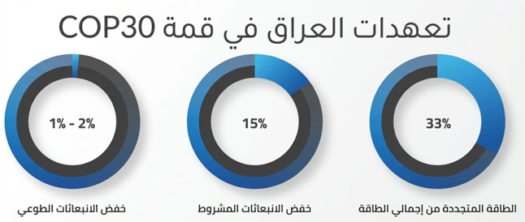

It is noted thatin October the secondFrom the year2023, Announced the government Iraqi on establishment" Company public For economics carbon"As described institution General It means By control in emissions Carbonaceous and limit From it on level The country.And it is this decision Transformation substantially in Politics environmental For Iraq, so He transports it from procedures to reply The verb Limited to approach more Organization and proactive.And from The awaited that Contributes This is amazing Step in Strengthening practices Energy Sustainable, and reduction fingerprint Carbonaceous For Iraq, and limit from Effects environmental For the sector oil gas.

And it came This is amazing The initiative response To grow Concerns from Challenges environmental that He faces it Iraq, especially in areas like Basra where Forms burn mystification companion from wells oil problem ongoing, Please on Being step To combat change climate Protection the environment For generations Next.

This company is supervised by the Ministry of Environment. whereTakes over responsible Main It is in a guarantee commitment all projects Energy in The country By standards and controls strict Related emissions Protection the environment.

Chapter One (Legal and Financial Framework) -appearance 10
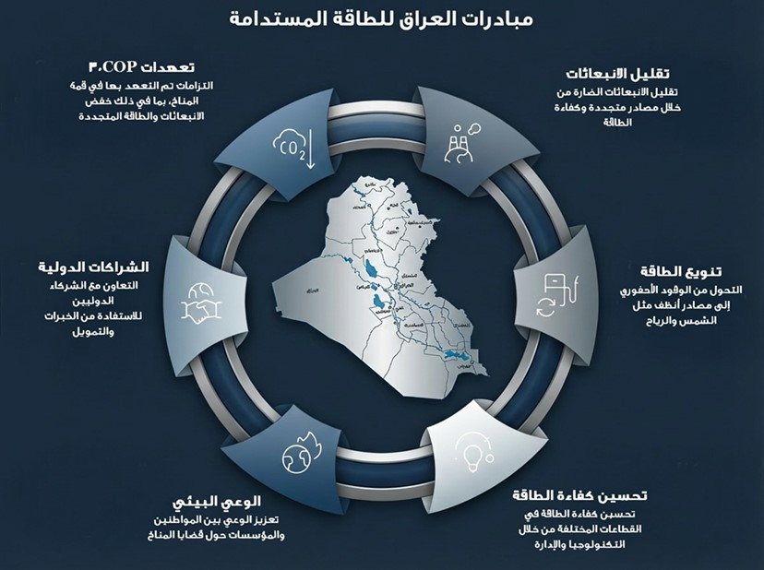

Chapter Two: Exploration and Production
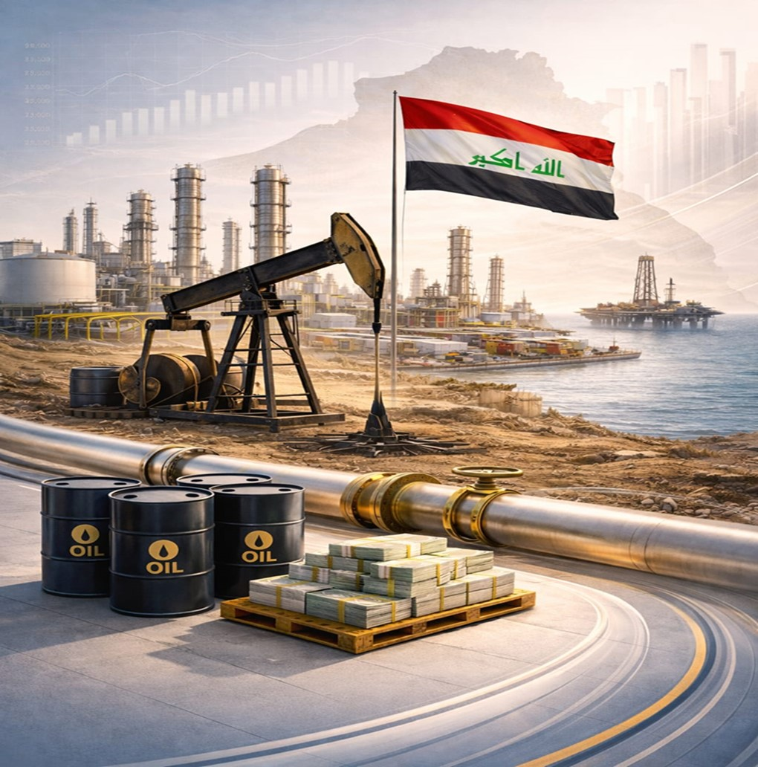

- Exploration and Production
  - Exploration
A group of national oil companies affiliated with the Iraqi Ministry of Oil are responsible for the exploration, development, and production of oil and gas in various governorates, within the scope of the fields under their management, and include:

- North Oil Company
- Middle Oil Company
- Missan Oil Company
- Dhi Qar Oil Company
- Basra Oil Company
- Oil Exploration Company
- Iraqi Drilling Company
These companies are managed(Excluding the Oil Exploration Company and the Iraqi Drilling Company)Some fields directly, whileShare in employmentOther fieldscompanies oil InternationalUnder service contracts concluded during licensing rounds. The attached tables detail the producing and non-producing fields operated by both national and foreign companies..
Chapter Two (Exploration and Production) -appearance 11
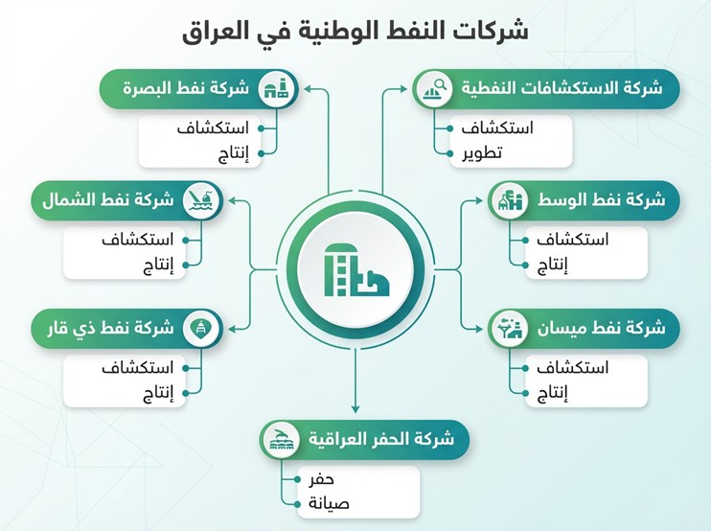
Chapter Two (Exploration and Production) -appearance 12
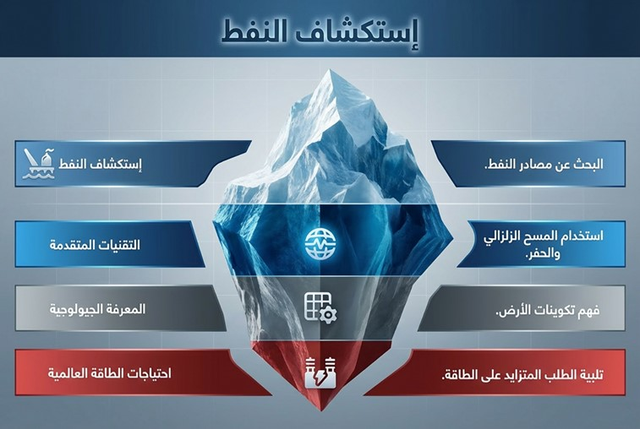

  - Fields
Tables Displayed Below It turned out names Fields oil gas Producer and other Producer that It is managed by companies oil Nationalism andWhich are involved in its operationcompanies oil International, according to the fields belonging to each of the five national oil companies.:

Chapter Two (Exploration and Production) -table 13
Company Name | producing fields |  | unproductive fields
Company Name | Fields operated by national oil companies | Fields jointly operated by international oil companies | Fields operated by national oil companies | Fields jointly operated by international oil companies
Company Name | gas fields
North Oil Company | Nothing | Nothing | 1- Khanouka | Nothing
North Oil Company | Nothing | Nothing | 2- Wood | Nothing
North Oil Company | oil fields
North Oil Company | 1- Kirkuk* | 1- Al-Qayyarah | 1- Javan | 1- The star
North Oil Company | 2- By Hassan |  | 2- Ismail | 2- Allan / Sasan
North Oil Company | 3- Jamboree |  | 3- Cane
North Oil Company | 4- Safia** |  | 4- Drunk
North Oil Company | 5- Baker |  | 5- New
North Oil Company | 6- Ajil + Hamrin |  | 6- Qara Juq
North Oil Company | 7- Ain Zala + Batma |  | 7- Balkan
North Oil Company |  |  | 8- Ibrahim
Source:thea reportannual toFor the company concerned.
*Northwest Avana (Jistan) station, which is under the control of the Kurdistan Regional Government.
**The Safiya field is under the control of the Kurdistan Regional Government.

Chapter Two (Exploration and Production) -table 14
Company Name | producing fields |  | unproductive fields
Company Name | Fields operated by national oil companies | Fields jointly operated by international oil companies | Fields operated by national oil companies | Fields jointly operated by international oil companies
Company Name | gas fields
Middle Oil Company | Nothing | Nothing | 1- Jariya Beka | 1- Reflector
 |  |  |  | 2- Al-Mansouriya
Middle Oil Company | oil fields
Middle Oil Company |  | 1- The hunchback | 1- Al-Nahrawan | 1- The eighth patch
Middle Oil Company |  | 2- Badra | 2- Tell Ghazal | 2- Injana / Khashm al-Ahmar
Middle Oil Company |  | 3- East Baghdad - Southern Region | 3- Now Doman | 3- East of Baghdad (Al-Rashidiya)
Middle Oil Company |  | 4- Oil Khana | 4- Coral | 4- Middle Euphrates
Middle Oil Company |  |  | 5- The sack | 5- Khalisiyah
Middle Oil Company |  |  | 6- West of Al-Kifl | 6- Zurbatiya
Middle Oil Company |  |  |  | 7- Exploration Block Seven
Middle Oil Company |  |  |  | 8- Zafariyah
Middle Oil Company |  |  |  | 9- Two horns
Source:thea reportannual toFor the company concerned.
Chapter Two (Exploration and Production) -table 15
Company Name | producing fields |  | unproductive fields
Company Name | Fields operated by national oil companies | Fields jointly operated by international oil companies | Fields operated by national oil companies | Fields jointly operated by international oil companies
Company Name | gas fields
Missan Oil Company | Nothing | Nothing | Nothing | Nothing
Missan Oil Company | oil fields
Missan Oil Company | 1- Architecture | 1- Al-Halfaya | 1- Kumait | 1- Al-Hawiza
Missan Oil Company | 2- Noor | 2- Maysan fields (Buzurkan, Fakkah, Abu Gharb) | 2- Dujail | 2- Dima
Missan Oil Company |  |  | 3- Rifai
Source:thea reportannual toFor the company concerned.

Chapter Two (Exploration and Production) -table 16
Company Name | producing fields |  | unproductive fields
Company Name | Fields operated by national oil companies | Fields jointly operated by international oil companies | Fields operated by national oil companies | Fields jointly operated by international oil companies
Company Name | gas fields
Dhi Qar Oil Company | Nothing | Nothing | Nothing | Nothing
Dhi Qar Oil Company | oil fields
Dhi Qar Oil Company | 1- Nasiriyah | 1- The graph | 1- Abu Amoud | 1- Arido (Exploration Block 10)
Dhi Qar Oil Company | 2- The concrete slab | 1- The graph | 1- Abu Amoud | 2- Sumer
Dhi Qar Oil Company |  | 1- The graph | 1- Abu Amoud | 3- Adan
Dhi Qar Oil Company |  | 1- The graph | 1- Abu Amoud | 4- Abu Khayma
Source:thea reportannual toFor the company concerned.

Chapter Two (Exploration and Production) -table 17
Company Name | producing fields |  | unproductive fields
Company Name | Fields operated by national oil companies | Fields jointly operated by international oil companies | Fields operated by national oil companies | Fields jointly operated by international oil companies
Company Name | gas fields
Basra Oil Company | Nothing | The chaos | Nothing | Nothing
Basra Oil Company | oil fields
Basra Oil Company | 1- Ibn Omar | 1- West of Qurna 1 | 1- Rachi | 1- Patch 12
Basra Oil Company | 2- Brick | 2- West of Qurna 2 | 2- Grishan | 2- Khader Al-Mai
Basra Oil Company | 3- Licking | 3- Al-Zubair | 3- Samawah | 3- Faw
Basra Oil Company | 4- Crazy | 4- Al-Rumaila (North and South) | 4- Abu Khayma | 4- Mount Sanam
Basra Oil Company |  | 5- Exploration Area 9 (Al-Fayha) |  | 5- Artawi
Basra Oil Company |  |  |  | 6- Sinbad
Source:thea reportannual toFor the company concerned.


  - Production data
    - Crude oil reserves size
It amountsIraq's proven crude oil reserves according to dataOrganization of StatesExporter For petroleum –OPECabout145.02 One billion barrels at the endyear2024(https://publications.opec.org/asb/chapter/show/139/2524/2527).

    - Crude oil production
In Iraq there are two types of oil production:
- The first is the production of licensing rounds, and this is done by foreign oil companies..
- The second is national effort production, which is oil extracted from fields operated by national oil companies themselves..

The following table shows the quantities of crude oil produced inyear 2023Whether produced through national effort or through licensing rounds.

Chapter Two (Exploration and Production) -table 18
Company | 2023
Company | National effort production (barrels) | Production of licensing rounds (barrels) | Total production (barrels) | Percentage of national effort output as a percentage of total output | Percentage of licensing rounds produced out of total production
North Oil Company | 111,391,529 | 6,339,043 | 117,730,572 | 95% | 5%
Middle Oil Company | 2,738,359 | 35,258,863 | 37,997,222 | 7% | 93%
Missan Oil Company | 584,227 | 233,724,151 | 234,308,378 | 0% | 100%
Dhi Qar Oil Company | 24,088,273 | 53,420,060 | 77,508,333 | 31% | 69%
Basra Oil Company | 68,008,178 | 1,035,606,195 | 1,103,614,373 | 6% | 94%
the total | 206,810,566 | 1,364,348,312 | 1,571,158,878 | 13% | 87%
Source:Forms AFor your companyatThe concerned.

Chapter Two (Exploration and Production) -appearance 13
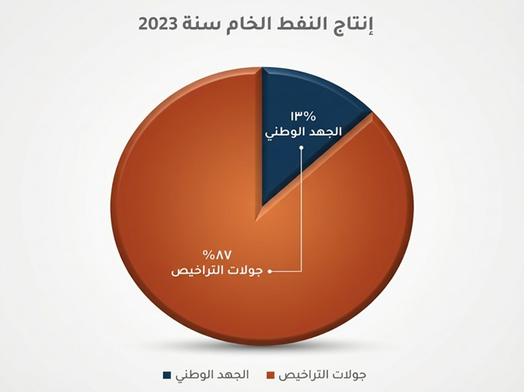


    - Gas reserves size
It amountsIraq's reserves ofnatural gasAccording to OPEC data, approximately3710one billion standard cubic metersinyear2024According to data from the Organization of the United NationsExporter For petroleum –OPEChttps://publications.opec.org/asb/chapter/show/139/2569/2571).

    - gas production
Associated gas is produced as a byproduct during crude oil extraction from oil fields, while non-associated (free) gas is extracted directly from gas fields.As for the dome gas, it formslike a dome gaseous above oil in warehouse.
The following table shows the total quantities of gas produced, invested, and burned duringyear 2023, according to data released by national oil companies.
Chapter Two (Exploration and Production) -table 19
Crude gas production in oil companies for 2023
Company | Associated gas | Gas dome | free gas | Total
Company | One million standard cubic feet per year | One million standard cubic feet per year | One million standard cubic feet per year | One million standard cubic feet per year
Basra Oil | 716,967 | 14,826 | 0 | 731,793
North Oil | 92,998 | 91,583 | 0 | 184,581
Maysan Oil | 144,487 | 0 | 0 | 144,487
Dhi Qar Oil | 42,877 | 0 | 0 | 42,877
Central Oil | 30,316 | 0 | 5,365 | 35,681
the total | 1,027,645 | 106,409 | 5,365 | 1,139,419

Chapter Two (Exploration and Production) -table 20
Raw gas investment position for 2023 (MMcf = Million Standard Cubic Feet per Year)
Company | Total gas produced | investor | Burned (million standard cubic feet per year) |  |  | Gas investment ratio | Percentage of flared gas that can be invested in | Percentage of flared gas that is not available for investment | Total percentage of gas flared
Company | Muqmaq | Muqmaq | Investable | Not investable | Total gas burned
Basra Oil | 731,793 | 379,658 | 54,660 | 297,475 | 352,135 | 52% | 7% | 41% | 48%
North Oil | 184,581 | 170,588 | 2,604 | 11,389 | 13,993 | 92% | 1% | 6% | 8%
Maysan Oil | 144,487 | 39,544 | 0 | 104,943 | 104,943 | 27% | 0% | 73% | 73%
Dhi Qar Oil | 42,877 | 9,446 | 33,431 | 0 | 33,431 | 22% | 78% | 0% | 78%
Central Oil | 35,681 | 24,520 | 10,016 | 1,145 | 11,161 | 69% | 28% | 3% | 31%
the total | 1,139,419 | 623,756 | 100,711 | 414,952 | 515,663 | 54.7% | 8.8% | 36.4% | 45.3%
Note: GasburntThe term "exploitable" refers to the quantities of gas that were flared due to operational circumstances and can be utilized using available processing units. The term "non-exploitable" refers to the quantities of raw gas flared due to the unavailability of gas processing equipment.

Chapter Two (Exploration and Production) -appearance 14
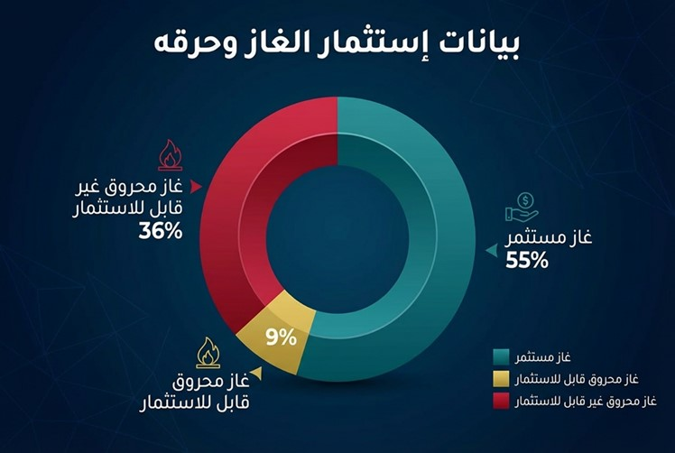
    - productionProducts oil from before refineries and companies mystification Nationalism

Chapter Two (Exploration and Production) -table 21
Some products (final production)* | unit of measurement | 2023
Some products (final production)* | unit of measurement | Northern Refineries | Central refineries | South Refineries | North Gas | South Gas | Total
Some products (final production)* | unit of measurement | the total | the total | the total | the total | the total | Total
Gasoline (regular + premium) | 1000 cubic meters | 928 | 1,111 | 3,682 |  |  | 5,721
white oil | 1000 cubic meters | 1,152 | 471 | 390 |  |  | 2,013
jet fuel | 1000 cubic meters |  | 140 | 73 |  |  | 213
gas oil | 1000 cubic meters | 2,173 | 1,710 | 2,362 |  |  | 6245
fuel oil | 1000 cubic meters | 5,395 | 3,293 | 5,181 |  |  | 13,869
Feed gas | 1000 cubic meters |  |  |  | 3,675 |  | 3,675
dry gas | 1000 cubic meters |  |  |  | 3309 |  | 3309
liquefied gas | thousand tons |  |  |  | 351 | 1,240 | 1,591
natural benzene | 1000 cubic meters |  |  |  | 201 |  | 201
matchsticks | thousand tons |  |  |  | 43 |  | 43
*Final production represents the actual production after processing the conversions within the refinery (including the converter and the converter).
    - Mining sector

Two categories of materials are produced within the mining sector in Iraq: mining materials, which are extracted from underground mines or from the interior of mountains, and are often associated with deep geological deposits, and quarry materials, which are extracted from quarries close to the Earth's surface, usually in the form of layers or rock formations..

The table below shows a summary of the mineral data. The main one in Iraq and its reserves, as stated According to a study prepared by the Geological Survey Authority in the Ministry of Industry and Minerals.

Chapter Two (Exploration and Production) -appearance 15
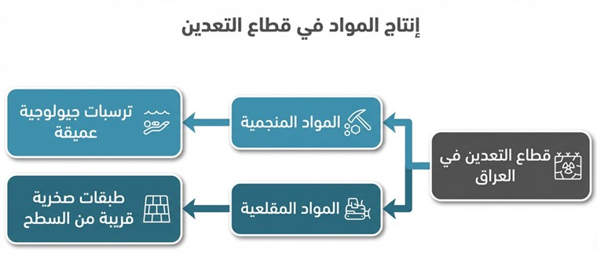

Chapter Two (Exploration and Production) -table 22
Mining materials
Material | the reserve | Location
phosphate rocks | 10,012,375,271 tons | Anbar Governorate
Bentonite clays | 326 million tons | Anbar Governorate
sodium sulfate | 20 million tons | Salah al-Din Governorate
Flint clay | 9 million tons | Anbar Governorate
red kaolin | 839 million tons | Anbar Governorate
Porcelain ore | 1.5 million tons | Anbar Governorate
Raw salt of Samawah | 43 million tons | Al-Muthanna Governorate
white kaolin | 412 million tons | Anbar Governorate
raw sulfur | 600 million tons | Mosul Governorate
silica sand | 342 million tons | Najaf Al-Ashraf/Anbar
Chlorides | 34 million tons | Salah al-Din Governorate
Source: Geological Survey Authority, Ministry of Industry and Minerals

Chapter Two (Exploration and Production) -table 23
quarry materials
Material | the reserve | Location
Dolomite stone / Anbar and Muthanna | 676 million tons | Anbar Governorate / Muthanna
Limestone / Najaf Governorate | 1.6 billion tons | Najaf Al-Ashraf
gravel deposits | 986 million tons | Some central and southern governorates
Limestone / Karbala Governorate | 369 million tons | Holy Karbala Governorate
Clays suitable for brick and cement production | 285 million tons | Some central and southern governorates
Limestone / Al-Muthanna Governorate | 545 million tons | Al-Muthanna Governorate
Sand suitable for construction purposes | 716 million tons | Holy Karbala Governorate / Najaf Governorate / Diwaniyah
Limestone / Anbar Governorate | 2.3 billion tons | Anbar Governorate
raw gypsum | More than 130 million tons | Some governorates of the country
Feldspar Sands | 7 million tons (20% feldspar) | Najaf Al-Ashraf
Source: Geological Survey Authority, Ministry of Industry and Minerals

The figure below represents the map of Iraq's minerals as prepared by the Geological Survey Authority.

Chapter Two (Exploration and Production) -appearance 16
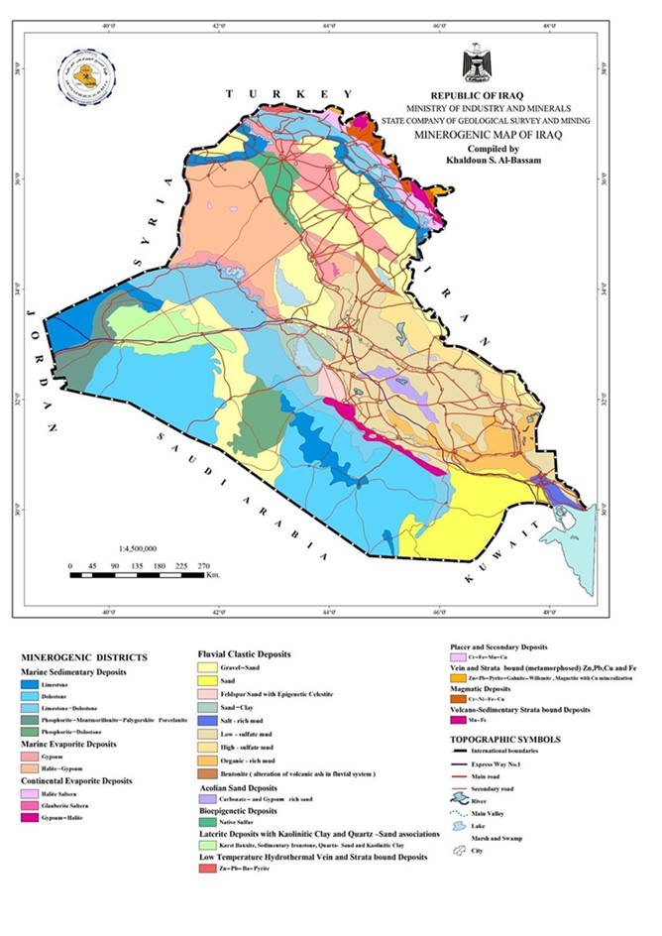


The following table showsquantities Production in sector Mining For some Minerals Home during2023

Chapter Two (Exploration and Production) -table 24
metal | Production quantities achieved in tons in 2023 | Uses
Industrial salt | 300,000 | Industries (Oil - Chemical - Petrochemical - Food)
Standard sand (Western Sahara + Najaf) | 16 | Cement testing laboratory (cement testing)
the total | 300,016
Source:General Company for Mining IndustriesAffiliated with the Ministry of Industry and Minerals.

    - productiongovernment province Kurdistan from oil gas minerals
All relevant data included in this report was obtained from publicly available sources..

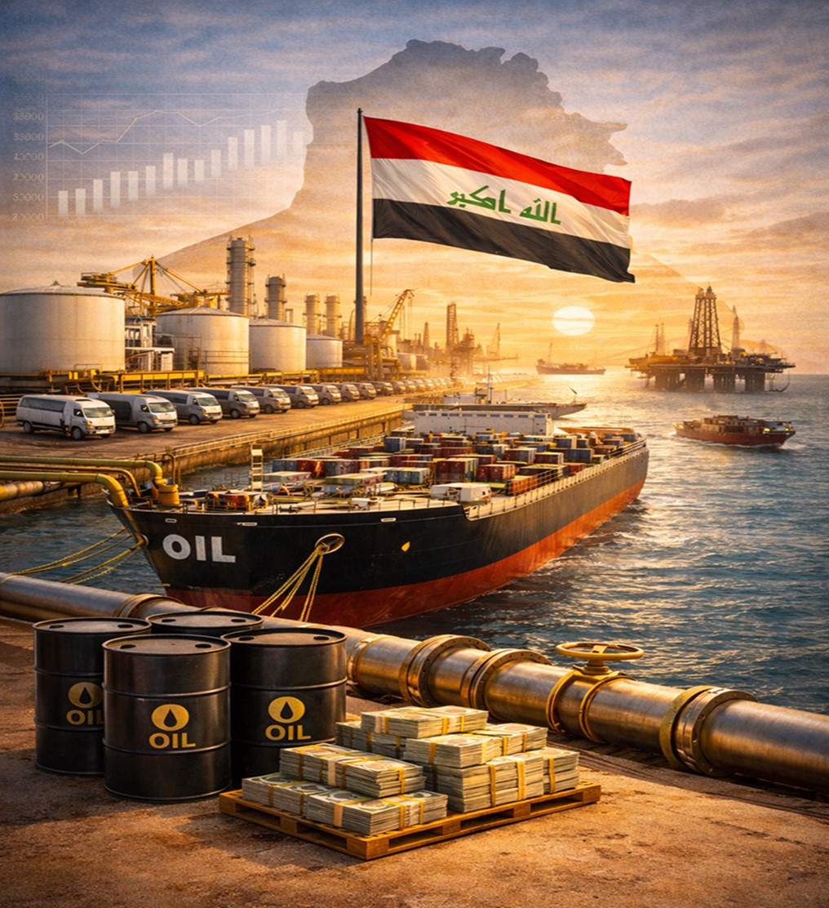
Chapter Three: Exports

- Export data

  - Crude oil flow
The oil produced in Iraq is used for domestic consumption (for refineries and electricity) and for export.
It is noted that the Basra Oil Company receives Some ofCrude oil produced byEveryoneMiddle Oil Company and Missan Oil CompanyDhi Qar Oil Company This is for the purpose of exporting throughBasra port located in Basra, which is affiliated with the Basra Oil Company.

The following diagram illustrates the general mechanism of crude oil flow.

Chapter Three (Exports) -appearance 17
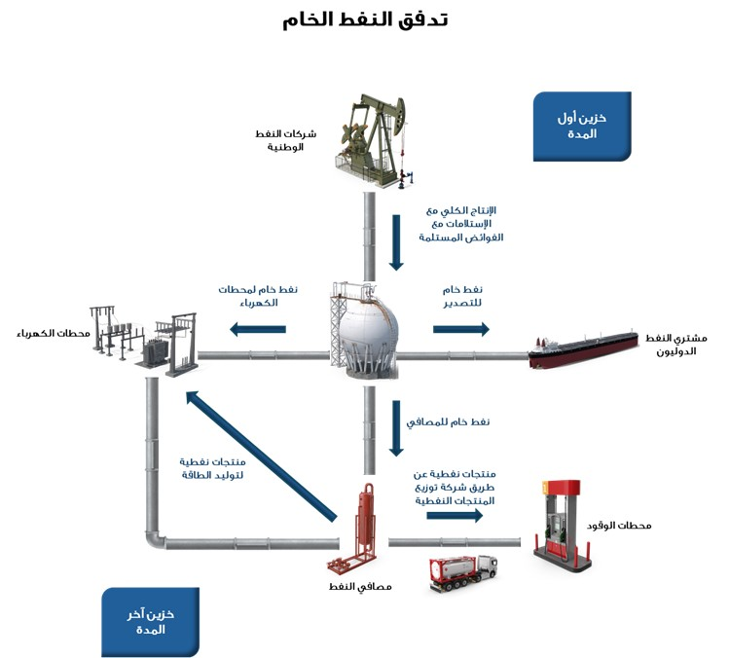
  - Crude oil exports
a company marketing oil(Sumo)she a company Government Follower Ministry Oil, It is The only one Authorized Legally Marketing and export oil Iraqi raw.Founded according to law companies public number(22)For the year1997The average, Its goal to support Economy Iraqi from during sale oil raw gas natural to outside Iraq.

Chapter Three (Exports) -appearance 18
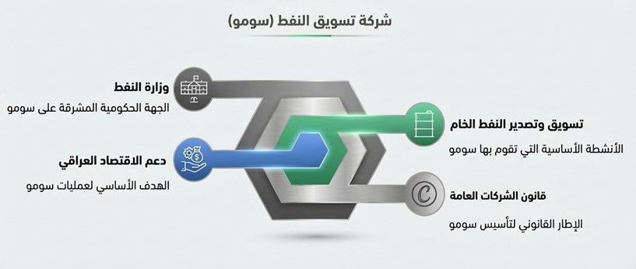
It does Company Exporting oil Next from a company oil Basra, In what In it production companies oil Middle Maysan And this Tar, via harbor Basra.As for oil North, It is exported mostly via harbor Jihan in Türkiye, or It is transferred With tanks from Refinery Resilience to Jordan.It is determined amount all shipment Using Counters especially in The port, And it is recorded after that in Lists shipping and the bills Commercial.
During 2023, 1,232,170,145 barrels of crude oil were exported as follows:

Chapter Three (Exports) -table 25
Export site | Type of crude oil source | Quantity in barrels | Percentage
From the port of Basra | heavy | 793,984,391
From the port of Basra | middle | 422,411,305
From the port of Basra | Total exports from Basra port | 1,216,395,696 | 98.7%
From Ceyhan port | Kirkuk | 7,037,403 | 0.6%
From the Qayyarah field with basins | Qayyarah | 4,920,348 | 0.4%
From Al-Sumoud Refinery to Jordan | Kirkuk | 3,816,698 | 0.3%
Total quantities of crude oil exported |  | 1,232,170,145 | 100%
Source:Oil marketing company.

The following table shows the destinations of crude oil exports during 2023, along with their quantities, values, and average prices.

Chapter Three (Exports) -table 26
Export destination | Quantity in barrels | Value of exported crude oil in US dollars* | Percentage of total exports | Average export price per barrel in US dollars | Standard price per barrel in US dollars | The difference (Sumo selling price minus the benchmark price) in US dollars
America (Basra Medium) | 68,152,990 | 5,066,271,206 | 5.5% | 74.34 | 76.84 | -2.50
America (Basra Heavy) | 4,647,314 | 331,134,780 | 0.4% | 71.25 | 78.81 | -7.55
Total source for America | 72,800,304 | 5,397,405,986 | 5.9%
Europe (Basra, medium) | 248,837,040 | 19,206,475,528 | 20.2% | 77.18 | 82.63 | -5.44
Europe (Basra Heavy) | 54,251,601 | 3,998,919,531 | 4.4% | 73.71 | 82.46 | -8.74
Europe (Kirkuk) | 7,037,403 | 529,953,741 | 0.6% | 75.31 | 80.77 | -5.46
Total source for Europe | 310,126,044 | 23,735,348,800 | 25.2%
East (Basra, Middle) | 476,994,361 | 39,233,351,227 | 38.7% | 82.25 | 82.11 | 0.14
East (Basra heavy) | 363,512,390 | 28,604,725,134 | 29.5% | 78.69 | 82.11 | -3.42
Total source for the East | 840,506,751 | 67,838,076,361 | 68.2%
Qayyarah (East - Qayyarah Field) | 4,920,348 | 346,153,550 | 0.4% | 70.35 | 83.64 | -13.29
Jordan (Kirkuk) | 3,816,698 | 256,560,304 | 0.3% | 67.22 | 82.41 | -15.19
Total source to other | 8,737,046 | 602,713,854 | 0.7%
Total | 1,232,170,145 | 97,573,545,001 | 100%
Source:Oil marketing company.
* from Don Calculation fines delay adult Around me8millions dollar AmericanAs a total

Chapter Three (Exports) -appearance 19
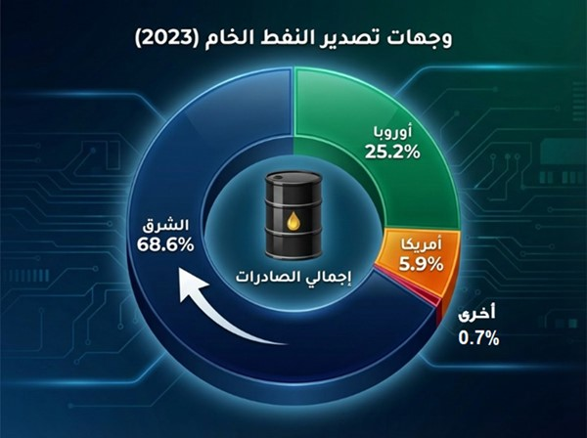

Sumo Company relies on the official selling price (OSP) for crude oil export sales to promote transparency when dealing with buyers, and to avoid buyers negotiating the price by standardizing the price of crude oil for all buyers in each market separately.

The general equation for the price of crude oil:D + (-) API + (-) F OSP+(-)

OSP Average Reference Price of Oil (according to international price lists, depending on the shipping destination)
:D indicates price differences that are calculated on a monthly basis
API refers to the price difference for density fluctuations (API Gravity) between contract specifications and the actual shipment.
F: Represents the shipping rate (according to international daily reports)

The following figure showsFactors influencing the pricing of Iraqi crude oil

Chapter Three (Exports) -appearance 20
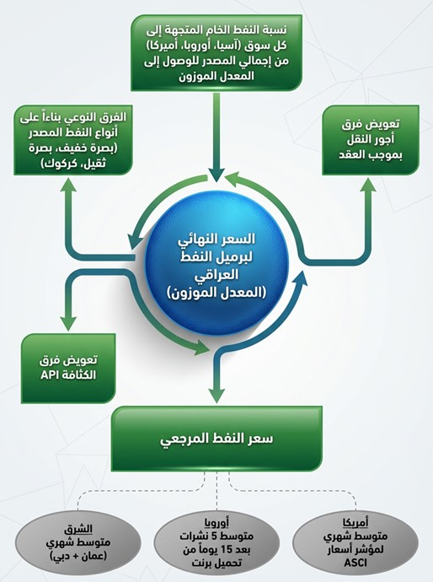

    - exports oil raw In favor of companiesInternational Oil The worker in IraqWithin the licensing rounds
Exported oil raw Return For companies foreign Contractor within Tours Licenses petroleum also via a company marketing oil(Also called oil loading), where It is Calculation Shares that companies In what Covers melasma Recovered AndProfitability due she has, And it is Settlement Eyes With oil raw Instead from Payment Critical, That's According to For prices Global oil.
The table below shows the details of crude oil export quantities as a settlement of dues owed to foreign companies operating in Iraq under licensing rounds during 2023.

Chapter Three (Exports) -table 27
Companies that participated in licensing rounds for crude oil during 2023
number | The name of the company uploaded in Arabic | The name of the uploading company in English | The amount (US dollars) after deducting late payment penalties (where applicable) | Quantity (barrels) | % of total quantity
1 | Basra Energy Company Limited (Rumaila Field) | BASRA ENERGY COMPANY LIMITED (RUMAILA) | 2,540,017,714 | 32,615,968 | 20%
2 | Eni Iraq B.V. (Zubair Field) | ENI IRAQ BV (ZUBAIR) | 1,232,484,789 | 15,729,896 | 10%
3 | Sinopec Iraq Limited and TP Maysan Limited (Maysan Field) | CNOOC IRAQ LIMITED & TP MISSAN LIMITED (MISSAN) | 869,144,002 | 10,873,102 | 7%
4 | PetroChina International Iraq (Halfaya Field) | PETROCHINA INTERNATIONAL IRAQ FZE (HALFAYA) | 742,259,841 | 9,707,569 | 6%
5 | BP Iraq and PetroChina International - Rumaila Field | BP IRAQ NV & PETROCHINA INTERNATIONAL - RUMAILA | 696,287,586 | 9,060,076 | 5%
6 | Lukoil Middle East Limited (West Qurna Field) | LUKOIL MID - EAST LIMITED (WEST QURNA) | 674,214,055 | 8,889,724 | 5%
7 | Kuwait Energy Company Basra Limited (Block 9 - Al Faiha) | KUWAIT ENERGY BASRAH LIMITED (BLOCK 9 - AL FAIHAA) | 526,900,841 | 6,698,964 | 4%
8 | ExxonMobil Iraq Limited (West Qurna Field) | EXXONMOBIL IRAQ LIMITED (WEST QURNA) | 422,607,396 | 5,631,863 | 3%
9 | Basra Oil Company (West Qurna) | BASRA OIL COMPANY (WEST QURNA) | 448,059,433 | 5,627,723 | 3%
10 | PetroChina International Iraq (West Qurna Field) | PETROCHINA INTERNATIONAL IRAQ FZE (WEST QURNA) | 384,004,518 | 4,965,366 | 3%
11 | Petronas Carigali Iraq Holding Company (Al-Gharraf Field) | PETRONAS CARIGALI IRAQ HOLDING BV (GARRAF) | 359,155,785 | 4,685,650 | 3%
12 | IBS Oil Company Limited (East Baghdad Field) | EBS PETROLEUM CO.LTD.(EAST BAGHDAD FIELD) | 366,898,252 | 4,465,369 | 3%
13 | PetroChina International Iraq (Halfaya Field) | PETRONAS CARIGALI IRAQ HOLDING BV (HALFAYA) | 323,937,729 | 4,209,256 | 3%
14 | Dragon Oil Company (Block 9) Limited | DRAGON OIL (BLOCK 9) LIMITED | 319,095,056 | 3,925,953 | 2%
15 | Japex Graff Limited (Graf Field) | JAPEX GARRAF LTD. (GARRAF) | 304,477,562 | 3,890,294 | 2%
16 | Kogas Company (Zubair Field) | KOGAS (ZUBAIR) | 304,881,864 | 3,887,437 | 2%
17 | Itochu Oil Exploration (Iraq) - West Qurna | ITOCHU OIL EXPLORATION (IRAQ) BV - WEST QURNA | 289,255,467 | 3,887,219 | 2%
18 | Al-Waha Oil Company Limited (Al-Ahdab Field) | AL - WAHA PETROLEUM CO. LTD. (AHDEB) | 251,832,371 | 3,176,435 | 2%
19 | Total Energies Exploration and Production Iraq (Halfaya Field) | TOTALENERGIES E&P IRAQ (HALFAYA) | 244,459,115 | 3,004,091 | 2%
20 | Pertamina Exploration and Production Iraq Limited (West Qurna Field) | PT. PERTAMINA IRAK EKSPLORASI PRODUKSI (WEST QURNA) | 231,200,180 | 2,997,872 | 2%
21 | Turkish Foreign Petroleum Limited (Maysan Field) | TURKISH PETROLEUM OVERSEAS COMPANY LIMITED - TP (MISSAN) | 203,942,454 | 2,531,115 | 2%
22 | Turkish Foreign Petroleum Limited (Siba Field) | TURKISH PETROLEUM OVERSEAS COMPANY LIMITED - TP (SIBA) | 179,370,397 | 2,192,181 | 1%
23 | Gazprom Neft Badra (Badra Field) | GAZPROM NEFT BADRA BV (BADRA) | 155,878,686 | 1,938,320 | 1%
24 | Kuwait Energy Basra Limited (Siba Field) | KUWAIT ENERGY IRAQ LIMITED (SIBA) | 131,831,563 | 1,732,173 | 1%
25 | Kogas Company (Badra Field) | KOGAS (BADRA) | 101,961,934 | 1,286,248 | 1%
26 | Unibek Asian Limited (China International) / Basra Oil Company / Majnoon | UNIPEC ASIA CO. LTD. / BASRA OIL COMPANY / MAJNOON | 74,150,457 | 997,504 | 1%
27 | Petronas Carigali Iraq Holding Company (Badra Field) | PETRONAS CARIGALI IRAQ HOLDING BV (BADRA) | 71,283,597 | 968,214 | 1%
28 | China International Offshore Oil Private Limited (Singapore) - Maysan | CHINA OFFSHORE OIL (SINGAPORE) INTERNATIONAL PTE LTD. - MISSAN | 67,180,673 | 952,269 | 1%
29 | Basra Oil Company (Zubair) | BASRA OIL COMPANY (BOC - ZUBAIR) | 61,008,231 | 860,742 | 1%
30 | Petronas Carigali Iraq Holding Company (Majnoon) | PETRONAS CARIGALI IRAQ HOLDING BV (MAJNOON) | 79,244,396 | 847,135 | 1%
31 | Egyptian General Petroleum Company (Siba Field) | EGYPTIAN GENERAL PETROLEUM CORPORATION (SIBA) | 60,679,833 | 832,653 | 1%
32 | Egyptian General Petroleum Company (Block 9) | EGYPTIAN GENERAL PETROLEUM CORPORATION (BLOCK 9) | 61,999,273 | 800,636 | 0.5%
33 | Shell International Eastern Trading Company (Majnoon) | SHELL INTERNATIONAL EASTERN TRADING COMPANY (MAJNOON) | 69,928,779 | 773,403 | 0.5%
34 | Turkish Foreign Petroleum Limited (Badra Field) | TURKISH PETROLEUM OVERSEAS COMPANY LIMITED - TP (BADRA) | 47,920,125 | 605,555 | 0.4%
Total |  |  | 12,897,553,952 | 165,247,975 | 100%
Source:Oil marketing company.
*The amounts represent the value of crude oil loaded as in-kind payment for recovered costs and profit fees due to licensing round companies, and are not considered as direct revenue such as crude oil export proceeds related to international companies purchasing crude oil..
**The fines are due to delays in loading oil beyond the specified time at export ports..

    - oil raw Source For the buyer oil Global
Table Below It is clear sales oil raw Exporter to companies Contractor with a company marketing oilFor the year 2023.

Chapter Three (Exports) -table 28
Companies that purchased crude oil during 2023
number | Name of the purchasing company in Arabic | Name of the purchasing company in English | The amount (US dollars) after deducting late payment penalties (where applicable) | Quantity (barrels) | % of total quantity
1 | Indian Oil Corporation Limited (Chennai) | INDIAN OIL CORPORATION LIMITED (IOC - CHENNAI) | 12,135,985,677 | 149,903,010 | 14%
2 | Yunyi Bek Asian Limited (China International) | UNIPEC ASIA CO. LTD. | 12,271,247,745 | 149,739,581 | 14%
3 | Reliance Industries Limited | RELIANCE INDUSTRIES LIMITED | 6,332,540,451 | 80,757,040 | 8%
4 | GS Caltex Singapore Limited | GS CALTEX SINGAPORE PTE. LTD. | 3,646,911,970 | 45,796,115 | 4%
5 | Sinochem International Petroleum (London) Limited | SINOCHEM INTERNATIONAL OIL (LONDON) CO. LTD. | 3,624,868,424 | 44,109,628 | 4%
6 | Rongxing Petrochemical Private Limited | RONGSHENG PETROCHEMICALS PTE LTD | 3,336,493,301 | 42,696,427 | 4%
7 | Shell International Eastern Trading Company | SHELL INTERNATIONAL EASTERN TRADING COMPANY | 2,822,803,736 | 36,587,137 | 3%
8 | Turkish Petroleum Refineries Company (Tüpraş)–Türkiye | TURKISH PETROLEUM REFINERIES CORP.(TUPRAS) – TURKEY | 2,722,319,847 | 35,713,595 | 3%
9 | Nayara Energy Limited | NAYARA ENERGY LIMITED | 2,769,835,235 | 35,190,242 | 3%
10 | ExxonMobil Sales and Supply Limited –USA | EXXONMOBIL SALES AND SUPPLY LLC. USA | 2,282,956,708 | 30,016,962 | 3%
11 | Motor Oil Hellas Company for Corinth Refineries | MOTOR OIL HELLAS CORINTH REFINERIES SA | 2,268,429,186 | 29,937,122 | 3%
12 | SK Energy Limited | SK ENERGY CO. LTD. | 2,019,644,883 | 25,614,237 | 2%
13 | PetroChina International (Middle East) Limited | PETROCHINA INTERNATIONAL (MIDDLE EAST) CO. LTD. | 2006,804,011 | 24,407,888 | 2%
14 | China International Offshore Oil Private Limited (Singapore) | CHINA OFFSHORE OIL (SINGAPORE) INTERNATIONAL PTE LTD. | 1,911,095,251 | 23,269,485 | 2%
15 | Shell Company (Sitco Agreement) | SHELL (SIETCO AGREEMENT) | 1,773,872,406 | 23,038,103 | 2%
16 | Hindustan Petroleum Corporation Limited | HINDUSTAN PETROLEUM CORPORATION LTD. | 1,807,221,609 | 22,028,966 | 2%
17 | HD Hyundai Oilbank | HD HYUNDAI OILBANK | 1,681,885,098 | 21,414,314 | 2%
18 | China Zenhua Oil Co., Ltd. | CHINA ZHENHUA OIL CO.LTD. | 1,697,377,715 | 20,887,427 | 2%
19 | Bharat Oil Company Limited | BHARAT PETROLEUM CORPORATION LTD. | 1,711,696,369 | 20,820,562 | 2%
20 | Chevron Products Company | CHEVRON PRODUCTS COMPANY | 1,457,810,701 | 19,645,378 | 2%
21 | Marathon Oil Company | MARATHON PETROLEUM CORP | 1,375,525,599 | 18,426,988 | 2%
22 | China Zhenhua Petroleum Co., Ltd. (Cynoshore Agreement) | CHINA ZHENHUA OIL CO.LTD. (SINOSURE AGREEMENT) | 1,479,363,951 | 18,298,858 | 2%
23 | Sinochem International Petroleum (London) Limited - Sinosure Agreement | SINOCHEM INTERNATIONAL OIL (LONDON) CO. LTD - SINOSURE AGREEMENT | 1,468,998,786 | 18,058,528 | 2%
24 | Repsol Trading Company | REPSOL TRADING SA | 1199,988,284 | 16,069,681 | 2%
25 | Mangalore Refineries and Petrochemicals Limited | MANGALORE REFINERY & PETROCHEMICALS LIMITED | 1,214,130,196 | 14,967,733 | 1%
26 | Valero Marketing and Supply Company | VALERO MARKETING AND SUPPLY COMPANY | 1,097,101,822 | 14,850,569 | 1%
27 | Saras Trading Company | SARAS TRADING SA | 1,090,452,094 | 14,023,763 | 1%
28 | HPCL Company–Metal Energy Limited | HPCL-MITTAL ENERGY LIMITED | 1126,063,865 | 14,012,558 | 1%
29 | Hellenic Petroleum Company (a public shareholding company) | HELLENIC PETROLEUM SA | 856,812,233 | 11,062,009 | 1%
30 | Eni Trading and Biofuels Company | ENI TRADE & BIOFUELS SPA | 608,268,268 | 7,994,645 | 1%
31 | SOCAR Trading Company | SOCAR TRADING SA | 446,267,763 | 6,057,181 | 1%
32 | Eblum International Company | IPLOM INTERNATIONAL SA | 390,001,640 | 5,086,958 | 0.5%
33 | Xinghong Petrochemical International Private Limited | SHENGHONG PETROCHEMICAL INTERNATIONAL PTE. LTD | 415,136,156 | 4,940,064 | 0.5%
34 | Totsa Total Energy | TOTSA TOTALENERGY | 285,797,818 | 4,062,275 | 0.4%
35 | Cepsa Company | CEPSA | 286,741,210 | 3,905,775 | 0.4%
36 | Hengli Petrochemical International Limited | HENGLI PETROCHEMICAL INTERNATIONAL PTE. LTD | 336,197,126 | 3,890,211 | 0.4%
37 | Formosa Petrochemical Company | FORMOSA PETROCHEMICAL CORPORATION (FPCC) | 295,893,098 | 3,856,740 | 0.4%
38 | Jordan Oil Refineries Company Limited | JORDAN PETROLEUM REFINERY CO.LTD | 256,560,304 | 3,816,698 | 0.4%
39 | Shandong Dongming Petrochemical Company | SHANDONG DONGMING PETROCHEMICAL | 156,966,753 | 1,967,717 | 0.2%
Total |  |  | 84,668,067,292 | 1,066,922,170 | 100%

Source:Oil marketing company.
*The fines are due to delays in loading oil beyond the specified time at export ports..

  - Export of petroleum products
Two categories of petroleum products are exported according to the source; the first category is the export of products from government entities, and the second category is the export of products from the Basra Gas Company, the details of which will be explained later in this report.

    - Export of petroleum products related to government entities
It is Naphtha and oil fueland others from Products oil Repeated that It producesBasically companies refineries affiliated Ministry oil in Iraq, It is companies Owned State.And it is export This is amazing Products via a company marketing oil(Sumo), That's after that It does a company distribution Products oil By collecting Quantities Produced from refineries and deliver it to a company Marketing. after that, Announcing a company Marketing on Quantities allocated For export and prices Sale In dollars American.
Table Below Tbetween amounts and quantities Products oil Source duringyear2023According to each product individually.

Chapter Three (Exports) -table 29
Total exports of petroleum products during 2023
number | Product Name | Quantity (tons) | Amount (US dollars) | % of total sales value
1 | fuel oil | 8,902,204 | 3,778,755,544 | 83.8%
2 | Naftha | 1,226,958 | 723,421,535 | 16%
3 | gas oil | 8,092 | 5,621,519 | 0.1%
4 | natural gasoline | 3,191 | 1,769,453 | 0.04%
5 | matchsticks | 9,945 | 364,443 | 0.01%
6 | bitumen | 545 | 149,807 | 0.003%
Total |  | 10,150,934 | 4,510,082,301 | 100%
Source:Oil marketing company.

Chapter Three (Exports) -appearance 21
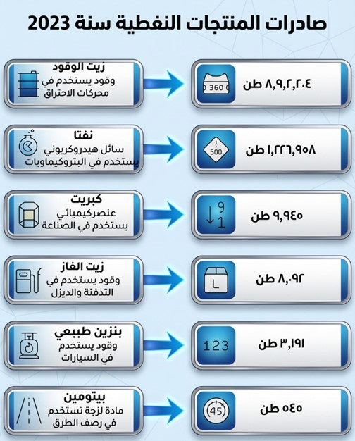

The following tables show the buyers of each type of exported petroleum product.

Chapter Three (Exports) -table 30
Companies that purchased fuel oil during 2023
number | Name of the purchasing company in Arabic | Name of the purchasing company in English | Quantity (tons) | Amount (US dollars) | % of total sales value
1 | Aramco Trading Company | ARAMCO TRADING COMPANY | 1,559,569 | 748,029,169 | 20%
2 | Wadi Al Wadi General Trading Company Limited | WADI AL-WADI GENERAL TRADING CO. LTD | 1,578,285 | 687,719,389 | 18%
3 | Ministry of Energy and Water (Lebanon) | MINISTRY OF ENERGY AND WATER (LEBANON) | 1,138,991 | 513,738,989 | 14%
4 | BP Energy | BB ENERGY | 667,322 | 287,061,567 | 8%
5 | Gunfor Company | GUNVOR | 659,713 | 274,173,092 | 7%
6 | Wellbread Trading Company | WELLBRED TRADING DMCC | 427,304 | 209,684,306 | 6%
7 | Finandi Projects Company | VENANDI VENTURES | 482,550 | 192,990,977 | 5%
8 | OQ Trading Company Limited | OQ TRADING LIMITED | 454,724 | 178,602,561 | 5%
9 | Sha'a Energy Oil Services Company Limited | SHUA ENERGY FOR OIL SERVICES LTD | 446,110 | 175,903,315 | 5%
10 | Chevron Products Company | CHEVRON PRODUCTS COMPANY | 357,960 | 151,189,298 | 4%
11 | Larak Oil Company | LARAAK OIL TRADING | 264,288 | 100,759,278 | 3%
12 | Anwar Baghdad General Services Company | ANWAR BAGHDAD GENERAL SERVICES COMPANY | 188,573 | 75,542,410 | 2%
13 | Pearl of the Pearl General and Public Transport Company for Oil Services | LOALOAT ALDUR GENERAL AND PUBLIC TRANSPORT COMPANY FOR OIL SERVICES | 159,247 | 40,894,055 | 1%
14 | Khairat Al Shaker Trading and General Contracting Company | KHAIRAT ALSHAKIR TRADING & GENERAL CONTRACTING COMPANY | 147,157 | 37,906,858 | 1%
15 | Kunooz Al-Rumaila Company for Importing and Selling Oil Derivatives | KNOOZ AL-RUMAILA COMPANY FOR IMPORTING AND SELLING PETROLEUM PRODUCTS | 144,433 | 35,834,905 | 1%
16 | Huda Iraq General Trading Company | HUDA AL IRAQ GENERAL TRADING COMPANY | 128,840 | 33,031,331 | 1%
17 | Syrian Arab Republic | SYRIAN ARAB REPUBLIC | 59,044 | 26,548,039 | 1%
18 | Hayat Al Janoub Oil Services Company | HAYAT AL-JANOUB OIL SERVICES COMPANY | 38,094 | 9,146,004 | 0%
Total |  |  | 8,902,204 | 3,778,755,544 | 100%
Source:Oil marketing company.
Chapter Three (Exports) -table 31
Companies that purchased naphtha during 2023
number | Name of the purchasing company in Arabic | Name of the purchasing company in English | Quantity (tons) | Amount (US dollars) | % of total sales value
1 | Sha'a Energy Oil Services Company Limited | SHUA ENERGY FOR OIL SERVICES LTD | 749,375 | 441,822,978 | 61%
2 | PTT Public Company Limited | PTT PUBLIC COMPANY LIMITED | 238,258 | 142,418,171 | 20%
3 | Rawat Oil Company for Oil Services | RWAAT ALNEFT COMPANY FOR OIL SERVICES | 159,356 | 90,624,362 | 13%
4 | PetroChina Global | PETROCHINA INTERNATIONAL | 79,969 | 48,556,024 | 7%
Total |  |  | 1,226,958 | 723,421,535 | 100%
Source:Oil marketing company.
Chapter Three (Exports) -table 32
Companies that purchased gas oil during 2023
number | Name of the purchasing company in Arabic | Name of the purchasing company in English | Quantity (tons) | Amount (US dollars) | % of total sales value
1 | Arab Republic of Egypt | REPUBLIC OF EGYPT | 8,092 | 5,621,519 | 100%
Total |  |  | 8,092 | 5,621,519 | 100%
Source:Oil marketing company.

Chapter Three (Exports) -table 33
Companies that purchased natural gasoline during 2023
number | Name of the purchasing company in Arabic | Name of the purchasing company in English | Quantity (tons) | Amount (US dollars) | % of total sales value
1 | Sha'a Energy Oil Services Company Limited | SHUA ENERGY FOR OIL SERVICES LTD | 3,191 | 1,769,453 | 100%
Total |  |  | 3,191 | 1,769,453 | 100%
Source:Oil marketing company.

Chapter Three (Exports) -table 34
Companies that purchased sulfur during 2023
number | Name of the purchasing company in Arabic | Name of the purchasing company in English | Quantity (tons) | Amount (US dollars) | % of total sales value
1 | Bayariq Al Saqr Company | BEARQ AL SAQER COMPANY | 9,945 | 364,443 | 100%
Total |  |  | 9,945 | 364,443 | 100%
Source:Oil marketing company.
Chapter Three (Exports) -table 35
Companies that purchased bitumen during 2023
number | Name of the purchasing company in Arabic | Name of the purchasing company in English | Quantity (tons) | Amount (US dollars) | % of total sales value
1 | Al-Awadaj General Contracting Company | AL AWDAJ GENERAL CONTRACTING COMPANY | 545 | 149,807 | 100%
Total |  |  | 545 | 149,807 | 100%
Source:Oil marketing company.

    - Products Source on road a company Sumo And the producer from before a company gas Basra
in year2016, And after coverage need market Local from mystification The liquid, It began a company gas Basra Exporting mystification liquid and capacitors from during a company marketing Oil, Because she The entity The only one Authorized Legally Exporting oil and its derivatives.And she goes returns Export to a company gas Basra, while Get a company Marketing on commission draw1%from value all shipment.

And with that a company gas South affiliated Ministry oil she One Shareholders in a company gas Basra, It is Receive Her share from earnings Company According to rate Its ownership, after rival Obligations Legal like the reserve Mandatory.And from during earnings a company gas South, Get the government on Her share not Direct, so go 60%from Profits midwife For distribution to Treasury public.
andYExplain Table the next quantities Values exports mystification liquid and capacitors that Produced it a company gas Basra during The year 2023.

Chapter Three (Exports) -table 36
Products exported by SOMO and produced by Basra Gas Company during 2023
Product | Quantity in tons | Amount in US dollars
Exporting capacitors | 568,310 | 344,250,418
liquefied gas source | 282,696 | 118,590,748
the total | 851,006 | 462,841,166
Source:Oil marketing company.

  - exports government province Kurdistan
Crude oil export revenue data for the Kurdistan Regional Government was collected from reports published on its official website.(https://gov.krd/arabic/information-and-services/open-data/deloitte-reports/deloitte-report-2023/)These reports include information on the quantities of crude oil exported and consumed from fields located within the region or in areas under its control, in addition to the revenues generated duringyear 2023, noting that the regional government issued a report on only the first quarter of 2023, due to the cessation of exports before the end of March 2023, as mentioned in this report.

Chapter Three (Exports) -table 37
Crude oil exports and consumption
Crude oil exports and consumption | Total period (barrels) | Average price per barrel in US dollars | Estimated total value in US dollars
Total crude oil exports via pipelines | 32,307,382 | 67.64 | 2,177,585,940
Crude oil delivered to refineries affiliated with the Ministry of Natural Resources in the region | 4,039,232
local sales | 241,528 | 58.64 | 22,098,456
Sales to oil refineries | 135,333 | 58.64 | 22,098,456
Total exports and consumption | 36,723,475 |  | 2199,684,396
Source:Kurdistan Regional Government website.

In February 2022, Iraq’s Federal Supreme Court ruled that the Kurdistan Regional Government (KRG) lacked the authority to produce or market oil and gas, and that its contracts with foreign oil and gas companies were illegal. The KRG rejected this ruling, asserting that the constitution guaranteed its right to export Kurdistan’s oil. This ongoing dispute has led to legal pressure from Baghdad on several companies operating in the region, and the continued presence of some companies could permanently suspend their operations, potentially leading to a decline in Kurdistan’s oil and gas production.
AndY23March2023, Decided Iraq In his favor suit arbitrationinternational It continued For years against Türkiye It relates exports oil province Kurdistan during period from2014to2018, Which Transferred via line pipes from crossing Fishkhabur to harbor Jihan Turkish Don consent the government Iraqi.And it issued court arbitration in Paris decision It is required Türkiye By paying about1.5one billion dollar For Iraq, according to what I transferred it sources Media International, asIt was completed Stop pumping oil Product inside region The source via harbor Jihan Turkish in March 25, 2023. On September 25, 2025, it was announced The agreement is between the Federal Ministry of Oil, the Ministry of Natural Resources in the Kurdistan Region, and most of the international oil companies operating in the region, where It states Agreementon delivery about190one thousand barrel daily from oil region to a company marketing oil Nationalism"Sumo addition to Allocation50one thousand barrel For consumption Local in Kurdistan.And it is sold Quantities allocated For export via The system Nationalism For pipes and line"Iraq-Türkiye", And it is deposited Its revenues in Treasury public State.On September 27, 2025, it wasappeal Operations export oil raw from region via Line Iraqi Turkish.


Chapter Four: Revenue Collection

- Major revenues of the extractive sector
  - relative importance
The stakeholder council identified inATransparencyIn natural resourcesIn Iraq, there is a specific percentage to indicate which revenues are important and should be included in the report. This percentage is1%Or more than the total amount the government receives from the oil, gas, and mining sector. Since these significant revenues represent more than99%Of the total revenues from extractive industries in Iraq (excluding revenues from the Kurdistan Region), reducing the percentage will not significantly alter the content of the report..
According to the initiative's requirements, the report includedMost importantRevenues that, if omitted or incorrectly presented, could affect the accuracy and comprehensiveness of the report. The table below shows the types of these revenues and the percentage contribution of each type to the total..

Chapter Four (Revenue Collection) -table 38
Major revenues of the extractive sector in 2023
Number | Type of revenue | Estimated value (in US dollars) and share of total extractive industry revenues | The government entity receiving the revenue | Included/Not Included in the Matching
Oil and Gas (Federal Iraq)
1 | Crude oil exports | 84,668,067,292 | Oil Marketing Company | Included
1 | Crude oil exports | 78.7% | Oil Marketing Company | Included
2 | Value of crude oil loaded by international oil companies operating within licensing rounds | 12,897,553,952 | Oil Marketing Company | Included
2 |  | 12% | Oil Marketing Company | Included
3 | Value of exported petroleum products | 4,510,082,301 | Oil Marketing Company | Included
3 | Value of exported petroleum products | 4.2% | Oil Marketing Company | Included
4 | Income tax for licensing round companies | 842,309,704 | Ministry of Oil - Department of Petroleum Contracts and Licensing | Included
4 | Income tax for licensing round companies | 0.8% |  | Included
5 | The government partner's share of profit-making fees | 631,527,832 | Ministry of Finance | Not included
5 | The government partner's share of profit-making fees | 0.6% | Ministry of Finance | Not included
6 | The Treasury's share of the profits of state-owned oil sector companies (60% of the distributable profit) | 1,415,746,624 | Ministry of Finance | Included
6 |  | 1.3% | Ministry of Finance | Included
7 | South Gas Company's share of the export values ​​of condensates and liquefied gas related to Basra Gas Company (51% of the export value). | 236,048,995 | Basra Gas Company | Not included
7 |  | 0.2% | Basra Gas Company | Not included
Minerals (Federal Iraq)
8 | The Treasury's share of the profits of state-owned mining companies (60% of the distributable profit) | 592,468 | Ministry of Finance | Not included
8 |  | 0.001% | Ministry of Finance | Not included
9 | Mining fees and investment allowances | 1,212,943 | Ministry of Finance | Not included
9 | Mining fees and investment allowances | 0.001% | Ministry of Finance | Not included
Oil and gas (Kurdistan Region)Excluded after failure to provide information from the Ministry of Natural Resources according to the exception (figures obtained from open sources)
10 | Revenues from crude oil exports related to the Kurdistan Region | 2,177,585,940 | Ministry of Natural Resources in Kurdistan | Not included
10 |  | 2.0% | Ministry of Natural Resources in Kurdistan | Not included
11 | Concession fees related to the Kurdistan Region | 130,791,000 | Ministry of Natural Resources in Kurdistan | Not included
11 | Concession fees related to the Kurdistan Region | 0.12% | Ministry of Natural Resources in Kurdistan | Not included
12 | Other payments related to the Kurdistan Region | 8,752,000 | Ministry of Natural Resources in Kurdistan | Not included
12 | Other payments related to the Kurdistan Region | 0.01% | Ministry of Natural Resources in Kurdistan | Not included
Total |  | 107,520,271,051
Total non-excluded revenue |  | 105, 203, 142, 111
Total revenues included (1-2-3-4-6) |  | 104,333,759,873
Percentage of included revenue out of total non-excluded revenue |  | 99.2%

Chapter Four (Revenue Collection) -appearance 22
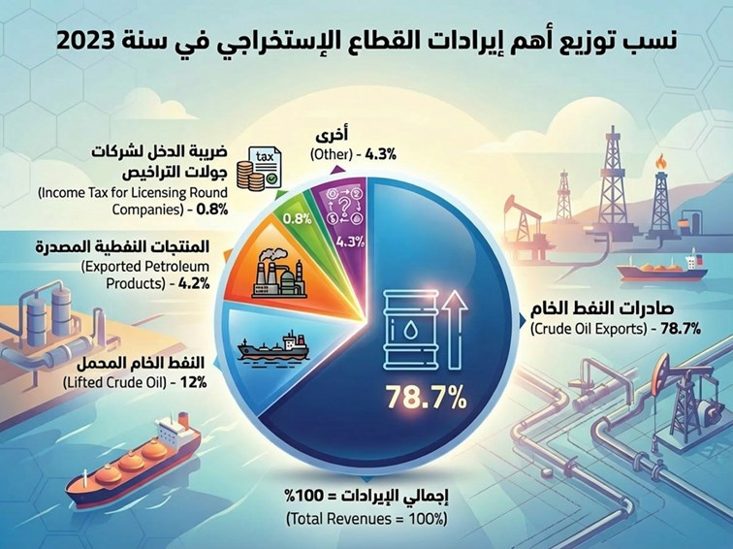

  - Description of the types of revenue generated from the extractive industries sector
- Revenues from crude oil exports under contracts (subject to matching):The revenues generated from sales of crude oil exported to global markets, under contracts concluded with the State Oil Marketing Company (SOMO) and recorded in its records, represent the main source of funding for the state’s general budget.
- revenuesoil raw The load(Included By matching): Represents value oil raw Exporter To calculate companies oil Global The worker in Iraq, within contracts Tours Licenses, what Equivalent amounts Costs Recovered Wages Profity allocated For that companies.And it is Payment This is amazing entitlements Eyes(oil)Preservation on Liquidity Cash in treasury State.
- Exported petroleum products belonging to the Petroleum Products Distribution Company (included)By matching): Represents Revenue resulting from sale Products oil Repeated like(Naphtha, oil Fuel, benzene natural Andmatchsticks), that It produces refineries Owned State in Iraq, Exported These productsvia a company marketing oil(Sumo).where Takes over a company distribution Products oil collection Quantities Produced from refineries Send Its details to Sumo, that In turn Announcing on Quantities allocated For export and prices Sell ​​it In dollars.
- Income tax on foreign extractive companies operating in Iraq (notIncluded By matching): Under contracts Service Signed with companies oil Global within Tours Licenses Petroleum, Obligatory This is amazing companies By paying tax income In proportion35%from wages Profit Verified during Year Taxation, after Exclusion a class Partner Governmental, That's Based on to law tax companies foreign number(19)For the year2010.Exceptions from that a contract field hunchback The permissible with a company Oasis Chinese, where text The contract – that Concluded before Issuance the law – on stability rate tax adult15%And not Modify it in Current Issuance laws New or amendment Laws window.and result Therefore, To bear ministry oil Iraqi to push the difference between rate tax Specific in The contract(15%)and the ratio The scheduled By law(35%).
- The government partner's share of profit-sharing fees (not included) By matching):It requires contracts Tours Licenses on companies foreign that It includes partner nationally from companies oil Iraqi(except The tour Fourth and subsequent rounds).And it is a class Partner Government rate from a class Company foreign in The contract usually between5%and25%.And it does ministry oil Discount This is amazing share from earnings companies foreign, And it is recorded As revenue In favor of ministry Finance, To reduce burden on Budget State in to push dues that companies.
- Treasury share of profits of public companies (included) By matching):It is necessary on all companies public Owned State- Including companies operating in the oil and mining sector, transformation 60%from Profits midwife For distribution And the proven in Its data Finance annual, in Current investigation profit, to treasury State.
- South Gas Company's share of exports of liquefied gas and condensates produced by Basra Gas Company (not included) By matching):Own a company gas South rate51%from capital a company gas Basra.And it is export mystification liquid and capacitors via a company marketing oil(Sumo)As The entity The only one Authorized Legally Exporting Products oil in Iraq, In exchange commission Her1%from value Exports.And it is deposited all revenues This is amazing Exports in account a company gas Basra.And in end all year Financial transformation Profits due For the company gas South In what Equivalent Her share adult51%from capital a company gas Basra, And it is recorded This is amazing Profits in Accounts a company oil South As revenue to intervene within results Her activity annual, where It does Later By converting60%From it to ministry FinanceAs mentioned in point number 6 above.
- The public treasury's share of public companies' profits– sector Mining(not Included By matching):she TThis is represented by the public treasury's share of the amount60% of net profits of operating companiesAs mentioned in point 6 above, noting thatThis revenue is financially limited due to the small number of profitable companies in this sector..
- Fees and investment allowances (not included) By matching):According toAccording to Article Eleven of the Mineral Investment Regulation Law No. 91 of 1988 (as amended), an annual investment fee shall be collected for the investment of quarries on state-owned lands.
- Revenues from crude oil sales in the Kurdistan Region (excluded) By matching):The quantities and revenues from crude oil exports obtained by the Kurdistan Regional Government were verified based on reports published on the regional government's website, which cover oil production, exports, consumption, and revenues.For the first quarter of 2023.
- Franchise fees/revenue (not included) By matching):According to Chapter One– Material First – Paragraph One thirty from law oil gas for the region Kurdistan – IraqThe ruling, annulled by Federal Supreme Court Decision No. 59/Federal/2012 and its consolidated No. 110/Federal/2019 issued on February 15, 2022, defines revenue as a percentage of the oil produced.And the content,Which is allocated to the regional government within the contract area, onunlessThe rent is less than ten percent and is paid in accordance with Article Forty-One of the aforementioned law.
- Other payments (not included) By matching): These are the amounts paid by international oil companies contracted under production-sharing agreements within the Kurdistan Region.Such as taxes and other paymentsTo support and finance certain infrastructure and capacity-building projects identified by the regional government at its own discretion.

  - Entities The revealer The Importance Relativity and subject For matching
The following are the relevant disclosure entities subject to verification:
- International oil companies that purchase crude oil
- Foreign oil companies operating in Iraq
- Companies purchasing petroleum products exported by SOMO
- Oil Marketing Company
- Ministry of Oil– circle Contracts and licenses The girlRolly

  - Details of the matching process
The Board of Trustees of the Transparency Authority coordinated with the International InitiativeEITIBy preparing an expedited mechanism for issuing the 2022 and 2023 reports in accordance with a practical and credible disclosure method, based on multiple sources of information and matching them.
this And It happened an offer Types Revenue that no It exceeds Threshold Relativity In the report Either from before The entity The recipient or The entity Registered For this Revenue.It contains this Part on amounts that Speak clearly About her In the It relates In types Revenue The one who speaks About her from side one.

    - matching crude oil exportspetroleum products For the year 2023

Matching crude oil exports to international oil buyers
For international companies that purchased Iraqi crude oil, the following occurred.MatchingExport revenuesBetween SOMO data and data from international oil buyers (through(Communicating with international oil buyers and receiving their data directly). Additionally, a review was conducted of the oil marketing company's records. andOil revenue calculationFollowerThe Ministry of Finance, an account managed by the Central Bank of Iraq at the Federal Reserve Bank of New York, reviewed all deposits into this account and compared them with all crude oil shipments exported to international companies, confirming their inclusion in the account statement. The Central Bank of Iraq (Investment Department) prepared this report.– to divide oil)Summary All This is amazing Deposits Private exports oil raw, And it was bulletin As a rule Data within The file Titled "a statement Credits deposits amounts oil raw"On the siteThe AuthorityNational, within the Reports and Publications section– Report annual – Accessories Report annual 2023.

Details of all crude oil export shipments were also published at the shipment level in a file attached to the appendices of the 2023 Annual Report under the title "Crude Oil Shipments Exported for the Year 2023".

Chapter Four (Revenue Collection) -table 39
Type of revenue | Quantity in barrels | Amount in US dollars | Percentage of the amount as a percentage of total revenue from the extractive sector
Exporting crude oil to international buyers | 1,066,922,170 | 84,668,067,292 | 78.7%
Source:Oil Marketing Company International companies that purchase crude oil

There were no unjustified discrepancies in the above conformity, as the justified discrepancies resulted from the difference in the dates of oil shipment by SOMO and the dates of payment (deposit) of its value by the purchasing companies in the above oil revenue account.

Matching companies Loaded oil raw
We matchedreturnsOil loading bycompanies International The worker within Tours Licenses that I received oil raw In exchange Her dues(Recovered costs and profitable wages) by matching SOMO’s records with the records of these loaded companies (by contacting them directly and receiving their data).

In addition, for This is amazing companiesLoaded Send to a company Sumo Messages electronic Confirms Receipt Attached In it Lists Issued from Sumo.And based on on that, We did By matching This is amazing Messages Supporter For pickup, In what in that Lists Commercial Attached, with Records a company Sumo To make sure from Her health.

Chapter Four (Revenue Collection) -table 40
Type of revenue | Quantity in barrels | Amount in US dollars | Percentage of the amount as a percentage of total revenue from the extractive sector
crude oil loading by licensing round companies | 165,247,975 | 12,897,553,952 | 12%
Source:Oil Marketing Company andcompanies Tours LicensesLoaded with crude oil

There were no discrepancies as a result of the above matching, as the loading date of the oil shipments in question was adopted as the basis for disclosure.

export oil raw from before province Kurdistan
Information on crude oil exports produced in the Kurdistan Region was not obtained from the region's Ministry of Natural Resources, but the relevant information was obtained through the website.The Kurdistan Regional Government's role in the oil sector througha reportReview (not auditing)About the first quarter of 2023Posted on the websiteMeaning(https://gov.krd/arabic/information-and-services/open-data/deloitte-reports/deloitte-report-2023/).Where itCover thisATheRirExport andACrude oil consumptionFor the first chapter ofgeneral2023.
In addition, the oil marketing company supplied us with quantitiesoil province Kurdistan that It was completed Exporting it outside eHe flew a company marketing oil via harbor JihanThe company stated that it had obtained this data.Under Information Incoming toHa from a company oil North.
We compared the quantities of crude oil exported via the pipelines shown inQuarterly ReportIssued by the Ministry of Natural Resources in the region, with company dataOil marketingIn this regard, the data I obtained from the North Oil Company shows that the difference between these figures on an annual basis is as follows:

Chapter Four (Revenue Collection) -table 41
Quantities of crude oil from the Kurdistan Region not exported through the oil marketing company via the Ceyhan port | Item | 2023 data
Data from the Ministry of Natural Resources in the region | Net crude oil exports via pipeline in barrels | 32,194,426
Data from the Ministry of Natural Resources in the region | Average price per barrel in US dollars | 67.64
Data from the Ministry of Natural Resources in the region | Value of crude oil exports via pipeline in US dollars | 2,177,585,940
SOMO (State Oil Marketing Organization) data, positive information from North Oil Company | Net crude oil exports via pipeline in barrels | 32,728,324
 | Average price per barrel in US dollars* | 75.44
 | Value of crude oil exports via pipeline in US dollars | 2,469,127,060
Differences | The difference is the quantities of crude oil exported via pipelines in barrels (SOMO minus Kurdistan). | 533,898
Differences | Percentage difference relative to export quantity | 1.63%
Differences | The difference in the value of crude oil exports via pipelines in US dollars (SOMO minus Kurdistan) | 291,541,120
Differences | Percentage difference relative to export value | 11.81%
Source:Oil Marketing Company and the Kurdistan Regional Government website.
* The prices above are estimates based on the oil marketing company's pricing mechanism, as I do not have the exact information.HaRegarding selling prices.

Matching revenues exports Products oil
We matchedreturnsExporting petroleum products by matching SOMO’s records with the records of these companies purchasing petroleum products (by contacting them directly and receiving their data).

In addition,We reconciled the oil product exports using SOMO records and deposit confirmations from the Trade Bank of Iraq, and there were no outstanding discrepancies in this regard..

Chapter Four (Revenue Collection) -table 42
Type of revenue | Quantity in tons | Amount in US dollars | Percentage of the amount as a percentage of total revenue from the extractive sector
Exporting petroleum products to international buyers | 10,150,934 | 4,510,082,301 | 4.2%
Source:Oil Marketing Company International companies that purchase crude oil

There were no unjustified differences as a result of the above matching.

    - MatchingPayments companies publicWorking in the extractive sector Owned For the(Treasury share transfers) For the year 2023

The state treasury's share is calculated as follows:60% From the net distributable profits of public companies, in accordance with the amended Public Companies Law No. (22) of 1997. These companies deposit the amounts with the Ministry of Finance/Accounting Department, where they are recorded as outstanding debts until paid, and are not cancelled until payment is received. It should be noted that the financial statementsFor the year 2023These companies have not yet been audited by the Federal Board of Supreme Audit.GenerallyThis hinders the payment of outstanding profits.
To enhance the treasury's cash flow, the federal budget law stipulatedFor the year2021 (Article 30)– Firstly)on Obligation This is amazing companies By paying 50% From its realized share, including for previous years, even before the completion of the audit by the Financial Control Bureau.This is still in effect.

We verified these transfers by reviewing the bank credit notes issued by the banks to which these amounts were transferred to the Ministry of Finance accounts.

The table below shows the amounts received by the Ministry of Finance from state-owned companies operating in the extractive sector duringyear 2023As a share for the treasury. It should be noted that this data was presented on a cash basis, meaning that the amounts received inyear 2023This does not necessarily reflect the profits due for the same year..

Chapter Four (Revenue Collection) -table 43
Transfers of the Treasury's share from state-owned oil sector companies during 2023
# | Company Name | Total transfer amount in Iraqi dinars | Total transfer amount in US dollars (1 US dollar equals 1,300 Iraqi dinars) | percentage of total
1 | Oil Products Distribution Company | 1002,563,407,484 | 771,202,621 | 54.47%
2 | Iraqi Oil Tankers Company | 430,077,484,900 | 330,828,835 | 23.37%
3 | Basra Oil Company | 193,029,943,288 | 148,484,572 | 10.49%
4 | Missan Oil Company | 87,410,475,668 | 67,238,827 | 4.75%
5 | Middle Oil Company | 38,100,977,759 | 29,308,444 | 2.07%
6 | Middle Refineries Company | 29,744,211,925 | 22,880,163 | 1.62%
7 | Dhi Qar Oil Company | 21,299,243,927 | 16,384,034 | 1.16%
8 | The State Oil Marketing Company (SOMO) | 17,165,659,536 | 13,204,353 | 0.93%
9 | North Oil Company | 11,839,070,334 | 9,106,977 | 0.64%
10 | Oil Exploration Company | 8,344,830,843 | 6,419,101 | 0.45%
11 | guest house | 515,745,960 | 396,728 | 0.03%
12 | Petroleum Cultural Center | 291,438,928 | 224,184 | 0.02%
13 | Heavy Engineering Equipment Company | 88,120,541 | 67,785 | 0.005%
Total |  | 1,840,470,611,093 | 1,415,746,624 | 100%
Source:Ministry of Finance–Accounting Department.

Chapter Four (Revenue Collection) -table 44
Transfers of the Treasury's share from government-owned mining sector companies during 2023
# | Company Name | Total transfer amount in Iraqi dinars | Total transfer amount in US dollars (1 US dollar equals 1,300 Iraqi dinars) | percentage of total
1 | General Directorate of Industrial Development | 770,208,890 | 592,468 | 100%
Total |  | 770,208,890 | 592,468 | 100%
Source:Ministry of Finance–Accounting Department.

  - statement melasma Recovered Wages ProfitabilityAnd its tax For companies Licensing rounds For the year 2023
We reviewed the data on recovered costs and profit wagesyBetween licensing round companies and the Ministry of Oil- Petroleum Contracts and Licensing Department (the Department)We reviewed the minutes of the committees that audited the accounts of each field duringyear 2023This includes claims, the government partner's share, and commercial statements from operators. After review, no discrepancies were found.Unjustified.

Review of reimbursed costs
Chapter Four (Revenue Collection) -table 45
The field | Company | Petroleum and additional costs recovered according to the department (US dollars) | Petroleum and additional costs recovered according to companies (US dollars) | The difference (circle minus company) (US dollars) | note
Al-Rumaila | Basra Energy Company LimitedBECL | 2,798,581,457 | 2,803,602,265 | -5,020,808 | The apparent difference in costs between the amount claimed by the contractor and the amount recovered is due to a deduction from the contractor's petroleum costs.
Al-Rumaila | the total | 2,798,581,457 | 2,803,602,265 | -5,020,808
Al-Zubair | Eni | 561,862,584 | 555,692,508 | 6,170,077 | The apparent difference in costs between the amount claimed by the contractor and the amount refunded results from the deduction and reimbursement of a portion of the contractor's petroleum costs.
Al-Zubair | Basra Oil (formerly Occidental) - not a government partner (government contractor) | 396,624,956 | 396,857,796 | -232,840
Al-Zubair | Kogaz | 321,064,328 | 317,538,576 | 3,525,752
Al-Zubair | the total | 1,279,551,868 | 1,270,088,879 | 9,462,989
West Qurna (Phase 1) | Exxon Mobil | 162,850,052 | 162,880,274 | -30,222 | The apparent difference in costs between the amount claimed by the contractor and the amount recovered is due to a deduction from the contractor's petroleum costs.
West Qurna (Phase 1) | PetroChina (acquired a portion of ExxonMobil's stake starting from the fourth quarter of 2023) | 225,028,348 | 225,070,466 | -42,118
West Qurna (Phase 1) | Basra Oil (acquired a portion of ExxonMobil's shareholding starting from Q4 2023) - Not a government partner (government contractor) | 0 | 0
West Qurna (Phase 1) | Etosho (moved from Shell) | 135,017,074 | 135,042,345 | -25,271
West Qurna (Phase 1) | Pertamina (acquired a portion of ExxonMobil's stake starting from the fourth quarter of 2023) | 132,115,048 | 132,139,828 | -24,780
West Qurna (Phase 1) | the total | 655,010,522 | 655,132,913 | -122,391
Maysan | Sinok Iraq | 805,707,458 | 805,707,458 | 0
Maysan | Tibao | 142,183,669 | 142,183,669 | 0
Maysan | the total | 947,891,127 | 947,891,127 | 0
Al-Halfaya | PetroChina Halfaya | 581,271,751 | 581,320,808 | -49,057 | The apparent difference in costs between the amount claimed by the contractor and the amount recovered is due to a deduction from the contractor's petroleum costs.
Al-Halfaya | Petronas | 290,635,875 | 290,660,404 | -24,529
Al-Halfaya | Total | 290,635,875 | 290,660,404 | -24,529
Al-Halfaya | the total | 1,162,543,502 | 1,162,641,616 | -98,114
The graph | Petronas | 274,623,860 | 274,742,050 | -118,190 | The apparent difference in costs between the amount claimed by the contractor and the amount recovered is due to a deduction from the contractor's petroleum costs.
The graph | Jabex | 183,082,574 | 183,161,367 | -78,793
The graph | the total | 457,706,434 | 457,903,417 | -196,983
West Qurna (Phase 2) | Lukoil Middle East | 617,425,671 | 621,570,780 | -4,145,109 | The apparent difference in costs between the amount claimed by the contractor and the amount recovered is due to a deduction from the contractor's petroleum costs.
West Qurna (Phase 2) | the total | 617,425,671 | 621,570,780 | -4,145,109
Badra | Gazprom | 100,971,108 | 45,193,326 | 55,777,782 | The difference is due to a deduction from the contractor's petroleum costs, in addition to the contractor's recovery of a portion of the petroleum costs carried forward from previous quarters.
Badra | Kogaz | 75,728,331 | 33,894,995 | 41,833,336
Badra | Petronas | 50,485,554 | 22,596,663 | 27,888,891
Badra | Tibao | 25,242,777 | 11,298,332 | 13,944,445
Badra | the total | 252,427,771 | 112,983,316 | 139,444,455
hunchback | Oasis Oil Company Limited | 161,546,175 | 137,638,411 | 23,907,763 | The difference results from a deduction from the contractor's costs, in addition to the contractor recovering part of the capital costs carried over from previous quarters, since the contract stipulates that capital costs be divided into 20 installments per quarter.
hunchback | SOMO (government partner) - 25% | 45,711,530 | 45,879,470 | -167,941
hunchback | the total | 207,257,704 | 183,517,882 | 23,739,823
Al-Fayha (Plot 9) | Kuwait Energy | 521,485,450 | 521,878,945 | -393,495 | The apparent difference in costs between the amount claimed by the contractor and the amount recovered is due to a deduction from the contractor's petroleum costs.
Al-Fayha (Plot 9) | Dragon Oil | 260,742,725 | 260,939,473 | -196,748
Al-Fayha (Plot 9) | Egyptian General Petroleum Corporation | 86,914,242 | 86,979,824 | -65,583
Al-Fayha (Plot 9) | the total | 869,142,416 | 869,798,242 | -655,826
Seba | Kuwait Energy | 58,719,372 | 32,025,616 | 26,693,756 | The difference is due to the contractor recovering a portion of the petroleum costs carried forward from previous quarters.
Seba | Tibao | 58,719,372 | 32,025,616 | 26,693,756
Seba | Egyptian General Petroleum Corporation | 29,359,686 | 16,012,808 | 13,346,878
Seba | the total | 146,798,429 | 80,064,039 | 66,734,390
East Baghdad | Chinese Zenhua Oil | 255,060,357 | 255,060,357 | 0
East Baghdad | the total | 255,060,357 | 255,060,357 | 0
Qayyarah | Sonangol | 58,068,847 | 35,976,623 | 22,092,224 | The difference is due to the deduction and reimbursement of petroleum costs to the contractor, in addition to the recovery of a portion of petroleum costs carried over from previous quarters.
Qayyarah | the total | 58,068,847 | 35,976,623 | 22,092,224
Artawi | Total Energy | 37,476,974 | 37,476,974 | 0
Artawi | Qatar Energy | 20,820,541 | 20,820,541 | 0
Artawi | Basra Oil (a government contractor) | 24,984,649 | 24,984,649 | 0
Artawi | the total | 83,282,164 | 83,282,164 | 0
the total |  | 9,790,748,271 | 9,539,513,620 | 251,234,651
Source:Ministry of Oil–Petroleum Contracts and Licensing Department.

Review of overall profitability fees (including the government partner's profitability fees)

Chapter Four (Revenue Collection) -table 46
The field | Company | Profitability according to the department (US dollars) | Profitability by company (US dollars) | The difference (circle minus company) (US dollars) | note
Al-Rumaila | Basra Energy Company LimitedBECL | 649,108,889 | 709,486,146 | -60,377,257 | The difference in profitability fees between what is claimed by the contractor and what is received is due to a difference in production quantities (the existence of quantities not agreed upon between the contractor and Basra Oil Company).
Al-Rumaila | SOMO (government partner) - 6% | 41,432,482 | 45,286,350 | -3,853,867
Al-Rumaila | the total | 690,541,372 | 754,772,496 | -64,231,125
Al-Zubair | Eni | 110,434,611 | 110,434,611 | 0
Al-Zubair | Basra Oil (formerly Occidental) - not a government partner (government contractor) | 78,893,253 | 78,893,253 | 0
Al-Zubair | Kogaz | 63,109,288 | 63,109,288 | 0
Al-Zubair | Maysan Oil (Government Partner) - 5% | 13,286,166 | 13,286,166 | 0
Al-Zubair | the total | 265,723,319 | 265,723,319 | 0
West Qurna (Phase 1) | Exxon Mobil | 50,087,987 | 53,763,702 | -3,675,715 | The difference in profitability fees resulted from the reimbursement of the amount related to the production reduction quantities under the OPEC+ agreement, in addition to a difference in production quantities between the contractor and Basra Oil Company.
West Qurna (Phase 1) | PetroChina (acquired a portion of ExxonMobil's stake starting from the fourth quarter of 2023) | 120,426,287 | 93,534,530 | 26,891,758
West Qurna (Phase 1) | Basra Oil (acquired a portion of ExxonMobil's shareholding starting from Q4 2023) - Not a government partner (government contractor) | 33,594,478 | 16,563,209 | 17,031,269
West Qurna (Phase 1) | Etosho (moved from Shell) | 72,260,700 | 56,120,712 | 16,139,988
West Qurna (Phase 1) | Pertamina (acquired a portion of ExxonMobil's stake starting from the fourth quarter of 2023) | 71,237,000 | 51,818,183 | 19,418,817
West Qurna (Phase 1) | Oil Exploration Company (Government Partner) - 5% | 18,418,428 | 14,305,281 | 4,113,147
West Qurna (Phase 1) | the total | 366,024,880 | 286,105,617 | 79,919,263
Maysan | Sinok Iraq | 164,655,770 | 132,244,397 | 32,411,373 | The difference in profitability fees resulted from the reimbursement of the amount related to the production reduction quantities under the OPEC+ agreement, in addition to a difference in production quantities between the contractor and Missan Oil Company.
Maysan | Tibao | 29,056,901 | 23,337,247 | 5,719,654
Maysan | Iraqi Drilling Company (Government Partner) - 25% | 64,570,890 | 51,860,548 | 12,710,342
Maysan | the total | 258,283,561 | 207,442,192 | 50,841,369
Al-Halfaya | PetroChina Halfaya | 141,128,269 | 82,201,327 | 58,926,942 | The difference in profitability fees resulted from the reimbursement of the amount related to the production reduction quantities under the OPEC+ agreement, in addition to a difference in production quantities between the contractor and Missan Oil Company.
Al-Halfaya | Petronas | 70,564,135 | 41,100,664 | 29,463,471
Al-Halfaya | Total | 70,564,135 | 41,100,664 | 29,463,471
Al-Halfaya | Basra Oil (government partner) - 10% | 31,361,838 | 18,266,962 | 13,094,876
Al-Halfaya | the total | 313,618,376 | 182,669,616 | 130,948,760
The graph | Petronas | 30,023,605 | 37,529,506 | -7,505,901 | The difference in profit wages between what is claimed by the contractor and what is received is due to a difference in production quantities (the existence of quantities not agreed upon between the contractor and Dhi Qar Oil Company).
The graph | Jabex | 20,015,736 | 25,019,671 | -5,003,934
The graph | North Oil (government partner) - 25% | 16,679,780 | 20,849,726 | -4,169,945
The graph | the total | 66,719,122 | 83,398,902 | -16,679,780
West Qurna (Phase 2) | Lukoil Middle East | 178,691,725 | 151,173,648 | 27,518,077 | The difference in profitability fees resulted from the reimbursement of the amount related to the production reduction quantities under the OPEC+ agreement, in addition to a difference in production quantities between the contractor and Basra Oil Company.
West Qurna (Phase 2) | North Oil Company (government partner) - 25% | 59,563,908 | 50,391,216 | 9,172,692
West Qurna (Phase 2) | the total | 238,255,634 | 201,564,864 | 36,690,770
Badra | Gazprom | 33,180,176 | 16,697,845 | 16,482,331 | The difference in profitability fees is due to the contractor recovering part of the carryover funds from the previous period.
Badra | Kogaz | 24,885,132 | 12,523,384 | 12,361,748
Badra | Petronas | 16,590,088 | 8,348,922 | 8,241,166
Badra | Tibao | 8,295,044 | 4,174,461 | 4,120,583
Badra | Oil Exploration Company (Government Partner) - 25% | 27,650,147 | 13,914,871 | 13,735,276
Badra | the total | 110,600,587 | 55,659,483 | 54,941,104
hunchback | Oasis Oil Company Limited | 67,047,492 | 67,047,492 | 0
hunchback | SOMO (government partner) - 25% | 22,349,164 | 22,349,164 | 0
hunchback | the total | 89,396,656 | 89,396,656 | 0
Al-Fayha (Plot 9) | Kuwait Energy | 45,189,980 | 45,189,980 | 0
Al-Fayha (Plot 9) | Dragon Oil | 22,594,990 | 22,594,990 | 0
Al-Fayha (Plot 9) | Egyptian General Petroleum Corporation | 7,531,663 | 7,531,663 | 0
Al-Fayha (Plot 9) | There is no government partner
Al-Fayha (Plot 9) | the total | 75,316,634 | 75,316,634 | 0
Seba | Kuwait Energy | 63,302,872 | 20,361,110 | 42,941,761 | The difference in profitability fees is due to the contractor recovering part of the carryover funds from the previous period.
Seba | Tibao | 63,302,872 | 20,361,110 | 42,941,761
Seba | Egyptian General Petroleum Corporation | 31,651,436 | 10,180,555 | 21,470,881
Seba | Maysan Oil (Government Partner) - 25% | 52,752,393 | 16,967,592 | 35,784,801
Seba | the total | 211,009,572 | 67,870,368 | 143,139,204
East Baghdad | Chinese Zenhua Oil | 54,527,522 | 54,527,522 | 0
East Baghdad | North Oil (government partner) - 10% | 6,058,614 | 6,058,614 | 0
East Baghdad | the total | 60,586,136 | 60,586,136 | 0
Qayyarah | Sonangol | 35,612,099 | 75,281,250 | -39,669,151 | The difference in profit-making fees between what is claimed by the contractor and what is received is due to a difference in production quantities (the existence of quantities not agreed upon between the contractor and the North Oil Company) in addition to the contractor receiving part of the carryover funds.
Qayyarah | Basra Oil (government partner) - 25% | 11,870,700 | 25,093,750 | -13,223,050
Qayyarah | the total | 47,482,799 | 100,375,000 | -52,892,201
Artawi | Total Energy | 58,836,054 | 58,836,054 | 0
Artawi | Qatar Energy | 32,686,697 | 32,686,697 | 0
Artawi | Basra Oil (a government contractor) | 39,224,036 | 39,224,036 | 0
Artawi | (Government share)Government Take | 265,533,322 | 265,533,322 | 0
Artawi | the total | 396,280,109 | 396,280,109 | 0
the total |  | 3,189,838,755 | 2,827,161,392 | 362,677,363
Source:Ministry of Oil–Petroleum Contracts and Licensing Department.

Statement of the government partner's profit margins for each field separately

Chapter Four (Revenue Collection) -table 47
The field | Government partner | Government Partner Ownership - Participation Rate (%) | Total income of the government partner in US dollars (2023)
Al-Rumaila | State Oil Marketing Company (SOMO) | 6% | 41,432,482
Al-Zubair | Missan Oil Company | 5% | 13,286,166
West Qurna (Phase 1) | Oil Exploration Company | 5% | 18,418,428
Maysan fields | Iraqi Drilling Company | 25% | 64,570,890
Al-Halfaya | Basra Oil Company | 10% | 31,361,838
The graph | North Oil Company | 25% | 16,679,780
West Qurna (Phase 2) | North Oil Company | 25% | 59,563,908
Badra | Oil Exploration Company | 25% | 27,650,147
hunchback | State Oil Marketing Company (SOMO) | 25% | 22,349,164
Al-Fayha (Exploration Area 9) | There is no government partner
The chaos | Missan Oil Company | 25% | 52,752,393
East Baghdad | North Oil Company | 10% | 6,058,614
Qayyarah | Basra Oil Company | 25% | 11,870,700
Artawi | Government percentage |  | 265,533,322
the total |  |  | 631,527,832
Source:Ministry of Oil–Petroleum Contracts and Licensing Department.

Tax statement related to the profit-sharing fees of licensing round companies
Service contracts signed under licensing rounds require international oil companies to pay income tax at a rate of (35%) of the contractor's taxable profits, as stipulated by law, which are the profit-generating fees collected during the relevant tax year..

Based on to resolution Honesty public Council Ministers number(24074)For the year 2024 It is discount amount tax adult(35%)from wages Profitability The recipient during2023from before a class Partner foreigner And it will be Discount from dues Contractor in the chapter the first2024This is where the relevant tax is calculated.Based on its total profitability, not on each individual license (for example, Petronas is a partner in three licenses, but it is registered in one license and pays the total).).

Chapter Four (Revenue Collection) -table 48
Company Name | Amount of tax due based on the profit received for 2023 (US dollars)
Basra Energy LimitedBECL | 227,188,111
PetroChina Limited | 87,216,179
Lukoil Public Shareholding | 62,542,104
Sinoc International Limited | 57,629,520
Total–Iraq Exploration and Production | 45,290,066
Petronas Karikale Private Limited | 41,012,240
Eni Iraq BV | 38,652,114
Kuwait Energy | 37,972,498
ExxonMobil Iraq Limited | 37,821,285
Turkish Petroleum Corporation Joint Venture | 35,229,186
Korea Gas Corporation | 30,798,047
Oasis Oil Limited | 23,466,622
Itochu Oil Exploration Iraq BV | 22,692,765
Zhenhua, China (east of Baghdad) | 19,084,633
Egyptian General Petroleum Corporation | 13,714,085
Sonakol Exploration and Production | 12,464,235
Gazprom Neft Shareholding | 11,613,062
Pertamina Iraq | 11,568,856
Qatar Energy | 11,440,344
Dragon Oil Holdings Limited | 7,908,247
Japan Petroleum Exploration Limited (JAPEX) | 7,005,508
the total | 842,309,704
Source:Ministry of Oil–Petroleum Contracts and Licensing Department.

  - Statement of other financial revenues
Costs(ancestor) production oil rawSource in companies oil Extractive Nationalism(Payments Service Interior)
The table below shows the value of internal service payments made by the Ministry of Finance through the Oil Marketing Company on behalf of national oil companies.relatedThis is to cover costseproductCrude oilExporterWe reviewed SOMO's records and matched them with the relevant company forms.'There were no unjustified differences.

Chapter Four (Revenue Collection) -table 49
Advances paid to private extractive companies for the cost of crude oil exported during 2023
Company | The amount according to the records of the oil marketing company (Iraqi Dinar) | The amount is in US dollars (1 US dollar equals 1,300 Iraqi dinars). | percentage of the total
Basra Oil Company | 836,633,320,000 | 643,564,092 | 65%
Missan Oil Company | 205,816,000,000 | 158,320,000 | 16%
Dhi Qar Oil Company | 76,610,000,000 | 58,930,769 | 6%
Oil Exploration Company | 74,200,000,000 | 57,076,923 | 6%
Middle Oil Company | 55,630,000,000 | 42,792,308 | 4%
North Oil Company | 42,079,000,000 | 32,368,462 | 3%
the total | 1,290,968,320,000 | 993,052,554 | 100%
Source:Oil Marketing Company and Relevant Company Forms

  - revenues government province KurdistanDuring the year 2023
The Kurdistan Regional Government's oil sector revenue data was obtained through quarterly review (not audit) reports published on the Kurdistan Regional Government's website.(https://gov.krd/arabic/information-and-services/open-data/deloitte-reports/deloitte-report-2023/)These reports cover crude oil exports and consumption for the year2023, noting that this data is only for the first quarter of 2023, as exports stopped before the end of March 2023, as mentioned in this report.
The table below shows the cash flows as listed in the aforementioned report..

Chapter Four (Revenue Collection) -table 50
Item | First quarter of 2023
Item | Amount (US dollars)
Total value realized from oil and condensate sold (export via pipeline and domestic sales) | 2199,684,396
Changes in buyer account balances* | -70,589,747
Interest and other fees** | -68,327,463
Payments to oil producers | -749,700,219
Tariff payments to the Turkish energy company (TEC) | -139,397,296
Payments to the Kurdish Pipe CompanyKPC) within the pipeline concession agreement | -129,303,354
Payments to third parties via or on behalf of the Kurdistan Regional Government | -95,869,175
Net amount received from sales for the period and related activities by the Kurdistan Regional Government | 946,497,142
Source:The official website of the Kurdistan Regional Government.
* It is the amount of change in the dues owed to buyers by the Kurdistan Regional Government.
**These amounts generally constitute the sum of interest, transportation costs, and shipping delay penalties.

additionFor the aboveSome information was obtainedFrom open sourcesRegarding payments made by foreign companies operating under oil production sharing contracts in the Kurdistan Region during the year2023as follows:

Chapter Four (Revenue Collection) -table 51
Company name in Arabic | Company name in English | License | Type of payments / What was disclosed for 2023 to the Kurdistan Regional Government | Amount in US dollars | Source
Genel Energy | Genel Energy | Knock knock | Franchise fees | 4,150,000 | https://genelenergy.com/wp-content/uploads/Genel-2023-Annual-Report.pdf
Genel Energy | Genel Energy | Knock knock | Capacity building | 290,000
Gulf Keystone Petroleum Company | Gulf Keystone Petroleum (GKP) | Two sheikhs | Franchise fees | 26,221,000 | https://www.annualreports.com/HostedData/AnnualReportArchive/g/LSE_GKP.L_2023.pdf
Gulf Keystone Petroleum Company | Gulf Keystone Petroleum (GKP) | Two sheikhs | License fees and skills development | 7,522,000
Shamaran Petroleum Company | ShaMaran Petroleum Corp | Atrash and Sarsang | Franchise fees | 16,520,000 | https://shamaranpetroleum.com/site/assets/files/5547/2023_estma_reporting_final-2.pdf
Shamaran Petroleum Company | ShaMaran Petroleum Corp | Atrash and Sarsang | Other fees | 940,000
DNOASA | DNO ASA | Tawqa and Ba'shiqa | Franchise fees | 83,900,000 | https://www.dno.no/media/vgplye3v/2023-annual-report.pdf
Total franchise fees paid in US dollars |  | 130,791,000
Total other payments in US dollars |  | 8,752,000
Total payments in US dollars |  | 139,543,000

  - Statement of in-kind revenues
In-kind revenues are those generated from the sale of the state's share of extractive resource production and collected in kind. Oil and gas production is a prime example of such revenue. Furthermore, under service contracts, the government reimburses costs and profits.yThe revenue owed to international oil companies operating in Iraq is in the form of crude oil loaded via SOMO. In the Kurdistan Region, production-sharing contracts grant international companies a percentage of oil production known as "profit oil.""

  - statementAgreements Loans Supported With resources (International Initiative Requirement No. 4-4)
The goal from this The requirement she a guarantee to understand The audience For rulings Structure Infrastructure and arrangements Barter, In what in that Loans Supported With resources, Which Availability a class a task from Benefits Government resulting on project My extraction, on that be proportionate with Payments Cash The other that Presented by companies revenues the government from oil gas Mining, That's As a basis For comparison with Agreements traditional.
The only resource-backed loan agreement related to the extractive sector in Iraq is "deal framework cooperation between Iraq China"Where in harmony withWithin the framework of the Belt and Road Initiative, Iraq and China signed a series of agreements in Beijing on September 23, 2019, to develop infrastructure in Iraq under a program known as"Oil for Reconstruction." This initiative aims to implement projects linking China to Europe via Asia and the Middle East by land. The framework agreement between the two sides was named the "Agreement on Economic and Technical Cooperation," which stipulated the provision ofSupportThrough Sinochem and China Zenhua Oil, investments and exports are guaranteed, in exchange for allocation.100 One thousand barrels per day are to be distributed equally between the two companies to secure the financial aspect. Cabinet Resolution No. 108 of 2018 was issued to cover the agreement. Two supplementary agreements (accounting and oil) were also signed to guarantee the export credits related to the "oil for reconstruction" agreement signed on May 11, 2018, which did not enter into force until these two agreements were approved.
Under the Accounts Agreement attached to the Framework Agreement, responsibility was assigned to oversee four sets of accounts.CITIC Bank China InternationalChina CITIC Bank InternationalChineseAt the Central Bank of Iraq, which is:
- Settlement accountThe net profits from oil are deposited into it to finance reconstruction projects implemented under the agreement, while maintaining a deposit of $100 million to which annual interest is added.
- Debt service accountIt is used to cover loans financed by Chinese banks, and is guaranteed by the institution.Cinnocsure SINOSURE.
- Loan repayment accountIraq contributes 15% of the value of each loan it obtains from Chinese banks, guaranteed by the bank.Cinnosure Foundation SINOSURE.
- surplus accountUnused Iraqi funds are deposited in it, and the Iraqi government is allowed to use them to finance projects within the country implemented by Chinese or foreign companies.
During the year2023Through this agreement, a quantity of 36,357,386 barrels of crude oil was exported with a value of US$2,948,362,737, which constitutes about 3% of the total amounts of crude oil exports through the Oil Marketing Company.

The table below shows the account balances for this agreement at CITIC Bank.CITICChinese as at the end of the year2023as follows:

Chapter Four (Revenue Collection) -table 52
account name | Balance in US dollars
Oil settlement accountCITIC - OSA | 348,836,620
Debt Service Reserve AccountCITIC - DSRA | 100,000,000
Payment accountCITIC-RA | 0
Investment accountCITIC - IA1 | 0
the total | 448,836,620
Source:Central Bank of Iraq–Investment Department.

In addition to the above, funds are invested from the open investment account at CITIC Bank.CITICThe Chinese by transferring it to JPMorgan Chase bankJP Morgan ChaseIn the United States of America, the account balances related to this investment as of the end of the year amounted to2023as follows:

Chapter Four (Revenue Collection) -table 53
account name | Balance in US dollars
Surplus investment accountJP MORGAN - IA2 | 2,000,000,000
Surplus balance investment accountJP MORGAN - MMF | 2,405,775,033
Calculating the interest on investing surplus fundsJP MORGAN - MMFI | 288,979
the total | 4,406,064,013
Source:Central Bank of Iraq–Investment Department.

  - Transportation revenues
If revenues from the transport of oil, gas, and minerals are deemed substantial, the government and companies are expected to disclose them. However, the Iraqi government does not currently receive substantial revenues of this type..

  - Transactions Related In institutions Owned State
There are no substantial payments made by the government to state-owned enterprises; rather, there are transfers made by those enterprises to the government related to the treasury's share of their profits.companies(As mentioned in this chapter), government transfers are also available toField development companiesState-ownedAs a predecessor, also called "Internal service fees"(Also mentioned in this chapter).

  - Payments on level region and the governorates
There are no substantial payments made by companies to government entities at the regional and provincial levels.

  - level classification Data Published
The Board of Trustees (multi-stakeholder) adopted the definition of a project as a set of operational activities governed by a single contract, license, lease, concession, or similar legal agreement, which forms the basis for determining repayment liability to the government. Accordingly, each license granted to a single company or a consortium of companies was considered a separate project. Data on recoverable costs, profit margins, and associated taxes were disclosed on a project-by-project basis, and no materially interconnected agreements existed, as each contract constituted a separate license..

  - date power Data Published
In accordance with the requirements of the international initiativeEITINumber 8-4,The data should not be older than the second accounting period, whereIt was completedCurrent report releaseRelating to the year 2023December 312025As required.

  - quality Data Finance Related By producing and export oil raw gas Products oil
Firstly!- Audit procedures in state-owned extractive sector companies
- External audit practices:
It does companies Owned State in Iraq, Face general, Prepared by Her accounts According to For the system Accountant Unified Instructions law companies public number(22)For the year1997Rate.And according to this the law, Based on to law Diwan censorship Finance Federal number(31)For the year2011The average, He takes over Diwan censorship FinanceFederal audit Data Finance For this companies And expressing Opinion Regarding it, from during Programs audit He counts it According to For the rules Accounting Iraqi and standards International For accounting and reporting Financial.And Published details This is amazing Operations on location Transparency Authority Iraqi.

And to side Tasks Auditing, He presents Diwan censorship FinanceFederal also Consultations and support The artist For companies Owned State in Fields Accounting and censorship and management and others from Specializations, That's Based on to Material(6)from His law, With the aim Strengthening Her capabilities Accounting And artistic.

- Internal audit and internal control practices:
- It depends companies Owned State procedures and controls Interior For verification and censorship on all Her transactions Finance before Disbursement And after that.
- Implement Tasks Auditing Interior via Sections Specialized, Based on to Laws and systems Iraqi and rules Accounting And evidence Auditing Official.
- in end all year Financial It is Sections Finance Data Finance And it is reviewed from before units Auditing internal, then approve from president council Administration.
- Send Data after Authentication to Ministries Specialist Among them to Diwan censorship Finance Federal For authentication Finalة And expressing Opinion.

secondly- proceduresAuditing in Entities Government
All state and government sector institutions that deal with public funds, whether in collection, spending, trade, or provision of services, are subject to oversight and auditing by the Federal Board of Supreme Audit.The Bureau, through its branches in ministries and public companies, implements audit programs to review performance and provide advice for its development.

Third- proceduresAuditing in companies oil Global
- International oil companies in Iraq are required to open a local branch registered with the Ministry of Trade for the duration of the contract..
- Annual financial statements must be prepared in accordance with the unified accounting system and audited by an external auditor..
- In addition, financial data specific to each oil field is prepared under the service contracts and is also audited according to international auditing standards..

  - a guarantee quality Data
He did council Trustees Authority Transparency in wealth natural By adopting Afor him Accelerated To issue My report2022and2023, That's because of delay Contract with Administrative Independent To issue The two reports Those concerned within Dates Final Agreed On it with The initiative International(a report2022It is Its release in30September2025– a report2023It is Its release in31Canon the first2025).
Below Most important details The mechanism The expedited According to per Entity Disclosure, where It is to explain Procedure Original, then Procedure alternative(Rate):

Firstly-companies Owned State
Procedure The originalYel: send model collection Data To be Fill it And he sealed it. And follow them To publish Their data Finance on Their locations Electronic Private, until and that did not Be Subject to For verification, with Disclosure Suitable in this The matter.
Procedure alternative: to receive Reports Annual and data Finance Annual The approved On it from before the boss Year per a company Owned State Concerned By disclosing, with signal to that This is amazing Data Finance usually no be Approved by the Federal Board of Supreme Audit until date Issue Reports sheAة Transparency in Resources natural For the years2022and2023, Due to delay Diwan censorship Finance Federal in Approval of Accounts companies Owned State For several years.As for In the It relates Publishing Data Finance For this Companies, So we will work with Authority Transparency in Resources natural on to publish This is amazing Data Finance on the site electronic private In it.

secondly-companies oil International buyer oil raw
Procedure The original: send model collection Data To be Fill it And he sealed it and attach Data Finance The auditor.Bonus on that, to publish sales oil Private Company marketing oil(Sumo)According to shipment In a way detailed in file Excel on the site electronic Authority Transparency in Resources natural.
Procedure alternative: Matching between Data a company marketing oil(Sumo)And revealed account Iraq2(number the account021082926IRAQ2) Open I have Bank the reserve Federal in New York, Which Deposit In it all returns sales oil raw.Managed this the account from before Bank Central Iraqi In favor of ministry Finance.We do Review all details Deposits in this the account and comparing them All Shipments Source to companies International The buyer oil raw, To check from Her presence in a statement the account The aforementioned.And Prepare Bank Central Iraqi(circle Investments-to divide oil)Summary All Deposits Related exports oil raw, where maybe inclusion this Summary As a rule Data.
from during application this The procedure, It is stated forthat Data may Done Matching it In a way correct Using Data party third(a statement the account Issued on Bank the reserve Federal in New York).

Third-companies oil International The worker in Iraq(Related With oil raw recipient Eyes-settlements Eye)
Procedure The original: send model collection Data To be Fill it And he sealed it and attach Data Finance The auditor.
Procedure alternative: review all Correspondence Official that Done between companies oil International Sumo, Which Confirms to receive Shipments And its details.

Fourth-companies oil International buyer For products oil
Procedure The original: send model collection Data To be Fill it And he sealed it and attach Data Finance The auditor.Bonus on that, to publish sales products oil Private Company marketing oil(Sumo)According to shipment In a way detailed in file Excel on the site electronic Authority Transparency in Resources natural.
Procedure alternative: Matching Exports Products oil on road Records Sumo endorsements deposit from Bank Iraqi For trade.

Below are tables of statistical data received directly from the relevant parties:

Chapter Four (Revenue Collection) -table 54
Data on companies holding crude oil in licensing rounds
Number of companies holding crude oil in licensing rounds | 34
Number of licensing round companies that disclosed their data directly | 31
Percentage of companies participating in licensing rounds that disclose their data directly | 91%
Total value of crude oil loaded by licensing round companies in US dollars | 12,897,553,952
Total value of crude oil loaded by licensing round companies that disclose their data directly in US dollars | 12,427,287,372
Percentage of payments from international companies that disclose their data directly | 96%
Number of audited financial statements submitted by licensing round companies | 20

Chapter Four (Revenue Collection) -table 55
Data from international companies that purchase crude oil
Number of international companies that purchase crude oil | 39
Number of international companies that disclosed their data directly | 34
Percentage of international companies that disclose their data directly | 87%
Total value of payments made by international companies purchasing crude oil in US dollars | 84,668,067,292
Total value of payments made by international companies disclosing their data directly in US dollars | 81,505,584,275
Percentage of payments from international companies that disclose their data directly | 96%
Number of audited financial statements submitted by international companies | 22

Chapter Four (Revenue Collection) -table 56
Data on international companies purchasing petroleum products
Number of international companies purchasing petroleum products | 24
Number of international companies that disclosed their data directly | 10
Percentage of international companies that disclose their data directly | 42%
Total value of payments made by international companies purchasing petroleum products in US dollars | 4,510,082,301
Total value of payments made by international companies disclosing their data directly in US dollars | 1,607,041,557
Percentage of payments from international companies that disclose their data directly | 36%
Number of audited financial statements submitted by international companies | 6

Based on data received directly from the above-mentioned disclosing entities and matching them with the records of the oil marketing company, in addition to applying the alternative procedures mechanism to match non-disclosing entities, the material data regarding the revenues of the extractive sector is credible.

  - Matching process
According to the expedited mechanism mentioned above, and to ensure the reliability of the relevant data, we rely on two or more sources, providing an appropriate explanation of the identified differences.
Implementing the matching process in detail and at the level of each export shipment of crude oil (and not just at the buyer level), in addition to the quantities of crude oil exported in the form of oil received related to the settlement of cost recovery and profitability fees for licensing round companies, as follows:
- Matching crude oil shipments between SOMO and international buyers at the level of each shipment and at the level of each buyer
- Matching Iraq Account 2 records with SOMO records and crude oil purchasing companies' records
- Matching the quantities of oil received for the benefit of international oil companies operating in Iraq between their records and SOMO's records
- Matching oil product shipments between SOMO and international buyers at the level of each shipment and at the level of each buyer, and reviewing deposit confirmations from the Iraqi Trade Bank.
  - Statement of production costs
According to International Initiative Requirement 10-4 concerning project costs,Requested from countries The executor Disclosure on Policies and practices Government Private Under surveillance Costs projects oil gas and mining Management risks loss Revenue.And it is necessary that Includes that Disclosure on Laws and systems and policies The The connection, In addition to procedures taken To monitor CostsThe audit programs specified by the Federal Board of Supreme Audit regarding the auditing of extractive and mining companies were included in the attachments section of the 2023 report.
asEncouraged companies and countries The executor on Disclosure on Costs The authorizing In it In a way detailed According to all project, According to Costs Related With expenses operational and capitalismWe have calculated the capital and operating costs and profit margins for each of the petroleum licensing rounds licenses that reached commercial production (as determined under each license contract) for the year 2023 as follows:

Chapter Four (Revenue Collection) -table 57
Production costs per license (costs and expenses in US dollars) for the year 2023 according to data from the Petroleum Contracts and Licensing Department at the Ministry of Oil
License Name | Capital expenditures (1)* | Operating expenses (2) | Total expenses (including carryover and disputed) | Approved total profit-making fees (including the government partner's share) | Total expenses and profitability | Total production (including disputed and reduced quantities) in barrels (6) | Cost of a barrel
License Name | Capital expenditures (1)* | Operating expenses (2) | (3) = (1) + (2) | (4) | (5) = (3) + (4) |  | (7) = (5) / (6)
Al-Rumaila | 774,164,479 | 1,268,109,253 | 2,042,273,732 | 690,541,372 | 2,732,815,103 | 479,780,167 | 5.7
Al-Zubair | 650,588,484 | 348,369,754 | 998,958,238 | 265,723,319 | 1,264,681,558 | 166,455,616 | 7.6
West Qurna 1 | 265,889,243 | 256,584,824 | 522,474,068 | 366,024,880 | 888,498,948 | 194,749,823 | 4.56
Maysan | 696,470,774 | 171,848,826 | 868,319,600 | 258,283,561 | 1126,603,160 | 106,288,024 | 10.6
Halfaya | 430,260,876 | 232,806,263 | 663,067,139 | 313,618,376 | 976,685,514 | 128,160,759 | 7.62
crazy | 629,754,743 | 157,058,009 | 786,812,753 | 0 | 786,812,753 | 91,250,066 | 8.62
The graph | 360,988,609 | 180,003,750 | 540,992,359 | 66,719,122 | 607,711,480 | 55,972,417 | 10.86
West Qurna 2 | 429,910,958 | 251,027,108 | 680,938,066 | 238,255,634 | 919,193,700 | 172,047,912 | 5.34
Badra | 241,985,744 | 111,549,573 | 353,535,318 | 110600587 | 464,135,904 | 10,119,906 | 45.86
hunchback | 246,730,231 | 171,311,528 | 418,041,759 | 89,396,656 | 507,438,415 | 15,963,689 | 31.79
Al-Fayha | 116,648,574 | 165,854,898 | 282,503,472 | 75,316,634 | 357,820,105 | 23,105,578 | 15.49
The chaos | 69,563,197 | 27,634,164 | 97,197,361 | 211009572 | 308,206,933 | 9,049,382 | 34.06
East Baghdad | 28,514,842 | 94,579,368 | 123,094,210 | 60,586,136 | 183,680,346 | 10,097,689 | 18.19
Qayyarah | 12,801,085 | 23,037,929 | 35,839,014 | 47482799 | 83,321,813 | 10,950,000 | 7.61
Total | 4,954,271,839 | 3,459,775,249 | 8,414,047,087 | 2,793,558,646 | 11,207,605,733 | 1,473,991,029 | 7.6
* It was completed Approval rate from melasma capitalismAccording to the year


Chapter Five: Revenue Distribution

- Distribution of extractive sector revenues
  - Lawsand legislation that organize administration State Iraqifinancially
State departments organizefinanciallyIn Iraq, according to the Financial Management Law No. (6) of 2019RateThe new law, issued in August 2019 and effective from January 1, 2020, replaced the amended Financial Management and Public Debt Law No. (95) of 2004. The new law stipulates that all revenues must be recorded in the State Treasury, and no revenues may be held outside of it..
According to Chapter Two, Article (4/First), the federal general budget is prepared based on economic development estimates, striving to achieve macroeconomic stability and sustainable development, ensuring its alignment with the government program, and addressing anticipated economic challenges and risks. This aims to stabilize Iraq's financial situation, reduce fluctuations in government spending, and ensure efficient revenue collection, relying on moderate projections for oil prices, oil production, tax revenues, and other factors..
In July of each year, the Federal Ministry of Finance receives the proposed budget estimates from ministries, non-ministerial entities, and the regions and governorates not organized into a region, and discusses them according to a pre-established detailed schedule. The Ministers of Planning and Finance then submit the draft budget law to the Economic Affairs Committee (or its equivalent in the Cabinet) at the beginning of August, for recommendations to be presented to the Cabinet at the beginning of September. After discussion, the Cabinet approves the draft and sends it to the Council of Representatives before October 15 for ratification and publication in the Official Gazette..
As for Chapter Six of the Law Financial ManagementThe aforementionedRegarding the management of oil revenues, it stipulated the following::
Article (35) thereof states that oil revenues represent:
First - Total revenues of public companies from sales of domestic and foreign crude oil, crude oil products and gas.
Second - All amounts arising from oil and gas contracts executed by international oil companies.
Third - The Treasury's share of the profits of public oil and gas companies.
Article (36) states: The proceeds resulting from the sale of crude oil, exported gas and extracted gas shall be considered revenue for the federal government. The amounts paid for oil resource exploration and any amounts arising from the investment of funds in the oil and gas revenue account shall be in the federal general budget within an account called (oil and gas revenues).

Article (37):
First - All oil and gas revenues shall be deposited into bank accounts opened specifically for the oil and gas revenue account by the Minister of Finance, and amounts arising from the investment of surplus from the oil and gas revenue account shall be deposited into bank accounts opened specifically for the oil and gas revenue account.
Second - Disbursements from the oil and gas revenue account are only to finance allocations in the federal general budget or to invest its surplus. Disbursements from the oil and gas revenue account for public companies are required to cover the cost of oil and gas operations from allocations in the federal general budget.
in caseThe federal general budget law for the year has not been approved.specific,YaskAt that timeApplying Article (13) of the aforementioned Federal Financial Management Law, which stipulates the following:
"In the event that the approval of the federal general budget is delayed until December 31st of the year preceding the year in which the budget was prepared, the Minister of Finance shall issue a circular as follows:
(1) Spending at a rate of (1/12) (one/twelve) or less of the total actual expenditures for current expenses for the previous fiscal year after excluding non-recurring expenses on a monthly basis and until the approval of the federal general budget.
(2) Spending on ongoing investment projects based on completed work or actual project preparation, after ensuring the availability of cash liquidity, which has allocations within the draft budget law for the following year.
(3) In the event that the draft federal general budget law for a particular fiscal year is not approved, the final financial statements that were actually spent shall be considered as the basis for the financial statements for the year in which the budget was not approved and shall be submitted to the House of Representatives for the purpose of ratification.

  - Transferson level region and the governorates
According to the annual budget laws, there are two types of local financial transfers allocated within the federal general budget and at the level of each governorate in Iraq and the Kurdistan Region.,In addition to what is allocated to those governorates from the current and investment budgetsThey are petrodollars and the development of regions and governorates.

    - Petrodollar
It is calculated Allocations Petrodollar For the governorates that todYeah activity It relates In industries petroleum, whether He was production oil raw or gas or filtering, whereIt is Allocation Petrodollar For the governorates Producer in Iraq For reasons Economic and legal and developmental Justice Interconnected, And it is possible Summary as follows:
First: Compensation for environmental and service damages
The oil-producing provinces bear the brunt:
- Environmental pollution (air, water, soil)
- Significant pressure on infrastructure (roads, water, electricity, sewage)
- Health and social impacts on the population
Therefore, petrodollars are considered an indirect financial compensation for these damages..
Second: Achieving justice in the distribution of national wealth
Oil is a national resource, but the cost of extracting it locally is borne by specific governorates..
Allocating a percentage of revenues:
- It achieves spatial justice in the distribution of wealth.
- Prevents the concentration of returns in the center only.
- This is consistent with the principles of financial equity between provinces.
Third: Supporting local development and stability
Petrodollar funds are typically used in:
- Service and development projects
- Infrastructure improvement
- Reducing the development gap with non-productive governorates
This contributes to:
- Promoting social stability
- Reducing congestion in oil-producing regions
Fourth: An incentive for local cooperation with the state and oil companies
Allocation of petrodollars:
- It encourages local governments to cooperate with oil operations.
- It reduces local conflicts over fields and facilities.
- It promotes societal acceptance of extractive activities.
Fifth: Legal and constitutional support
The allocation of petrodollars is based on:
- Annual (and sometimes quarterly) federal budget laws
- The principle of distributing wealth in a way that achieves balanced development
- Financial powers of provinces not organized within a region
Sixth: Compliance with international practices
In many oil-producing countries:
- A percentage of the revenue is allocated to the producing regions.
- This is known asRevenue sharing mechanism(Revenue Sharing Mechanism),This is in line with:
- Principles of good governance
- Transparency and local development requirements(Including EITI)
a summary:
Petrodollars are not a grant, but a tool for compensation, development, and justice aimed at balancing the cost of oil production with its benefits, and ensuring that the producing provinces actually benefit from the wealth extracted from their lands..

Chapter Five (Revenue Distribution)appearance 23
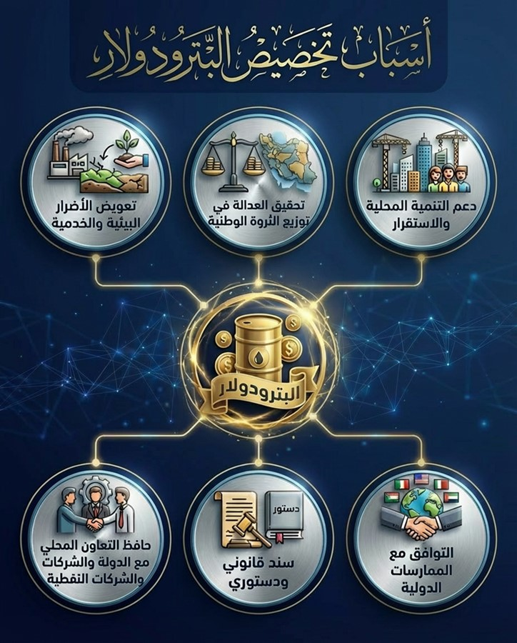

Based on the instructions to facilitate the implementation of the Federal General Budget Law for the fiscal years (2023-2024-2025) No. 13 of 2023 (https://iraqld.e-sjc-services.iq/legislations/showlegislation?lawbookid=49685Chapter Two, Section Two, Article Six, Fourth (a), where the mechanism was describedthat It is Its adoption for calculation pertains toYSounds PetrodollarOn the condition thatHe chooses region and the governorates Producer in to choose One Revenue Producer Below:
- (5%)five from One hundred from revenues oil raw(At the price Specific in Budget public)Product in region and the governorates not Regular in province Producer.
- (5%)five from One hundred from revenues oil raw Repeated in refineries region and the governorates not Regular in province(At the price Specific in Budget public).
- (5%)five from One hundred from revenues mystification natural Product in region and the governorates not Regular in province Producer At the price equivalent barrel oil on basis the price Specific in Budget public.
Grandfatherto Below It shows Allocations andFunding(Transfers) Petrodollar that It happened Implementing it from before ministry Finance duringyear 2023:
Chapter Five (Revenue Distribution)table 58
Petrodollar allocations and funding for 2023
# | Governorate | Revised allocation amount in the investment budget |  | Actual amount funded (transferred) |  | Unfunded (untransferred) balance |  | Actual implementation rate
# | Governorate | Iraqi dinar | Its equivalent in US dollars (1 dollar equals 1,300 Iraqi dinars) | Iraqi dinar | Its equivalent in US dollars (1 dollar equals 1,300 Iraqi dinars) | Iraqi dinar | Its equivalent in US dollars (1 dollar equals 1,300 Iraqi dinars) | Actual implementation rate
1 | Basra | 1,641,445,495,567 | 1,262,650,381 | 959,578,770,255 | 738,137,516 | 681,866,725,312 | 576,875,402 | 58%
2 | Maysan | 203,132,656,480 | 156,255,890 | 117,353,066,576 | 90,271,590 | 85,779,589,904 | 72,571,565 | 58%
3 | Dhi Qar | 76,778,599,000 | 59,060,461 | 53,537,307,196 | 41,182,544 | 23,241,291,804 | 19,662,683 | 70%
4 | Wasit | 71,671,598,586 | 55,131,999 | 46,541,795,100 | 35,801,381 | 25,129,803,486 | 21,260,409 | 65%
5 | Baghdad | 55,840,000,000 | 42,953,846 | 0 | 0 | 55,840,000,000 | 47,241,963 | 0%
6 | Kirkuk | 50,570,000,000 | 38,900,000 | 14,760,438,163 | 11,354,183 | 35,809,561,837 | 30,295,738 | 29%
7 | Saladin | 11,377,000,000 | 8,751,538 | 12,725,087,853 | 9,788,529 | -1,348,087,853 | -1,140,514 | 112%
8 | Diwaniyah | 6,960,000,000 | 5,353,846 | 414,951,994 | 319,194 | 6,545,048,006 | 5,537,266 | 6%
9 | Najaf Al-Ashraf | 6,670,000,000 | 5,130,769 | 7,142,214,020 | 5,494,011 | -472,214,020 | -399,504 | 107%
10 | Al-Muthanna | 5,092,000,000 | 3,916,923 | 2,094,097,000 | 1,610,844 | 2,997,903,000 | 2,536,297 | 41%
11 | Babylon | 2,260,000,000 | 1,738,462 | 0 | 0 | 2,260,000,000 | 1,912,014 | 0%
12 | Anbar | 1,580,000,000 | 1,215,385 | 749,984,400 | 576,911 | 830,015,600 | 702,213 | 47%
13 | Nineveh | 1,240,000,000 | 953,846 | 1,297,781,675 | 998,294 | -57,781,675 | -48,885 | 105%
14 | Diyala | 320,000,000 | 246,154 | 0 | 0 | 320,000,000 | 270,728 | 0%
the total |  | 2,134,937,349,633 | 1,642,259,500 | 1,216,195,494,232 | 935,534,996 | 918,741,855,401 | 777,277,373 | 57%
Source:Ministry of Finance–Accounting Department.

Chapter Five (Revenue Distribution)appearance 24
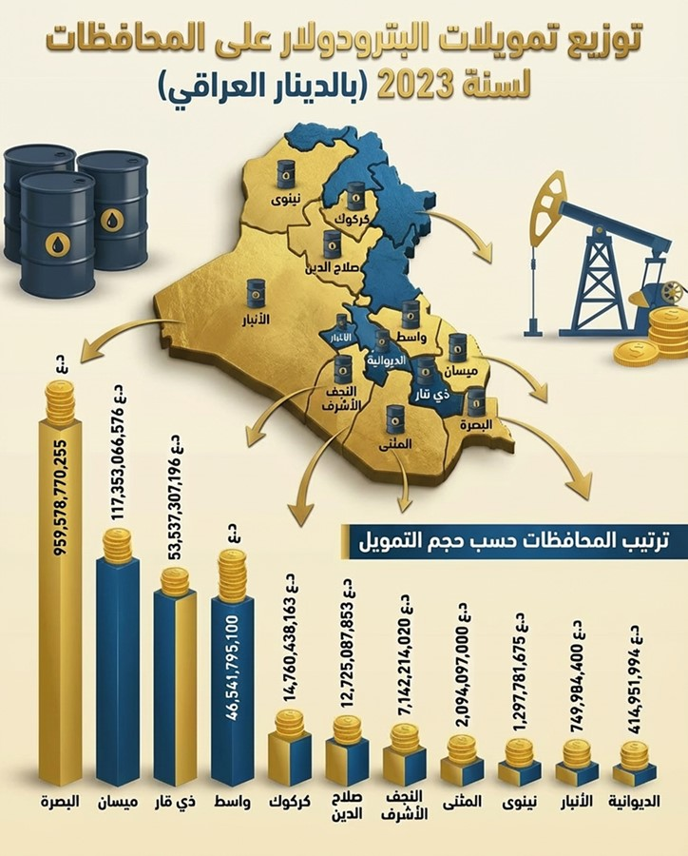

    - development Regions and the governorates
The purpose of the Regional and Provincial Development Program is to finance reconstruction projects in all Iraqi provinces, including those within the Kurdistan Region (excluding their share of public spending after deducting sovereign and governing expenses according to the federal budget). Federal budget laws typically allocate an amount for the Regional and Provincial Development Program, which is then distributed among the provinces based on their population..
According to the lawBudget public Federal Republic Iraq For years Finance(2023-202402025)–Chapter Two - First - 4 on Allocationamount Its amount(2,500,000,000)one thousand Dinar(two trillion and five hundred one billion Dinar)for(eAmmar and development Projects in governorates all)from pedigreed Allocations Participant To her By clause(Firstly/2)from This is amazing Material It is Its distribution according to number Population in all governorate and line poverty , In what in that governorates region.

According to the Government Investment Programs Department at the Ministry of Planning, the mechanism for calculating allocations for the development of regions and governorates is as follows:
First - The amount allocated in the budget law is adopted for the purposes of regional development.
Second - The relative importance of each governorate is calculated using the equation below:
The relative importance of each governorate = the governorate's population for the year of distribution 100 x
Population of Iraq for the year of distribution
Third– after that It is application The equation The following To calculate share from Allocation development Regions per governorate:
Regional development for the governorate = Total amount allocated in the budgetx a Due to the relative importance of each governorate
100
Table Below It shows Allocations andFunding Regions and provinces that It happened Implementing it from before ministry Finance For the year 2023:
Chapter Five (Revenue Distribution)table 59
Allocations and funding for regional and provincial development for the year 2023
# | Governorate | Revised allocation amount in the investment budget |  | Actual amount funded (transferred) |  | Unfunded (untransferred) balance |  | Actual implementation rate
# | Governorate | Iraqi dinar | Its equivalent in US dollars (1 dollar equals 1,300 Iraqi dinars) | Iraqi dinar | Its equivalent in US dollars (1 dollar equals 1,300 Iraqi dinars) | Iraqi dinar | Its equivalent in US dollars (1 dollar equals 1,300 Iraqi dinars) | Actual implementation rate
1 | Baghdad | 815,613,340,767 | 627,394,878 | 476,005,275,641 | 366,157,904 | 339,608,065,126 | 287,316,468 | 58%
2 | Nineveh | 697,232,280,375 | 536,332,523 | 739,688,607,989 | 568,991,237 | -42,456,327,614 | -35,919,059 | 106%
3 | Anbar | 631,022,002,569 | 485,401,540 | 374,917,169,416 | 288,397,823 | 256,104,833,153 | 216,670,756 | 59%
4 | Saladin | 566,370,897,610 | 435,669,921 | 299,382,022,274 | 230,293,863 | 266,988,875,336 | 225,878,913 | 53%
5 | Karbala | 426,567,806,000 | 328,129,082 | 386,295,667,120 | 297,150,513 | 40,272,138,880 | 34,071,183 | 91%
6 | Diyala | 400,719,228,609 | 308,245,560 | 283,478,660,249 | 218,060,508 | 117,240,568,360 | 99,188,298 | 71%
7 | Basra | 394,773,226,304 | 303,671,713 | 498,590,313,073 | 383,531,010 | -103,817,086,769 | -87,831,715 | 126%
8 | Dhi Qar | 390,713,212,483 | 300,548,625 | 404,639,908,625 | 311,261,468 | -13,926,696,142 | -11,782,315 | 104%
9 | Babylon | 390,383,217,242 | 300,294,782 | 181,535,361,289 | 139,642,586 | 208,847,855,953 | 176,690,233 | 47%
10 | Wasit | 331,288,596,414 | 254,837,382 | 304,133,464,758 | 233,948,819 | 27,155,131,656 | 22,973,885 | 92%
11 | Diwaniyah | 328,504,081,578 | 252,695,447 | 127,176,096,121 | 97,827,766 | 201,327,985,457 | 170,328,245 | 39%
12 | Maysan | 323,339,177,000 | 248,722,444 | 227,260,109,471 | 174,815,469 | 96,079,067,529 | 81,285,167 | 70%
13 | Najaf Al-Ashraf | 316,327,609,021 | 243,328,930 | 332,715,178,970 | 255,934,753 | -16,387,569,949 | -13,864,272 | 105%
14 | Kirkuk | 312,892,073,223 | 240,686,210 | 266,762,855,961 | 205,202,197 | 46,129,217,262 | 39,026,411 | 85%
15 | Al-Muthanna | 292,860,719,000 | 225,277,476 | 240,907,729,871 | 185,313,638 | 51,952,989,129 | 43,953,460 | 82%
the total |  | 6,618,607,468,195 | 5,091,236,514 | 5,143,488,420,828 | 3,956,529,554 | 1,475,119,047,367 | 1,247,985,658 | 78%
Source:Ministry of Finance–Accounting Department.

Chapter Five (Revenue Distribution)appearance 25
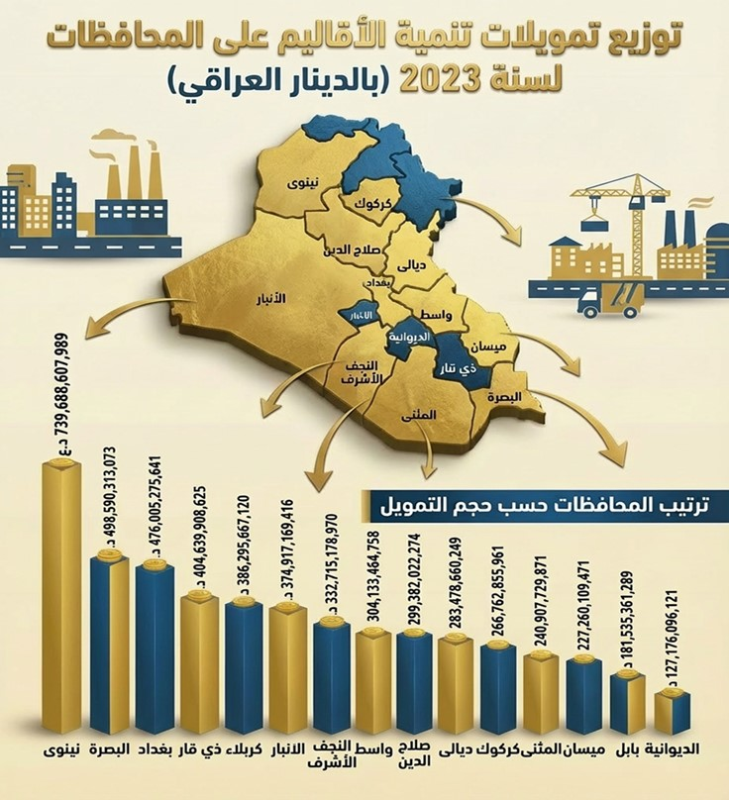
  - Federal General Budget
In the sixth month of 2023, the Iraqi Council of Representatives approved a federal general budget law for three years (2023-2024-2025), which was published in the Official Gazette of the Republic of Iraq under Law No. 13 of 2023 (https://iraqld.e-sjc-services.iq/legislations/showlegislation?lawbookid=49562)after that Disruption His acknowledgment For the duration general and a half, where amount total Revenue public b(134.5)trillion Dinar, and total Expenses public b(198.9)trillion Dinar, And in total inability a plan reached(64.3)trillion Dinar.
YgoalThis law to Strengthening Stability Financial and planning middle The term, And ending Problem delay Declaration Budgets Annual.It depends Budget In a way major on Revenue Oil, with to set price oil hypothetical and quantities export As a basis For appreciation, and guidance Spending between expenses operational High and expenses investment Dedicated For services And the structure Infrastructure.

Supports Budget decentralization and development Local via Allocations For the governorates, no Sima governorates Producer, within Budgets Investment, In what Investigates Destiny from Justice in distribution wealth.as organize relationship Finance with province Kurdistan, And strengthen Frames Governance and censorship Finance.

Represents Budget The trilogy step reformatory a task, unless that Her success remains mortgaged By reducing Accreditation on Oil, to improve efficiency Implementation, and development Revenue not oil.

It should be noted that all revenues related to the extractive sector are included in the state treasury revenues, and there are no revenues that are not recorded in the state treasury.

  - Components of the State's General Budget Revenues (Actual) for the year 2023
In 2023, public revenues recorded a significant decline of 16.1%, reaching 135.7 trillion dinars, compared to 161.7 trillion dinars in 2022. This decrease is primarily attributed to the drop in oil prices. Oil revenues remain the main source of public revenues, contributing 90.9% and amounting to 124.4 trillion dinars, reflecting a decrease of 16.1%. (19%).
In the same context, both commodity taxes and production fees decreased by (12.6%), and transfer revenues also declined by (220.9%).
In contrast, taxes on income and wealth saw a significant increase of (77.2%), attributed to a decline in tax evasion levels, as well as an increase in the number of government employees during the year, given that taxes on state employees' salaries represent the largest share of this type of tax..
Other revenues also increased by (204.1%), along with an increase in fees and the budget's share of public sector profits, as well as capital revenues by (4.2%), with growth rates of (69.6%) and (165.5%) respectively compared to the previous year..
It is noted that oil revenues continue to dominate the structure of public revenues at a very high rate compared to other revenue sources, which necessitates the adoption of effective policies aimed at diversifying and expanding the base of public revenues..

Chapter Five (Revenue Distribution)table 60
Table of components of the state's general budget revenues (actual) for the years 2022-2023
Revenue Gates | 2022 |  | 2023 |  | Percentage change % (change in 2023 compared to 2022)
Revenue Gates | The amount is in billions of Iraqi dinars. | Percentage contribution to total public revenues % | The amount is in billions of Iraqi dinars. | Percentage contribution to total public revenues % | Percentage change % (change in 2023 compared to 2022)
Oil revenues and mineral wealth | 153,623 | 96% | 124,429 | 90.9% | -19.0%
Taxes on income and wealth | 2,778 | 1.7% | 4,923 | 3.6% | 77.2%
Commodity taxes and production fees | 1,133 | 0.7% | 990 | 0.7% | -12.6%
Other revenues | 1,124 | 0.7% | 3,419 | 2.5% | 204.1%
Transfer revenues | 1,042 |  | -1,259
Fees | 1,258 | 0.8% | 1,311 | 1.0% | 4.2%
The budget's share of public sector profits | 641 | 0.4% | 1,703 | 1.2% | 165.5%
capital revenues | 97 | 0.1% | 165 | 0.1% | 69.6%
Total revenue | 161,697 |  | 135,681 |  | -16.1%
Revenue excluding transfer income | 160,656 | 100% | 136,941 | 100% | -16.1%
Source: Annual Economic Report issued by the Central Bank of Iraq for the year2023. This report can be viewed on the National Initiative website.– Reports and publications – Report annual – Accessories Reportannual2023
*Transfer revenue was excluded as itno It is calculated As a result economic new, but rather re distribution For resources

Chapter Five (Revenue Distribution)appearance 26
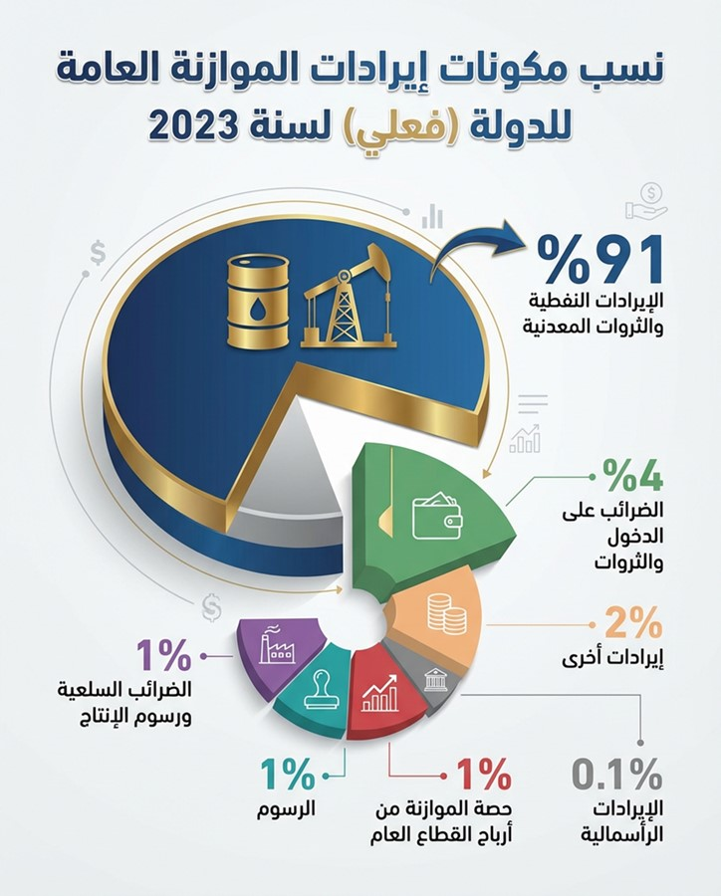

  - law Administration the moneyYة Federal
The Federal Financial Management Law No. (6) of 2019 included advanced methods in budget preparation, and we list some of what was included in Chapter Two (Budget Preparation) of the aforementioned law:
Article 3– Firstly:It is My ministry Planning Finance beginning from month March from all year Report on Priorities Politics Finance and strategy The program Government Recommendations Central For trends Budget public Federal State from where Its elements And its size and its distribution Functionally and sectorally Please on a report Criticism foreigner Proposal from Bank Central Iraqi For the duration(3)three years or more And he presents it to Committee Affairs Economic or what Solves Its place in council Ministers beginning month April from Year itself It includes Report what It comes:
- Macroeconomic forecasts for the next (3) three years or more and their assumptions, including oil prices and production quantities.
- Forecasts regarding revenues and expenditures for the next (3) three years or more in the government sector whose current and investment expenditures are centrally funded.
- Financial forecasts for (3) three or more years for public companies.
- Analysis of the foreign trade sector.
- The targeted deficit, if any, in the federal general budget and other financial indicators for a period of (3) three years or more.
- The ceilings for total expenditures in the federal budget for the following three years or more.
- The ceilings for current and investment expenditures for each ministry or entity not affiliated with a ministry for a period of (3) three years or more.
Article 3– secondly:Takes over Committee Affairs Economic or what Solves Its place in council Ministers With the help of number from Experts from Ministries and the sector private discussion Report The stipulated attic in(Material3– Firstly)And raise it to council Ministers end month April To approve it And it will be Basically To prepare Budgets For years The suffix.
Article 8: The Federal Ministers of Planning and Finance shall submit to the Economic Affairs Committee, or its replacement in the Council of Ministers, at the beginning of August of each year, the draft Federal General Budget Law for study and the submission of recommendations to the Council of Ministers at the beginning of September of each year, accompanied by the following:
First: The fiscal policy document, which includes the following:
- Objectives and rules of the fiscal policy adopted in preparing the federal general budget law.
- Updated macroeconomic forecasts, public finance indicators and key budget assumptions covering the budget year within a medium-term plan for (3) three years or more with respect to estimates of oil prices, production and other budget financing resources and to the extent appropriate to the prevailing economic and financial conditions in Iraq.
- The new policies included in the annual budget and their specific financial implications.
- Financial risks facing fiscal policy for the coming period, including an analysis of macroeconomic risks arising from changes in oil prices and production volumes.
- A list of all guarantees issued by the federal government.
- Unified budgets for the region and provinces not organized into a region.
Article 10– Item(Haa):It is ministry oil Reports tables Detailed on quantities oil Product The source and percentage Costs Production to Revenue Oil, and amounts allocated To import Derivatives oil Governor Its distribution, size Production Export Expected oil raw and derivatives oil For three years deification And attach with law Budget public Federal during month July from year numbers Budget.
  - Budget audit Federal
According to Article (34) of the Federal Financial Management Law No. (6) of 2019 (https://iraqld.e-sjc-services.iq/legislations/showlegislation?lawbookid=41717The Minister of Finance is required to submit the federal financial statements (the state's final accounts) to the Federal Board of Supreme Audit no later than the end of March of the following year, in accordance with the requirements set by the Board for their audit.The Federal Board of Supreme Audit prepares a report on federal financial data, which it submits to the Federal Minister of Finance on September 15th, for submission to the Committee on Economic Affairs or its replacement, for review and submission to the Council of Ministers for presentation to the House of Representatives before September 30th for discussion and approval. The report approved by the House of Representatives is then published in the Official Gazette and on the official websites of the Ministry of Finance and the Council of Ministers.
The final accounts for the year have not yet been audited.2023. The importance of issuing the final accounts lies in the fact that they represent a presentation of the actual implementation of the federal budget law, and thus knowing how the state departments spend the funds allocated and financed by the Ministry of Finance.

Chapter Six: Benefits of the Extractive Sector
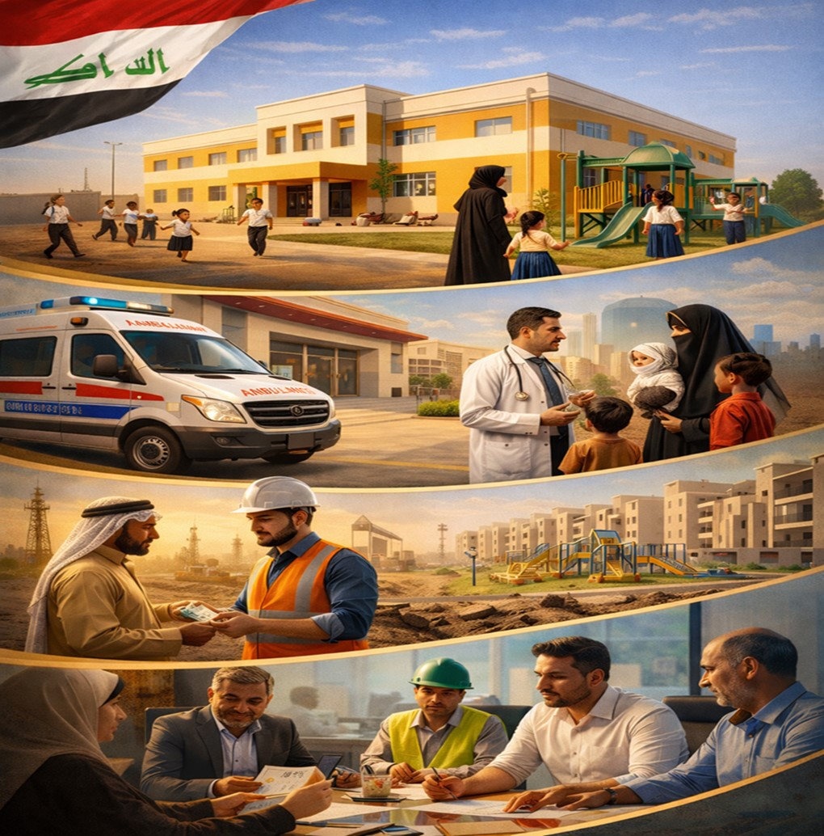

- Benefits of the extractive sector
represents sector Extractive in Republic Iraq Source Mainly For benefits Economic And finance, so He provides Revenue public resulting from export oil gas and activities Related With them, Which It is The foundation Basic To finance Budget public Federal.And include This is amazing Benefits Revenue Finance Direct, and transfers Finance For the governorates And the regions, Please on to support Development Economic social and funding projects Structure Infrastructure Services public.

as Contributes sector Extractive in Strengthening Stability The economist Providing currency foreign, And attracted Investments, addition to turn in to support Governance Finance and transparency Management Resources natural according to Frameworks Legal and standards International The Connection.

One of the most importantBenefits sector Extractive in Iraq:
First: Direct financial benefits
It is the most important and largest in size, and includes:
- Crude oil export revenues(The main source of the federal general budget)
- Revenues from refined crude oil
- Taxes and fees imposed on extractive companies
- State shares of profits according to oil service contracts
- Signing bonuses
- returnsinvestmentAssociated gas
Second: Benefitsfinancing
These are benefits resulting from the redistribution of oil revenues, such as:
- Allocations for the development of producing regions and governorates (petrodollars)
- Federal transfers to local governments
- Funding provincial projects from the investment budget
Third: Indirect economic benefits
The broader economic effects of the sector include, such as:
- Creating job opportunities(Directly and indirectly)
- Activating the supporting sectors (transport, services, contracting)
- Supporting the trade balance
- Providing foreign currency
- Stimulating foreign investment
Fourth: Social and developmental benefits
And include:
- Infrastructure project financing(Roads, electricity, water, sewage)
- Improving health and education services
- Supporting social stability in productive areas
- Reducing development gaps between governorates
Fifth: Local benefits
Specifically for producing regions, and includes:
- Social responsibility projects
- Developing local communities
- Support for municipalities and services
- Improving public acceptance of oil operations
Sixth: Institutional and Governance Benefits
Through sector management, this is achieved:
- Enhancing transparency and accountability
- Developing government accounting systems
- Improving public revenue management
- Adherence to international standards(Example of standards)EITI)
- Building the capacities of national institutions
Seventh: The strategic benefits for the state
These include:
- Strengthening economic sovereignty
- Supporting fiscal and monetary policy
- Enabling the state to implement its public policies
- Improving Iraq's international economic standing

In addition, the extractive sector contributes significantly to implementationGoals Development Sustainable in Iraq(https://iraq.un.org/ar/sdgs), including Goal Number One, which is to eradicate poverty.

Chapter Six (Benefits of the Extractive Sector) -appearance 27
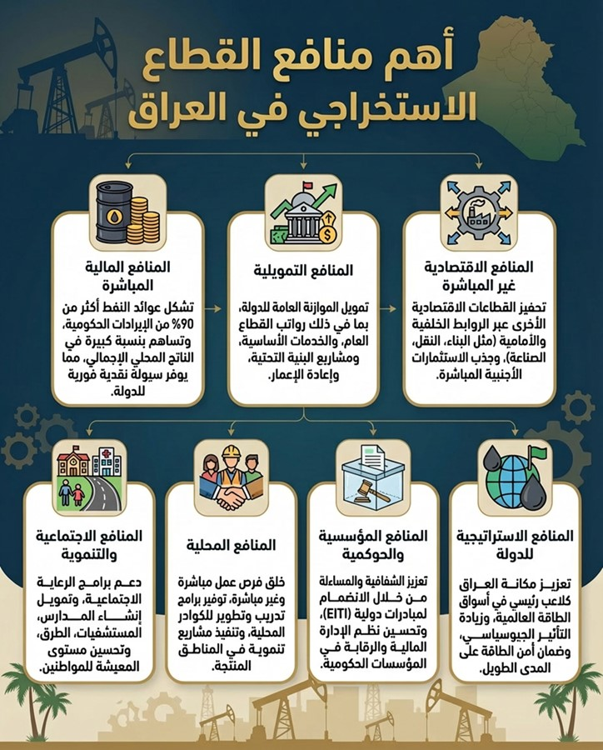

  - Social spending by extractive companies
National and foreign oil companies operating in the extractive industries allocate funds to support social services provided to citizens, particularly in areas surrounding oil fields that are negatively impacted by extraction activities from an environmental and health perspective. These contributions also aim to raise living standards and promote economic and social well-being in those areas.These contributions were published in a file attached to the appendices of the 2023 Annual Report under the title "Social Benefits".
Social services contributions in Iraq are divided into two main types.:

    - Social contributionsThe scheduled from during legislation or contracts with the government
This is amazing Contributions be Mandatory And there Two types from This is amazing Contributions It is:

- Contributions social the introduction from before companies oil Global And the approved from before Committee Energy affiliated Council Ministers, According to For her decision Numbered(139)in23Canon the first2013Sincecompanies oil Global The worker in Fields Iraqi Obligatory By allocating amount annual no Exceeds(5)million dollar American on all a contract service For tours Licenses, behavior For projects Implement from before that companies As benefits social For the regions surrounding In the fields And patches Exploration that It works In it.amount Attachment The matter In the field hunchback and tours Licenses First The second And the third According to For the decision The aforementioned above, register amounts This is amazing Contributions under item melasma petroleum Mustard, where It is Paying it to Contractor within His entitlements that He retrieves it Later.
Awhat with regards For the tour Fourth Lost It included Banda It is necessary companies Contractor By allocating amount Its value Equal(10%)from value Budget Annual The approved On it For projects Structures Infrastructure in governorates that Located Including patches Exploration And so It will allow By providing amounts To create and development Structures Infrastructure In it.
And it is to implement Projects from This is amazing Contributions In coordination Live with governorates Local and companies oil Nationalism The relationship in areas Production According to For needs Communities Local annually Which It will contribute gradually in Getting up In fact This is amazing Communities And its development To achieve Development Sustainable In it.And we see A N Allocation amounts For projects Services social And the structures Infrastructure in governorates Producer It will contribute in development that governorates that It was completed His investment In the form optimum.

- According to Article (11) of the Public Companies Law No. (22) of 1997 (as amended), state-owned companies are required to allocate (5%) of their net annual profits, after their accounts have been audited by the Federal Board of Supreme Audit, to social services. The amounts collected from the aforementioned percentage are paid directly by the national companies to the accounts of the Ministry of Oil's central office, to be distributed as follows:

  - 25% is paid into the health insurance fund for employees and workers.
  - 20% is paid to the Ministry's Social Security Fund.
  - 20% to support the guesthouse at the Ministry of Oil (which is used for the accommodation and hospitality needs of oil sector delegates, official visitors and foreign delegations) and the Oil Cultural Center, at a ratio of (60%: 40%, respectively).
  - 5% to support oil sports clubs in Iraq.
  - 15% to support residential investment projects for the Ministry of Oil in Iraq.
  - Allocate 15% to various social initiatives (such as building schools and nurseries and supporting social service projects for employees).

    - Contributionssocial the introduction According to To estimate companies oil Global-Expenses social Voluntary
These contributions represent social expenditures made and disbursed at the discretion of international oil companies. Voluntary social expenditures are non-refundable and are referred to in service contracts (Annex C) as "any costs, wages, or expenses, including donations, related to public relations or improving the operator's image."
PublishedSome information on social benefitsAs a database on the siteThe AuthorityNational, within the Reports and Publications section– Report annual – Accessories Report annual 2023.

  - quasi-financial expenditures
The International Monetary Fund defines quasi-fiscal activities as financial activities "often introduced by a simple administrative decision, not recorded in the budget or in budget reports, and which are not usually subject to legislative and public oversight. They are provided by governments to achieve a variety of objectives, such as promoting certain activities, redistributing income, or collecting revenue."
no apply Expenses semi Finance in Iraqin general, But Despite from that, from Possible consideration Selling oil and its products to the Iraqi Ministry of Electricity at a reduced price,non Calculation benefit Commercial on dues Debts Honestly ministry electricity In favor of companies public affiliated Ministry oilAs quasi-financial expenses.

  - The extractive sector's contribution to the economy
Iraq is heavily reliant on oil thanks to its vast reserves, making it the primary driver of most of its economic activities across production, trade, and finance. Oil is also the world's primary energy source and a crucial factor in sustaining global economic growth, as well as a decisive variable in future development plans. In Iraq specifically, crude oil extraction is the cornerstone of economic growth, holding the highest relative importance compared to other sectors, while most non-oil activities have failed to play their required role in supporting the development process..
It shows Table the next Output Local Total According to Activities Prices The current For two years 2022and2023According to To report Economic annual Issued on Bank Central Iraqi For the year 2023:

Chapter Six (Benefits of the Extractive Sector) -table 61
Gross Domestic Product by Economic Activity at Current Prices for 2022 and 2023
Economic activities | 2022 |  | 2023 |  | Percentage change % (change in 2023 compared to 2022)
Economic activities | Value added (billion Iraqi dinars) | Relative importance % | Value added (billion Iraqi dinars) | Relative importance % | Percentage change % (change in 2023 compared to 2022)
Agriculture, forestry and fishing | 6,796 | 1.6% | 9,256 | 2.8% | 36.2%
Mining and quarrying:Crude oil | 239,770 | 57.4% | 148,141 | 44.6% | -38.2%
Mining and quarrying:Other types of mining | 840 | 0.2% | 940 | 0.3% | 11.9%
manufacturing industry | 10,456 | 2.5% | 11,783 | 3.5% | 12.7%
Electricity and water | 5,494 | 1.3% | 3,788 | 1.1% | -31.0%
Construction and building | 17,042 | 4.1% | 18,802 | 5.7% | 10.3%
Transportation, communications, and storage | 31,181 | 7.5% | 33,222 | 10.0% | 6.5%
Wholesale and retail trade, hotels and the like | 22,523 | 5.4% | 23,718 | 7.1% | 5.3%
Finance, insurance, and real estate services:Banks and Insurance | 3,107 | 0.7% | 3,214 | 1.0% | 3.4%
Finance, insurance, real estate, and business services:Ownership of residential units | 18,658 | 4.5% | 16,430 | 4.9% | -11.9%
Social and personal development services:General Government | 48,309 | 11.6% | 48,869 | 14.7% | 1.2%
Social and personal development services:Personal services | 13,511 | 3.2% | 14,011 | 4.2% | 3.7%
Total by activity | 417,686 | 100% | 332,175 | 100% | -20.5%
Minus: Calculated service fee | 2,058 |  | 2,128 |  | 3.4%
gross domestic product | 415,629 |  | 330,046 |  | -20.6%
Source: Annual Economic Report issued by the Central Bank of Iraq for the year2023. This report can be viewed on the National Initiative website.– Reports and publications – Report annual – Accessories Report annual 2023

According to the annual export report for the year2024Issued byStatistics Authority and Geographic Information Systems–The Directorate of Trade Statistics reported thatThe value of crude oil exports is approximately (1271 trillion dinars per year2023The following table shows the total value of exports for the year2023According to the aforementioned report, which can be viewed on the National Initiative website– Reports and publications – Report annual – Accessories Report annual 2023.

Chapter Six (Benefits of the Extractive Sector) -table 62
Total value of exports for the years 2022 and 2023
Commodity exports | 2022 |  |  | 2023 |  |  | Percentage change % (change in 2023 compared to 2022)
Commodity exports | One million Iraqi dinars | Its equivalent in one million US dollars (exchange rate 1,450 dinars per dollar) | Percentage of total exports | One million Iraqi dinars | Its equivalent in one million US dollars (exchange rate 1,300 dinars per dollar) | Percentage of total exports | Percentage change % (change in 2023 compared to 2022)
Crude oil | 167,574,470 | 115,569 | 92.6% | 126,845,680 | 97,574 | 92.3% | -24.3%
Petroleum products:
fuel oil | 5,810,150 | 4007 | 3.2% | 4,060,680 | 3,124 | 2.95% | -30.1%
Naftha | 1,310,075 | 904 | 0.7% | 822,770 | 633 | 0.6% | -37.2%
natural gasoline | 105,415 | 73 | 0.1% | 2,340 | 1.8 | 0.002% | -97.8%
Vacuum distillation oil | 0 | 0 | 0.00% | 0 | 0 | 0% | 0%
matchsticks | 28,565 | 20 | 0.02% | 520 | 0.4 | 0.0004% | -98.2%
bitumen | 0 | 0 | 0% | 130 | 0.1 | 0.0001% | -
jet fuel | 0 | 0 | 0% | 0 | 0.0 | 0.0000% | -
Total petroleum products | 7,254,205 | 5,003 | 4.0% | 4,886,440 | 3,759 | 3.56% | -32.6%
Confiscated goods | 6,081,934 | 4,194 | 3.4% | 5,711,242 | 4,393 | 4.2% | -6.1%
Total exports | 180,910,609 | 124,766 | 100% | 137,443,362 | 105,726 | 100% | -24.0%
Source: The ReportAnnual exports for the year2024Issued byAuthority Statistics And organized Information Geography – Directorate Statistics commerce.

  - Labor in the extractive sector
The extractive sector in Iraq provides tens of thousands of direct and indirect jobs and represents a key pillar in building technical and engineering capabilities. However, its contribution tonumberThe number of jobs is limited compared to its size in the economy, which necessitates diversifying the economy and activating other sectors capable of absorbing a larger workforce..

Chapter Six (Benefits of the Extractive Sector) -table 63
Number of personnel in the Ministry of Oil and its affiliated formations as of June 30, 2025
# | Formation | English name of the formation | Number of staff by type |  | Total number of staff | Male percentage | Percentage of females
# | Formation | English name of the formation | Males | females | Total number of staff | Male percentage | Percentage of females
1 | Ministry Center | MINISTRY OF OIL HEADQUARTER | 851 | 525 | 1,376 | 62% | 38%
2 | Basra Oil Company | BASRA OIL COMPANY | 27,285 | 3,473 | 30,758 | 89% | 11%
3 | Oil Products Distribution Company | OIL PRODUCTS DISTRIBUTION COMPANY | 19,995 | 3,541 | 23,536 | 85% | 15%
4 | North Oil Company | NORTH OIL COMPANY | 10,470 | 1,884 | 12,354 | 85% | 15%
5 | Oil pipeline company | OIL PIPELINES COMPANY | 9,843 | 1,087 | 10,930 | 90% | 10%
6 | Middle Refineries Company | MIDLAND REFINERIES COMPANY | 8,931 | 1,533 | 10,464 | 85% | 15%
7 | South Refineries Company | SOUTHERN REFINERIES COMPANY | 8,194 | 792 | 8,986 | 91% | 9%
8 | North Refineries Company | NORTH REFINERIES COMPANY | 8,203 | 371 | 8,574 | 96% | 4%
9 | General Company for Gas Filling and Services | GAS FILLING COMPANY | 7,030 | 1,138 | 8,168 | 86% | 14%
10 | Iraqi Drilling Company | IRAQI DRILLING COMPANY | 6,955 | 335 | 7,290 | 95% | 5%
11 | Missan Oil Company | MISSAN OIL COMPANY | 5,609 | 681 | 6,290 | 89% | 11%
12 | Oil Projects Company | OIL PROJECTS COMPANY | 5,422 | 474 | 5,896 | 92% | 8%
13 | Dhi Qar Oil Company | THI QAR OIL COMPANY | 4,894 | 711 | 5,605 | 87% | 13%
14 | Middle Oil Company | MIDLAND OIL COMPANY | 4,711 | 678 | 5,389 | 87% | 13%
15 | South Gas Company | SOUTH GAS COMPANY | 4,797 | 373 | 5,170 | 93% | 7%
16 | Oil Exploration Company | OIL EXPLORATION COMPANY | 2,584 | 485 | 3,069 | 84% | 16%
17 | North Gas Company | NORTH GAS COMPANY | 2,685 | 280 | 2,965 | 91% | 9%
18 | General Company for Heavy Engineering Equipment | HEAVY ENGINEERING EQUIPMENTS STATE COMPANY | 1,220 | 184 | 1,404 | 87% | 13%
19 | Iraqi Oil Tankers Company | IRAQI OIL TANKERS COMPANY | 648 | 164 | 812 | 80% | 20%
20 | Oil Marketing Company | OIL MARKETING COMPANY | 394 | 148 | 542 | 73% | 27%
21 | Oil Training Institute - Baghdad | BAGHDAD OIL TRAINING INSTITUTE | 337 | 183 | 520 | 65% | 35%
22 | Oil Training Institute - Basra | BASRA OIL TRAINING INSTITUTE | 295 | 80 | 375 | 79% | 21%
23 | Oil Training Institute - Baiji | BAIJI OIL TRAINING INSTITUTE | 351 | 17 | 368 | 95% | 5%
24 | Oil Research and Development Center | PETROLEUM RESEARCH AND DEVELOPMENT CENTER | 221 | 123 | 344 | 64% | 36%
25 | Oil Training Institute - Kirkuk | KIRKUK OIL TRAINING INSTITUTE | 179 | 40 | 219 | 82% | 18%
26 | Oil Training Institute - Maysan | MISSAN OIL TRAINING INSTITUTE | 86 | 13 | 99 | 87% | 13%
27 | Petroleum Cultural Center | OIL CULTURAL CENTER | 47 | 6 | 53 | 89% | 11%
28 | guest house | GUEST HOUSE | 23 | 6 | 29 | 79% | 21%
Total |  |  | 142,260 | 19,325 | 161,585 | 88% | 12%
Source:Ministry of Oil–The administrative and financial department.
    - Employment, training and technology transfer (Training Fund)–Article 26 of the licensing round contracts
According to the Petroleum Licensing Rounds contracts (Article 26), an amount is allocatedAs specified in the table belowThis is because it is spent on recruitment, training, and technology transfer, which are considered non-refundable costs.
The table below shows what is allocated for the year2023And what was spent in the year in question.

Chapter Six (Benefits of the Extractive Sector) -table 64
The amounts allocated and spent for Article (26) Training for the year 2023 for rounds from the first to the fourth with the Al-Ahdab, East Baghdad and Artawi fields (calculated according to the quarterly operators’ lists)
The field | The allocation for 2023 in US dollars | Expenditure for 2023 in US dollars | Unspent (remaining) in US dollars | Percentage of what was spent
Al-Rumaila | 5,000,000 | 3,087,337 | 1,912,663 | 62%
Al-Zubair | 5,000,000 | 1,811,340 | 3,188,660 | 36%
West Qurna 1 | 5,000,000 | 0 | 5,000,000 | 0%
Maysan | 5,000,000 | 2,437,899 | 2,562,101 | 49%
West Qurna 2 | 5,000,000 | 6,764,522 | -1,764,522 | 135%
Halfaya | 5,000,000 | 3,741,284 | 1,258,716 | 75%
The graph | 5,000,000 | 1,868,411 | 3,131,589 | 37%
Badra | 5,000,000 | 0 | 5,000,000 | 0%
Qayyarah | 5,000,000 | 0 | 5,000,000 | 0%
The chaos | 1,000,000 | 477,764 | 522,236 | 48%
Patch 9 (Al-Fayha) | 1,000,000 | 710,316 | 289,684 | 71%
East Baghdad | 1,000,000 | 0 | 1,000,000 | 0%
hunchback | 1,000,000 | 0 | 1,000,000 | 0%
Artawi | 5,000,000 | 0 | 5,000,000 | 0%
Total | 54,000,000 | 20,898,873 | 33,101,127 | 39%

Chapter Six (Benefits of the Extractive Sector) -table 65
The amounts allocated for Article (26) Training for the fields of the fifth and sixth rounds
The field | Contract amount in US dollars
Oil Khana | 2,000,000
Al-Hawizeh | 2,000,000
Khader Al-Mai | 2,000,000
Claws–Camel | 2,000,000
Anjana - Khashm al-Ahmar | 2,000,000
East Baghdad, northern extension | 2,000,000
Middle Euphrates | 2,000,000
Dima | 2,000,000
Ann/Sasan | 10% of the annual budget, not to exceed $2,000,000
Khalisiyah | 10% of the annual budget, not to exceed $2,000,000
FAO | 10% of the annual budget, not to exceed $2,000,000
Zarbatia | 10% of the annual budget, not to exceed $2,000,000
Mount Sanam | 10% of the annual budget, not to exceed $2,000,000
Exploration Block 7 | 10% of the annual budget, not to exceed $2,000,000
Zafariyah | 10% of the annual budget, not to exceed $2,000,000
Sumer | 10% of the annual budget, not to exceed $2,000,000
Adan | 10% of the annual budget, not to exceed $2,000,000
Abu Khayma | 10% of the annual budget, not to exceed $2,000,000
Two horns | 10% of the annual budget, not to exceed $2,000,000
Total | 38,000,000

  - Environmental impact of extractive activities

Extractive activities in Iraq, despite their economic importance, leave significant negative environmental and health impacts, most notably air, water, and soil pollution. Addressing these challenges requires serious investments in environmentally friendly technologies, strengthened legislation, and a shift towards renewable energy to achieve sustainable development..
According to the Environmental Protection and Improvement Law No. 27 of 2009, the protection of the environment from pollution resulting from the exploration and extraction of oil and natural gas resources was referred to in the seventh section of the aforementioned law, where Article 21 stated the following:
The authorities responsible for exploring and extracting oil and natural gas resources must do the following::
Firstly!Taking measures to reduce the damage and risks resulting from oil and gas exploration and drilling operations, and taking the necessary precautions and measures to protect the land, air, water, and groundwater basins from pollution.and destruction.
secondly:Taking the necessary measures to dispose of the brine associated with crude oil extraction in environmentally safe ways.
Third: Preventing the spillage of oil onto the earth's surface or its injection into layers used for human and agricultural purposes.
Fourth: Providing the Ministry (Ministry of Environment) with information on the causes of fires, explosions, ruptures, and crude oil and gas leaks from wellheadsAFor wells, transport pipelines, and the procedures undertaken for treatment.

Some environmental impact studies were published in a file attached to the appendices of the 2023 Annual Report under the title "Some Environmental Impact Studies," which include the following environmental impact studies:

- Abar Al-Yamamah
- theAPipes Navy4and5
- Nahrawan
- Bazarkan Improved
- to equip Water The hidden For the field Al-Rumaila
- to set range toAPipes brick Al-Faw
- field Siba
- field The graph
- Apatch12
- Apatch Ninth
- water the sea Subscriber

One of the most important environmental challenges, primarily concerning the extractive sector, is the flaring of associated gas from extracted oil. Iraq has implemented several projects to reduce the flaring of associated gas from oil.Where the Ministry of Oil prepared–Department of Studies, Planning and Follow-up–The Gas Studies Department has prepared a report on the most important completed and ongoing projects to reduce gas flaring, as follows:

- Completed associated gas investment projects
- The new Basra Gas Project, Phase One, to invest in 200 million cubic meters./y, who started working in June 2024.
- Halfaya Gas Investment Project with a capacity of 300 million cubic meters/Y, who entered the workforce in June 2024.
- Operating the gas compressors in the East Baghdad-Rashidiya field and delivering gas to the Taji power station and stopping the flaring in the aforementioned field.
- New Basra Gas Project Phase Two to invest in 200 million cubic meters/y, who entered the workforce in June 2025.
- Al-Faihaa Gas Investment Project with a capacity of 130 million cubic meters/y, who entered the workforce in June 2025.

- Projects for investing in associated gas are underway:
- Gas investment project in the Nasiriyah and Gharraf fields with a capacity of 200 million cubic feet per day./Y with a completion rate of more than 70% and expected to be launched in 2026.
- Artawi project, accelerated, with a capacity of 50 cubic meters.It is expected to be launched in 2026.
- The East Baghdad gas field investment project in the southern region is expected to be completed by mid-2026.
- The Artawi Central Gas Project aims to utilize associated gas from the West Qurna 2, Majnoon, Subba, Lahis, Tuba and Artawi fields with a capacity of 300 million cubic feet per day (MMcf/d)./y as a first phase expected to be completed at the beginning of 2028 and the addition of another 300 mcg/y as a second phase.
- The Bin Omar gas field investment project, with a capacity of 150 million cubic meters per day (MMcf/d) as a first phase, is expected to be completed in 2028.
  - study on Transparency Initiative Implementation in Iraq stomach from before Ladies and gentlemenRepresentatives the society Civilian in council Trustees(Owners Interest multiple)beguileAة Transparency in Iraq(Work is underway)

Chapter Seven: Corrective Actions and Recommendations


- Key corrective actions and recommendations

It is considered season Corrective actions Recommendations from more Chapters importance in any a report or study, so represents Director practical that Translate from During it results Analysis And the data Field to Summaries midwife For the application.And aims this the chapter to presentation an offer Integrated For the most prominent Notes that It was completed He spotted it, In what Includes Trends Positivity and challenges The list, Introduction
To formulate group from Recommendations The process midwife For implementation.

In addition, this chapter includes the most important corrective actions arising from the most recent verification report (Iraq's Standard Implementation Validation Report) issued in February 2025.https://eiti.org/documents/iraq-2024-validation-report), and to show the progress made in implementing these corrective actions up to the date of issuance of this report, in addition to the recommendations related to them.

  - Observations and Recommendations

In implementing the themes of this year's annual report, we noted several points, the most important of which are:

Delay in sharing information from the Ministry of Oil
Conclusion
The Ministry of Oil established an Information Release Committee, chaired by the Undersecretary for Extraction Affairs, tasked with receiving and reviewing requests for information release from relevant departments before authorizing its release. We had requested data from several departments within the Ministry, which in turn forwarded these requests to the aforementioned Information Release Committee. However, we encountered delays in the committee's decision to release the information.
Recommendation
Nguardian that It does ministry oil Review mechanisms a job Committee release Information In what Guarantees acceleration procedures study Requests Disclosure And the decision In it within Extension Time clear And declared, with to set Responsibilities Entities The concerned In a way precise.as It is suggested Approval framework Time binding To reply on Requests release Information and activation Channels coordination directly between Committee and circles The specialist, In what Contributes in reduction cases Delay, and strengthening principles Transparency, Guarantee Smoothness exchange Information Required For purposes the job institutional and the supervisory.

Failure to make efficient use of funds allocated for recruitment, training, and technology transfer (Article 26 of the Petroleum Licensing Rounds Contracts)
Conclusion
According to the Petroleum Licensing Rounds contracts (Article 26), an amount of (five million US dollars) is allocated for the contracts of the first and second rounds.– million dollar American For decades The two rounds Third And the fourth), addition For amounts Other For tours The suffix Mentioned in inThis report details expenditures on recruitment, training, and technology transfer, which are considered non-refundable costs. Most of the contracting companies involved did not fully utilize these annual amounts.For several internal and external reasons,This deprives staff of the opportunity to benefit from continuous training and development.
Recommendation
The Ministry of Oil should establish a strict monitoring and oversight mechanism to ensure that contracting companies adhere to the annual allocations for recruitment, training, and technology transfer stipulated in the licensing round contracts (Article 26). It is also recommended that...:
- Working with contracting companies to remove any obstacles to the implementation of employee training and development projects.
- Companies are required to submit detailed periodic reports showing the amount of money spent, the training programs implemented, and the target groups..
- Financial compliance is linked to contract execution, through imposing penalties or discounts on non-compliant companies..
- Allocate a portion of these funds to develop national training centers in partnership with companies, ensuring the sustainability of knowledge transfer and enhancing local capabilities..
Thus, these unrecovered funds can be maximized and transformed into a strategic opportunity to build the capacities of Iraqi personnel and ensure effective knowledge transfer..

Continue publishing detailed and shipment-level oil export data.
Conclusion
Work has been done to publish detailed shipment-level conformities related to crude oil exports on the websiteThe AuthorityNational to the public, which contributes to providing accurate details about crude oil trading to the public.
Recommendation
Continuing to publish shipment-level conformities for greater transparency, and to enable followers, parliamentary, regulatory and judicial bodies to view details of shipments actually sold.

Failure of some state-owned extractive sector companies to pay the treasury's share to the Ministry of Finance
Conclusion
The Treasury's share of (60%) of the net distributable profits of public companies is calculated according to the Public Companies Law No. (22) of 1997 (as amended). These amounts are deposited by these companies with the Ministry of Finance/Accounting Department, and are recorded in the creditors' account in the companies' books until payment. If not paid, they are carried over to the following year's accounts and do not lapse until paid. It should be noted that the majority of these companies' financial statements for the year [year missing in original text]2023It is still under audit as of the date of this report by the Federal Board of Financial Control, and therefore the companies concerned have not been able to pay what they owe of those profits.
To enhance the state treasury's cash flow, Federal Budget Law No. 23 of 2021 stipulated that relevant companies must pay 50% of the treasury's share calculated according to the preliminary data they submitted and before auditing by the Federal Board of Supreme Audit.
After following up with the Ministry of Finance, it became clear that some of those companies did not comply with what was stated in the aforementioned budget law, as they did not pay what they owed under the pretext of the lack of cash liquidity.
Recommendation
The Ministry of Finance must follow up with state-owned companies to ensure they pay (50%) of the treasury's share, even if it is not yet due.Approved by the Federal Board of Supreme Audit.

State-owned companies delayed publishing licensing round contracts.
Conclusion
On January 10, 2020, the Undersecretary of the Ministry of Oil issued an official letter addressed to the national oil and gas companies, confirming the directive of the former Minister regarding the necessity of adhering to the publication of copies of the service contracts signed since the first licensing round, in their final form, and with all their provisions, conditions, appendices, and attachments.
Despite the above instructions, no license contracts granted have been published as of the date of this report.
Recommendation
He urged national oil companies to comply with the ministry's directives and urged international companies.

The implementation of the usufruct ownership roadmap has been delayed.
Conclusion
Requirement (5-2) requires the organization of a “beneficial owners” register containing detailed data on companies wishing to participate in licensing rounds or holding a share in an oil exploration or extraction license. The register must include (according to agreed standards and mechanisms) information on the identity of the company’s owners, the percentage of shares they own, their positions, etc. The Board of Trustees (Multi-Stakeholder Council) has developed a roadmap for implementing the requirement.
Although this requirement became mandatory from 1/1/2020, and the work planAuthorityTransparency in Iraq includes detailed roadmaps, but the report noted delays by government agencies and international companies in implementing the roadmap and establishing a comprehensive registry. This is due to incomplete cooperation from license holders, and because this is the first time beneficial ownership has been implemented in Iraq.AuthorityTransparency in Iraq has contracted with a consultant to implement a benefit ownership roadmap.
Recommendation
Work is underway to complete the usufruct ownership register and urge the relevant authorities to disclose usufruct ownership as quickly as possible.

National oil extraction companies are late in disclosing their financial data.
Conclusion
Despite a direct directive issued by the Minister of Oil in 2019 to national oil and gas companies requiring them to publish their certificate of incorporation and final financial statements (even if they are notApproved by the Federal Board of Supreme AuditDespite an official confirmation issued by the Undersecretary of the Ministry of Oil for Extraction Affairs on January 10, 2021, most of these companies were still late in publishing this data at the time of this report, even though requirement (B6-2) mandates that the aforementioned companies disclose their annual financial statements. It is worth noting that this report includes an analysis of several financial statements published by some of the companies concerned.
Recommendation
The Board of Trustees (Multi-Stakeholder Council) will follow up on the implementation of the requirement by holding meetings and workshops for those concerned in the aforementioned companies, urging them to publish data and overcome obstacles that prevent this, and also coordinating with the Ministry of Oil and the National Oil Company in this regard.

Funding for the agency was delayed.
Conclusion
There has been a significant delay in funding the Natural Resources Transparency Authority, which has clearly affected the implementation of the current action plan.
Recommendation
The relevant authorities should ensure that the necessary funding is allocated to the Natural Resources Transparency Authority in a regular and timely manner, through:
- Including a fixed budget for the agency within the federal general budget to ensure the sustainability of funding..
- Establishing a flexible and rapid disbursement mechanism that enables the authority to implement its plans without delay..
- Studying the possibility of providing additional support from international partners to bolster financial resources in the event of any internal deficit or delay..
Securing stable funding will help the organization implement its plans efficiently and effectively, and ensure its continued ability to fulfill its role in accordance with requirements.theinitiativeInternational.

Lack of staff
Conclusion
We have noted that the Transparency Authority for Natural Resources Management (NRTC suffers from a shortage of personnel, which necessitates strengthening its institutional capabilities and enabling it to perform its tasks more efficiently, in order to keep pace with the requirements of the constantly evolving Extractive Industries Transparency Initiative (EITI) standard.
Recommendation
The institutional capacities of the Transparency Authority for Natural Resources Management should be strengthened.(NRTC) through:
- Appointing additional staff specializing in transparency, accounting, data, and economic analysis.
- Implementing training and capacity-building programs for current employees in line with the latest standard requirements.EITI.
- Allocating sufficient financial and technical resources to ensure the continuity of tasks performed with quality and effectiveness..
- Leveraging technical support and international partnerships (such as the World Bank and civil society organizations) to accelerate the institutional development process.
This will enable the Authority to address staffing shortages, enhance its readiness to meet its obligations, and ensure the effective application of international standards..

Delays in auditing companies' financial statements
Conclusion
According to the requirements of International Initiative No.2.6.b. State-owned enterprises are expected to publicly disclose their audited financial statements.(Approved by the Federal Board of Supreme Audit)Or at least about the most important key financial items (such as the balance sheet, profit and loss statement, and cash flows) if complete financial data is not available..
Recommendation
The Ministry of Oil must coordinate directly with the Federal Board of Supreme Audit to ensure speed inApproval ofFinancial data of state-owned companies (It is also recommended to establish a mandatory and periodic mechanism for disclosing financial data (SOEs) and to publish them publicly.Approved by the Federal Board of Supreme AuditOr, if that is not possible, publish the main financial items (balance sheet, profit and loss statement, cash flows) in line with the requirements of the international initiative, in order to enhance transparency and public confidence in the management of state resources.

Systematic disclosure
Conclusion
We have noticed a delay in the approval and implementation of the systematic disclosure policy, as the implementation of this policy would greatly facilitate the Authority’s work in obtaining and disseminating information on the extractive sector efficiently, effectively and in a timely manner.
Recommendation
The Transparency Authority for Natural Resources Management should expedite the adoption and implementation of a systematic disclosure policy by establishing a clear timeline for its ratification in coordination with relevant entities (the Ministry of Oil, the Ministry of Finance, the Federal Board of Supreme Audit, and state-owned enterprises). It is also recommended to assign a technical team to monitor the policy's practical application and ensure the regular and timely provision of data, thereby enhancing the efficiency and effectiveness of disclosure and guaranteeing that information reaches the public in a timely manner and in accordance with requirements.EITI.

  - Corrective actions
The international initiativeEITIBy verifying the implementation of its international requirements in Iraq, the International Initiative issued a detailed report on the validation of progress in implementing the International Initiative standard, as mentioned above. The report included several corrective actions proposed by the International Initiative, which we followed up with the National Secretariat to determine the actions taken. We present these corrective actions, along with the progress made in their implementation, and finally, our related recommendations, as follows:


Unit 1: General description of the extractive industries sector (requirements 3.1 and 6.3)

Procedure Correction 1
Requirement: 3-1 Activities Exploration
Corrective action
In order to maintain full commitment, the initiative in Iraq advises the following:
- Exploration activities are updated systematically on an annual basis.
- Including information about new licenses or blocks under negotiation.
- Involving the Ministry of Petroleum and Geological Institutions in promoting the reporting of activities at the upper level and border areas.
Progress made
Exploration and drilling activities were published in the annual report, in addition to updating the licensing register to include new licenses.
Recommendation
Recommended that It is continued thatInclude Transparency Authority for Natural Resources Disclosure Methodological and annual on Activities Exploration, In what Includes Licenses or blocks New Under Negotiation, with Strengthening Coordination with ministry oil and institutions Geology Specialist To improve Report on Activities Exploration, no Sima in areas border and levels deep, In what Supports Compliance The complete For requirements The initiative.

Procedure Correction 2
Requirement: 6-3 input sector Industries Extractive in Economy
Corrective action
For the purpose of Strengthening Implementation and deepening to understand role sector:
- It should on The initiative in Iraq signal to Estimates Parties Third losses smuggling oil and costs Support.
- inclusion Discussions around Economy not The organizer and costs environmental As part from analysis Contributions.
- Expansion in Report To assess Antiquities Economic Regional and comparison Roles The two sectors Year Private in Employment Investment.
Progress made
The contribution of the extractive industries sector was mentioned inEconomyThe annual report includes an analysis of the budget and transfers to the governorates (petrodollars and regional and governorate development).
Recommendation
Recommended that expansion Transparency Authority for Natural Resources range Analysis in Its reports from during signal to Estimates Trusted For the limbs Third about losses smuggling oil and costs Support, and inclusion Discussions around Economy not The organizer and costs environmental and delving deeper in evaluation Antiquities Economic on Level Regional, In what in that comparison Roles The two sectors Year Private in Employment And investment To promote to understand role sector and support Implementation The effective For the initiative.


Unit 2: The Legal Environment and the Financial System
Procedure Correction 3
Requirement 2-1:framework Legal and the system Financial
Corrective action
It should on Iraq Use Reports The initiative As a platform For documentation The scene Legal and legislative In a way systematic, In what in that:
- summary around Laws and the decrees The flagpole, And institutions, with presence Links For texts The complete.
- existing With reforms The current or The scheduled, especially what Call By law petroleum Commentator.
- sharing Regular with Entities Government To present Updates around the condition In the Regarding Initiatives Legislative and mechanisms Governance Finance.
Progress made
The annual report included an explanation of the most important laws, for example the Triennial Budget Law and the Financial Management Law.
Recommendation
Recommended that Used Iraq Reports initiative Transparency in Industries Extractive As a platform methodology For documentation framework Legal and legislative For the sector Extractive from during summary Laws and institutions The flagpole with Its links, And follow reforms The current no Sima law oil gas The commentator, and strengthening communication Regular with Entities Government To present Updates around Initiatives Legislative and mechanisms Governance Finance, In what Supports Transparency and compliance For requirements The initiative.

Procedure Correction 4
Requirement 2-4: Contracts and licenses
Corrective action
It should on Iraq:
- numbers and published policy Official For disclosure on Contracts Which It explains Contracts that It will be Disclosure About her and the framework Time Therefore.
- to publish barren complete For all contracts Services The flagpole And the modified one, with signal In a way clear For contracts Governmental, Which no Still secrecy, And why?.
- a guarantee inclusion Contracts Future paragraphs Allow By disclosure For the general public.
- inclusion map The road This is amazing in plan a job The initiative and review Progress Al-Mahrez annually.
Progress made
The issue of publishing contracts in their full form is still under discussion in Iraq, although some details of the current contracts and their amendments have been included in the annual report.
Recommendation
Recommended that He depends Iraq policy Official and transparent For disclosure on Contracts in sector Industries Extractive include to set range Contracts Included and its schedule Time, and published barren Updated For decades Services The flagpole and modified with clarification Contracts Secrecy And its causes, and inclusion Terms Disclosure in Contracts Future, and merge map The road within plan a job initiative Transparency with review annual To apply Al-Mahrez.

Procedure Correction 5
Requirement 6-4: The impact environmental social For activities Industries Extractive
Corrective action
To ensure agree Iraq with practices The best Disclosures The initiative that Recommended In it:
- It should on Iraq to set framework Legislative environmental Applied on sector Industries Extractive.
- Obligation companies and legislators By disclosure on Reviews The impact environmental, And permits, Works Auditing environmental from during platform The initiative.
- inclusion text Narrative around How to impact Activities Extractive on quality air and water And the soil, with signal to Enforcement or sanctions.
- study to implement study Standard around Governance environmental in sector Industries Extractive To guide Report in the future.
Progress made
The Authority’s latest action plan included in its eighth section several activities to analyze and study the environmental impact of extractive industries.
Recommendation
Recommended that Enhances Iraq Disclosures environmental within initiative Transparency in Industries Extractive from during documentation framework Legislative environmental, and obligation Disclosure on Reviews The impact environmental and permits Works Auditing, Including analysis Narrative Effects Activities Extractive and mechanisms Enforcement, and study numbers reference normative For governance environmental He directs Reports Future, In what harmonize with better practices International and requirements The initiative.


Unity3:Licenses and rights Royalty

Procedure Correction 6
Requirement 2-2:Allocation Contracts and licenses
Corrective action
For the purpose of Strengthening Transparency Building trust public in Allocation Sources:
- It should on The initiative in Iraq to publish Rules and procedures Applied on all shapes anchoring Contracts And licenses, In what in that that Issued from during Negotiation Live.
- It should Disclosure on all anchoring or transfer new with summary For the process The followed, and standards Applied, and explanation For any deviation on procedures Standardization.
- It should that He does council Owners Interest Review Allocation Contracts annually, Specifically that not Granted from during Tours Tenders, and published His conclusions As part from a report The initiative.
Progress made
The mechanism for allocating licenses was mentioned and the latest license record was included in the annual report.
Recommendation
Recommended that Enhance Transparency Authority for Natural Resources Disclosure on mechanisms anchoring Contracts and licenses from during to publish Rules and procedures Approved For all shapes Anchoring, Disclosure on all practical anchoring or transfer New with clarification Standards and deviations that I found, and assignment council Owners Interest Review annual For operations Allocation not competitiveness and published Its results within Reports The initiative, In what Enhances trust public and compliance For requirements Transparency.

Procedure Correction 7
Requirement 2-3:register Licenses
Corrective action
It should on Iraq giving Priority To find system register Real estate electronic and year and unified For licenses oil gas and mining Which It includes:
- campaign Contracts/Licenses, and coordinates Geography, and dates presentation Orders/Anchoring/an end Validity, And goods, and type License, And the situation Current.
- Updates Regular(annually on The least), with to set Responsibility Legal on Sustainability Data In a way clear.
- integration with ministry Oil, Ministry Industry And minerals, Devices The concerned The other To ensure Consistency Removal Duality.
- It should on council Owners Interest Verification from completion reliability this The record annually Disclosure on His rating in a report The initiative.
Progress made
Work is still ongoing to continuously update the licensing record in the annual reports, which are publicly available on the Authority’s website.
Recommendation
Recommended that gives Iraq Priority To create register electronic unified Available For the general public For licenses oil gas Mining, It includes Data Comprehensive and updated around Licenses and coordinates The situation Legal, with to set Responsibilities clear To sustain Data, Guarantee integration between Entities The specialist, on that He does council Owners Interest Review completion reliability The record annually Disclosure on results Evaluation within Reports initiative Transparency in Industries Extractive.


4:ownership Benefit

Procedure Correction 8
Requirement 2-5:ownership Benefit
Corrective action
For the purpose of Meeting Requirement Guarantee Transparency in Structures Royalty in sector Industries Extractive It should on Iraq:
- Reform Legal:Input rulings legal or Organizational It is necessary all companies Extractive-In what in that Contractors sub- and presenters Services-By disclosure on information ownership The benefit, In what in that Data around People prominent figures politically.
- Mechanism Disclosure:numbers and perpetuate register available For the general public around ownership The benefit, or on The least to publish Data ownership Benefit For all companies that to bear Licenses or contracts Extractive from during The initiative in Iraq.
- censorship council Owners Interest:It should on Council review completion presence Data ownership The benefit, Guarantee Consistency with Definitions International, and determining gaps in Report.
- Verification:situation procedures To check from Data ownership Benefit the introduction, In what in that Verification tangled with Records Companies, and reports the introduction for the market Papers Finance, and records tax.
- integration:Coordination with register Companies, devices Combat Corruption, and partners International To ensure agree Disclosures ownership Benefit with efforts The blind For transparency and accountability in Iraq.
- communication Training:a contract sessions awareness For companies around requirements ownership The benefit, Building Abilities legislators and society Civilian on Use Data ownership Benefit In a way effective in censorship.
Progress made
Work is currently underway to prepare a register of usufruct ownership to be integrated into the Authority’s website later.
Recommendation
Recommended that Enhances Iraq Transparency in Structures ownership companies Extractive from during anchoring framework legal binding For disclosure on ownership The benefit, and creating register general And a modernist, with Standing council Owners Interest Review completion Data and verification From it In coordination with Records Official devices censorship, and support that With programs Awareness Building Abilities To ensure Usage The effective For data ownership The benefit, In what harmonize with requirements initiative Transparency in Industries Extractive.


Unity5:sharing State

Procedure Correction 9
Requirement 2-6:sharing State
Corrective action
It should on Iraq:
- Use Reports The initiative For documentation Rules Legal and practices Actual Related I enter companies The general public, And expenses, and profits The detainee, and return Investment, and transfers State.
- Disclosure on the details The complete For changes in sharing The state, In what in that Guessing and responsibilities.
- clarification Guarantees Loans and rulings financing Related In projects(on Way For example, agreement framework Chinese).
- expansion Publishing and review For lists Finance in order to include Numbers The auditor Guarantee evaluation council Owners Interest what if She was Reflect Commitment By the rules The Connection.
Progress made
Communication is being worked onwithGovernment agencies are required to publish their financial data regularly, and the Iraqi-Chinese framework agreement was also mentioned in the annual report.
Recommendation
Recommended that Used Iraq Reports initiative Transparency in Industries Extractive For documentation And he explained Rules and practices Finance For companies The general public, Disclosure The complete on Changes sharing State and obligations and guarantees financing Related With projects, with expansion to publish Lists Finance The auditor and enabling council Owners Interest from evaluation bezel Her commitment By the rules Legal Finance The The connection, In what Enhances Transparency and accountability.

Procedure Correction 10
Requirement 4-2:sales a class State from Production or Revenue The other that pool Eyes
Corrective action
It should on Iraq:
- Matching In a way complete For revenues sale oil For the company marketing oil with Deposits account fund thedevelopment toIraq and published Lists Finance Therefore the account.
- Disclosure on Data and values on level beneficiary For sales oil gas Local(on Way For example, For refineries, ministry electricity).
- a description practical and standards choice For the buyer oil and published Contracts The Connection.
- clarification and reporting In a way consistent on Agreements Exchange and agreements oil In exchange Structure Infrastructure(on Way For example, with China).
Progress made
Oil sales were published in detail at the shipment level, and all related deposits were published in Iraq Account 2 (the account subsequent to the Development Fund for Iraq account), noting that there have been no special financial statements for this account since 2022. The Authority’s website also includes the mechanism for selecting crude oil buyers.
Recommendation
Recommended that Enhances Iraq transparency sales oil gas from during Matching The complete For revenues a company marketing oil with Deposits account fund thedevelopment toIraq and published His lists Finance, Disclosure on sales market Local on level beneficiary, and explanation Standards to choose Buyers and published Contracts The The connection, with Report Consistent on Agreements Exchange and oil In exchange Structure Infrastructure, In what Supports Compliance For requirements initiative Transparency in Industries Extractive.

Procedure Correction 11
Requirement 4-5:Transactions Related In companies Owned State
Corrective action
It should on Iraq:
- Return to Disclosure In a way systematic on all Payments Services Interior the introduction For companies The general public, Classified According to Company public And the year.
- a guarantee to set Transfers and entitlements between companies public and publish it on fee flow My statement.
- Obligation all a company General By disclosure on Payments The recipient from or the introduction to the government, and companies public The other, and the parties Third, Using form Standard.
Progress made
The advances transferred by the Ministry of Finance (through the Oil Marketing Company) to the national oil companies against the costs of producing exported crude oil were listed at the company level.
Recommendation
Recommended that Enhances Iraq Disclosure Methodological on Payments Services and transfers between companies public and the authorities Government in sector Industries Extractive from during to publish Data Classified According to Company And the year, and explanation flows Finance via Fees graphical, and obligation companies public Using Models Disclosure Standard To ensure Transparency Consistency and compliance For requirements initiative Transparency in Industries Extractive.

Procedure Correction 12
Requirement 6-2:Expenses semi theFinance
Corrective action
It should on Iraq:
- Find identification and classification Accredited And it's clear from before council Owners Interest For expenses semi Finance In what It agrees with Guidelines International.
- Verification from Expenses from during works audit from Parties Third or Operations verification Government Disclosure on Values Cumulative Annual.
- Addressing to Religion not Paid from before ministry electricity Ministry Oil, and explanation How to His treatment, Evaluation what if He was It is considered part From him As expenses semi Finance.
Progress made
No official definition has been adopted bycouncil Owners InterestFor quasi-financial expenses.
Recommendation
Recommended that He depends Iraq Definition and classification Clear For expenses semi Finance They agree with Guidelines International, with Subjugation This is amazing Expenses For operations verification Independent or Governmental, Disclosure on Its values Annual And cumulative, addition to clarification to treat Debts not Paid between Entities Government Evaluation what if She was It is Part from Expenses semi Finance, In what Enhances Compliance For requirements initiative Transparency in Industries Extractive.


Unity6:Production and exports

Procedure Correction 13
Requirement 3-2:Data Production
Corrective action
It should on Iraq:
- a guarantee Disclosure on Values Production According to The commodity, In addition to Sizes.
- inclusion The designNIn According to The region, And the company, And the project, And he explained methodology Calculation Sizes and values.
- clarification Responsibilities Ministerial from during policy transparency Guarantee cooperation between My ministry oil Finance.
- signal to Estimates Parties Third Trusted around Production not The organizer from oil minerals To assess The scene The real For production and dam gaps Transparency.
- Use Reports The initiative in Monitoring Structure Guessing and the cost To produce Industries Extractive.
Progress made
Production volumes and production costs for crude oil were mentioned in the annual report.
Recommendation
Recommended that Enhances Iraq Disclosure Comprehensive on production Industries Extractive from during to publish Sizes and values According to The commodity, with Its classification geography According to Company And the project, and explanation Methodologies Calculation, and determining Responsibilities Institutional, and seeking help Estimates Parties Third Trusted To monitor Production not The organizer and use Reports initiative Transparency in analysis Structure Guessing And the cost, In what Supports Compliance For requirements The initiative And limits from gaps Transparency.

Procedure Correction 14
Requirement 3-3:Data Exports
Corrective action
It should on Iraq:
- Use Reports The initiative For reference to Estimates Trusted around exports oil not The organization In what in that range and the effect Financial For smuggling and trade not legitimate.
- Comparisons exports oil Iraqi Announced with Data Import from Partners commercial Main To determine Disparities.
- to publish Panel Data Interactive For exports I have ministry oil and inclusive Disclosures The initiative.
- clarification Methodologies Guessing Used from before a company marketing oil and matching revenues sale oil with Deposits Bank Central, Which It stands out Amendments because of fines Delay, or Standards Accounting.
- study to publish Agreements Exchange and contracts Structure Infrastructure In exchange oil To present to explain better around Exports not Registered As an income monetary.
Progress made
The records of the oil marketing company were matched with those of the companies importing the exported crude oil, whether they were buyers of crude oil or loaders of crude oil (licensing round companies), as in-kind payment of their dues (refundable costs and profit wages).
Recommendation
Recommended that Enhances Iraq transparency Data exports oil from during drawers Estimates Trusted For exports not The organization and procedure Comparisons Regular between Data Export Announced and data Import I have Partners Commercial, and published paintings Data Interactive, and explanation Methodologies Guessing and matching Revenue with Deposits Bank Central, with study Disclosure on Agreements Exchange and contracts oil In exchange Structure Infrastructure, In what Contributes in dam gaps Transparency and compliance For requirements initiative Transparency in Industries Extractive.


Unity7:collection Revenue

Procedure Correction 15
Requirement 4-1:Disclosure Comprehensive on Taxes and revenues
Corrective action
It should on Iraq a guarantee:
- Disclosure Comprehensive on all Paths Payment Important relatively, In what in that pay Cost, and transfers Finance, Fees fines.
- Participation The complete For all Entities The mission relatively from during mechanisms tracking and enforcement Targeted.
- study range annual Detailed To determine ceilings Importance Relativity and flows Home.
- Inclusion Methodological For transactions Finance that Reduce from Revenue The pure one, like Fees delay Payments Services Interior.
Progress made
The most important revenues of the extractive sector were disclosed and explained in the annual report, for example, revenues from the export of crude oil and its products, taxes, and the treasury's share.
Recommendation
Recommended that Guarantees Iraq Disclosure Comprehensive And the methodological on all Paths Payment The Importance Relativity in sector Industries Extractive In what in that pay Costs and transfers And fines, with a guarantee Participation The complete For the authorities The concerned via mechanisms tracking and enforcement Effective, and procedure range annual To determine border Importance Relativity and flows Main, and inclusive Transactions that Affect on net Revenues, In what Enhances Compliance For requirements initiative Transparency in Industries Extractive.

Procedure Correction 16
Requirement 4-3:rulings Structure Infrastructure and arrangements barter
Corrective action
It should on Iraq:
- Disclosure In a way complete on The contract(Iraqi-Chinese Framework Agreement) and rulings Home For the agreement, In what in that period The loan, and prices Interest, and conditions Payment, and value Structure Infrastructure Muslim woman.
- to publish Updates annual around Expenses Implementation Projects.
- comparison This is amazing Agreement with Finance traditional For the sector Industries Extractive and use The initiative in to encourage censorship public on Loans Supported Sources.
Progress made
The Iraqi-Chinese framework agreement was mentioned in the annual report and its balances were mentioned at the end of the 2023 fiscal year.
Recommendation
Recommended that Enhances Iraq Transparency about Agreements financing Supported With resources, from during Disclosure The complete on rulings President For the agreement Framework Iraqi-Chinese, and published Updates annual on to implement Projects And expenses, and comparison this The model With funding traditional, In what maybe Reports initiative Transparency in Industries Extractive from to support censorship public on Loans Related With resources.

Procedure Correction 17
Requirement 4-7:level classification Data
Corrective action
It should on Iraq:
- classification Data For all Payments The mission relatively According to The company, and the party Governmental, and path Revenues, The project.
- identification term"Project"In a way clear and consistent and its application via Reports.
- classification Data Supplies Local from before companies public The recipient The goal from that(Refining, electricity).
Progress made
The data was classified according to companies with regard to the export and loading of crude oil and petroleum products, and the project was identified based on the contract or license.
Recommendation
Recommended that Enhances Iraq Disclosure Joint on Payments The Importance Relativity from during Its classification According to Company and the party Government and path Revenue And the project, with Approval identification unified And it's clear For the concept“The project and its application In a way consistent in Reports, addition to classification Data Supplies Local according to The entity The recipient The purpose From it, In what Supports Transparency and compliance For requirements initiative Transparency in Industries Extractive.

Procedure Correction 18
Requirement 4-9:quality Guarantee Data
Corrective action
It should on Iraq:
- Enforcement procedures Warranty Agreed On it For all Entities The informant.
- Obligation Publishing Lists Finance For all the accounts Government The concerned(on Way For example, fund thedevelopment toFor Iraq, a company marketing oil).
- procedure Diagnosis annual For standards Auditing Guarantee agree practices Nationalism with Standards International(on Way For example, For standards International For devices Upper For censorship Finance public And accounting, Standards Accounting International in sector Year).
- to publish Tables Time and results For verification on the site electronic For the initiative in Iraq.
Progress made
The quality and reliability of the data received were assessed, and the Ministry of Oil was contacted to publish all financial data for the companies affiliated with the Ministry.
Recommendation
Recommended that Enhances Iraq Reliability Disclosures Finance within initiative Transparency in Industries Extractive from during Enforcement procedures Warranty on all Entities The informant, and obligation to publish Lists Finance For accounts Government The The connection, and procedure Diagnosis annual For practices Auditing To ensure Her agreement with Standards International, and published Tables and results Auditing on platform The initiative, In what Supports Transparency and accountability.

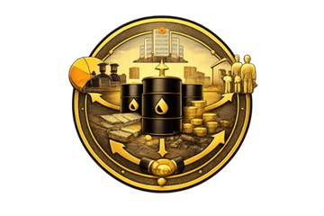
Unity8:administration Revenue

Procedure Correction 19
Requirement 5-1:distribution Revenue
Corrective action
It should on Iraq:
- Disclosure In a way clear on revenues Industries Extractive Restricted in Budget Nationalism, In what in that Payments Cash And the eye.
- with regards For revenues not Restricted in Budget(on Way For example, income companies public The detainee, the accounts Foreign Ministry), He should clarification How to Assigning it and published Reports Finance The The connection, like Accounts revenues oil gas and the box thedevelopment toIraq.
- Disclosure About if She was there any funds(on Way For example, Payments delay or Transfers Services Interior)Spend directly outside practical Budget.
- Use Reports The initiative To analyze Commitment With reforms administration Finance The general public, like account Treasury Unified reforms order Integrated For management Finance, In coordination with ministry Finance and the box Criticism International.
- Return practice to publish Lists Finance The auditor For accounts Government Home that Manages revenues oil gas.
Progress made
The revenues of the extractive sector were disclosed in the actual general budget, and the Ministry of Oil was asked to publish all financial data of the companies affiliated with the ministry.
Recommendation
Recommended that Enhances Iraq Transparency in administration revenues Industries Extractive from during Disclosure Clear on Revenue Listed and other Listed in The budget, and explanation mechanisms Assigning it and spending outside framework Budget that He found, and published Lists Finance The auditor For accounts Government The President, with Use Reports initiative Transparency in Industries Extractive To follow Commitment With reforms administration Finance public In coordination with Entities The relationship.

Procedure Correction 20
Requirement 5-3:information Additional on administration Revenue and spending
Corrective action
YAdvice Iraq In what Next:
- Use Reports The initiative in Exclusion Operations administration Revenue and scrutiny On it, especially around How to Track and allocation revenues oil gas.
- to publish Assumptions Supported For balance Nationalism(on Way For example, Prices Oil, sizes Production, Revenue Finance Expected)To ignite discussion around Sustainability.
- the job with ministry Finance and partners International To integrate The initiative in repairs administration Finance The general public, like to implement order Integrated Management Information Finance and account Treasury Unified.
- Use The initiative As a tool To explain How to administration Revenue outside Budget And how application mechanisms accountability On it.
- re application Auditing and publishing Regular For reports Finance around Accounts Industries Extractive Main, like account revenues oil gas and the box thedevelopment toIraq.
Progress made
The Authority publishes details of the extractive sector’s revenues through the issuance of the annual report, which is published in an open and easily accessible manner on the Authority’s website.
Recommendation
Recommended that Used Iraq Reports initiative Transparency in Industries Extractive As a tool methodology To track and auditing administration revenues oil And gas, and published Assumptions President To balance, And he explained administration Revenue inside And outside The budget, with to merge The initiative in repairs administration Finance The general public, and return Auditing and publishing Regular For accounts Government The President, In what Enhances Sustainability and transparency and accountability.


Unity9:Contribution semi Nationalism

Procedure Correction 21
Requirement 4-6:Payments to level Don National
Corrective action
It should on Iraq:
- re release Substance abuse The organizer with government province Kurdistan and companies oil International The worker in region To ensure Disclosures Comprehensive around Payments semi Nationalism.
- Use Reports The initiative in signal to all Data Available For the worker from ministry thewealth natural in province Kurdistan, and records Loans Supported With oil, Disclosures companies.
- Exclusion gaps in Disclosures from region and explanation what she Information Incomplete or that no maybe Verification From it.​
Progress made
The data for the Kurdistan Region was obtained through open sources, for example, the regional government website and the websites of some international oil companies operating in the region.
Recommendation
Recommended that Enhances Iraq Coordination Methodological with government province Kurdistan and companies oil International The worker in region To ensure Disclosure Comprehensive on Payments semi Nationalism, with to gather And the signal to all Data Available from Entities Regional and companies, and determining gaps Disclosure clearly and statement Information not Available or not midwife To check within Reports initiative Transparency in Industries Extractive.

Procedure Correction 22
Requirement 5-2:Transfers on Level Don National(Local)
Corrective action
It should on Iraq:
- a guarantee Publishing annual For transfers Petrodollar within Budget And the actual Classified According to Governorate and source Revenue.
- Disclosure on The equation Actual Used in distribution The foundation Legal or resolution council Ministers Supporter For any review.
- inclusion comment around Hassan Timing, And completion, and use For transfers semi Nationalism, In what in that mechanisms Auditing and tracking.
- numbers procedure normative To collect Data Guarantee Quality For data Transfers semi Nationalism, according to what he required Under Requirement4.9.
Progress made
The allocations and funding for petrodollars and regional and provincial development have been published at the provincial level, and the bases for calculating petrodollars have been established in accordance with the applicable budget law.
Recommendation
Recommended that Guarantees Iraq Disclosure annual Regular on Transfers Petrodollar Listed And the actual Classified According to Governorate and source Revenues, with clarification equation distribution The foundation Legal she has, Including evaluation Hassan Time and completion and use and mechanisms Auditing And tracking, and adoption procedure normative To collect Guarantee quality Data Transfers semi Nationalism, In what harmonize with requirements initiative Transparency in Industries Extractive.

Procedure Correction 23
Requirement 6-1:Expenses social Payments environmental
Corrective action
It should on Iraq:
- a guarantee Standing all companies oil International The large By disclosure on Payments social and the environment Voluntary, In what in that that the introduction For beneficiaries from party third.
- to improve Verification and scrutiny from This is amazing Payments from during cooperation with Entities Government(on Way For example, ministry the environment, body Integrity).
- separation In a way clear between Payments Mandatory For the government, and expenses Mandatory For the limbs Third, and expenses Voluntary.
- inclusion Texts narrative around Antiquities environmental social For projects Extractive And how to treat Expenses For that Issues.
- Use Reports The initiative To prepare standard For the frame Legislative and the executive around Commitment social and environmental.
Progress made
A benefits database was preparedsocialIn addition to some environmental impact studies.
Recommendation
Recommended that Enhances Iraq Disclosure Comprehensive And the trustworthy on Payments social and environmental in sector Industries Extractive from during Obligation companies oil International By disclosure on Payments Mandatory And voluntary, In what in that the introduction For the limbs Third, and improving mechanisms Verification In coordination with Entities Government The specialist, with Discrimination Clear between Types Payments, Including analysis For the monuments social Environmental and use Reports initiative Transparency in Industries Extractive As a reference To develop framework legislative My executive To commit social and environmental.

units Involvement Owners Interest And the results and the effect


Unity1:procedures Corrective Related By involving Owners Interest

Procedure Correction 24
Requirement 1-1: Government participation
Corrective action
It should on Iraq a guarantee that Lead the government In a way complete And active and effective all Aspects to implement The initiative.on face Definition, It should on the government Issue Data General Explicit around Her commitment Towards The initiative and goals Her participation.It is necessary on the government hiring responsible High To lead to implement The initiative.And it should that Enjoy this responsible Confidently all Owners Interest, and authority Freedom in coordination procedures around The initiative via all Ministries and circles The concerned party, In what in that ministry Finance, And the ability on crowd Resources To implement The initiative.And it should on the government a guarantee to provide resources Finance and artistic Enough To support all Aspects to implement The initiative, In a way Exceeds to publish Reports Annual For the initiative.According to For rulings Implementation Rate in Iraq, It is necessary on the government presentation Updates around Continuing with Authorities in government province Kurdistan To strive behind ideas constructive around Her participation in The process Nationalism For the initiative.
Progress made
In December 2024, a new royal decree was issued clarifying the government's commitment to implementing the initiative in detail, through the establishment of a board of trustees (multi-stakeholder) representing stakeholders in the extractive sector (government).–companies–(Civil society).
Recommendation
Recommended that Enhance the government Iraqi Its leadership The active one To implement initiative Transparency in Industries Extractive from during advertisement commitment political sincere, and appointment responsible High Enjoy Confidence and powers Necessary For coordination Implementation and crowd Resources via Entities The concerned party, Guarantee to provide Support Financial And the technician Al-Kafi with presentation Updates Regular around Coordination with government province Kurdistan, In what Establishes Sustainability And ownership Nationalism To implement The initiative.

Procedure Correction 25
Requirement 1-2:sharing companies
Corrective action
It should on Iraq a guarantee sharing companies In a way complete And active and effective in all Aspects The initiative, In what in that Report and communication Generalization.as It should on the government to encourage sharing Companies, especially that The worker in province Kurdistan.
Progress made
Government and private companies are represented on the Board of Trustees and participate in all the Authority’s activities.
Recommendation
Recommended that Guarantees Iraq Participation The complete and effective For companies in all Aspects to implement initiative Transparency in Industries Extractive In what Includes Report and communication And awareness, with Standing the government By taking measures proactive To encourage Engagement Companies, no Sima The worker in province Kurdistan, In what Enhances inclusiveness Disclosures and effectiveness to implement The initiative.

Procedure Correction 26
Requirement 1-3:sharing the society Civilian
Corrective action
It should on The initiative in Iraq to support Generalization The widest on the society Civilian Guarantee input Members council Owners Interest In a way tangible.And it is necessary on Council Monitoring Restrictions on outer space Civilian Guarantee Treating it In a way collective.
Progress made
Civil society is effectively represented on the Board of Trustees of the Authority in a way that adds value to the implementation of the initiative in Iraq.
Recommendation
Recommended that Enhance Transparency Authority for Natural Resources Generalization Participation The active one For organizations the society Civilian, with a guarantee input tangible and independent For members council Owners Interest, And undertaking Council Badr active in Monitoring any restrictions on outer space Civilian And treating it In a way collective, In what Supports Inclusivity and accountability according to requirements The initiative.

Procedure Correction 27
Requirement 1-4:group Owners Interest multiple
Corrective action
It should on Iraq a guarantee representation Al-Kafi For all Owners Interest Those concerned in council Owners Interest.And it should that be Invitation To participate in Council explicit and transparent.And it is necessary that He is I have all category Owners an interest, Specifically the society Civilian And the sector, Right in hiring Their representatives away on any suggestion or coercion, with Taking Eye Consideration preference presence acting multi and diverse.And it is necessary documentation procedures hiring Change Actors in The council, and practices The followed, In a way public.And it is necessary that He takes Council And all component major Balance between Gender in practical representation To proceed in fairness between Gender in Council.And it should on Members Council Strengthening communication and coordination with Their components The widest.And from Expected that He adheres Members Council blog rules behavior For the initiative.It requires The initiative presence practical inclusiveness To take Decisions throughout practical Implementation, with Dealing with all component on that it a partner.And it is necessary that He owns all member in Council Right in Presentation any topic For discussion.It is necessary on Council that Documents In a way public His practices around Payments Daily wage For members The council, And it is necessary unless leads This is amazing Practice To create conflict in Interests.And it should that He provides Council In a way public Records Written For his discussions and his decisions in timing appropriate.
Progress made
The stakeholders are represented on the Board of Trustees of the Authority in accordance with the Diwani Order issued in December 2024. Representatives of civil society were also determined through elections, in which a large number of civil society organizations participated.
Recommendation
Recommended that Guarantees Iraq representation fair and transparent Comprehensive For all Owners Interest in council Owners Interest For the initiative Transparency in Industries Extractive from during Invitations sharing Publicly, and enabling all category from hiring Its representatives Independently, with Consideration Diversity and balance between Both genders, Documentation procedures Appointment and practices and decisions and blog behavior Payments Daily wage In a way public, and strengthening communication with the components The widest, In what Guarantees partnership Equivalent and process Taking resolution inclusiveness Reliable.


Unity2:procedures Corrective Related Results and the effect

Procedure Correction 28
Requirement 1-5:plan the job, monitoring and review
Corrective action
It should on Iraq a guarantee that place plan the job Goals strategy It agrees with Priorities Nationalism, It includes Activities Specific In a way good, And calculated Costs with Responsibilities and results Clear, and that Availability framework To monitor Evaluation Progress Al-Mahrez.
Progress made
A detailed work plan for the years 2025-2026 has been issued and published on the Authority’s website.
Recommendation
Recommended that Guarantees Iraq that It includes plan a job initiative Transparency in Industries Extractive Goals strategy harmonious with Priorities Nationalism, and activities Specific and midwife For implementation, and appreciated Costs with to set Responsibilities And the results Expected, addition to framework clear To monitor Evaluation Progress, In what Enhances effectiveness Implementation and accountability.

Procedure Correction 29
Requirement 7-1: Discussion Year
Corrective action
It should on Iraq numbers Implementation strategy Generalization Comprehensive, It includes a contract events release Annually, And it continues specialized with journalists and communities Local, and published Materials contextual And in The consumer.
Progress made
A special section has been prepared that includes promoting public debate in the 2025-2026 Action Plan (Section Three), which includes a detailed plan to carry out several activities in this regard.
Recommendation
Recommended that It is considered Iraq And it is implemented strategy Generalization Comprehensive For the initiative Transparency in Industries Extractive include to organize events release Annually, and strengthening communication specialist with journalists and communities Local, and published Materials contextual Simplified and available For the public, In what Enhances Awareness Year And it increases from effect Disclosures.

Procedure Correction 30
Requirement 7-2:ease Get to Data and data Open
Corrective action
It is recommended Iraq By strengthening Disclosures methodology via all The authorities and strengthening Capability Reading The mechanism, and integration This is amazing Improvements in the site electronic Next Center Data National.
Progress made
The Authority has prepared a systematic disclosure policy in cooperation with a World Bank expert, and work is underway to have it approved by all relevant disclosure authorities.
Recommendation
Recommended that Enhances Iraq Disclosures methodology via all Entities The concerned party, with to improve Capability reading Data Automatically, and merge This is amazing Improvements within the site electronic New Center Data National, In what Supports ease Access, and return Usage, and compliance For requirements initiative Transparency in Industries Extractive.

Procedure Correction 31
Requirement 7-3:Recommendations emerging on to implement The initiative
Corrective action
It should on Iraq re formation Mechanism Systematic and subject For accountability public Council Owners Interest regarding review Implementation Recommendations, with Frames Time and responsibilities and reports clear.
Progress made
A special axis has been allocated to activities for addressing recommendations within the 2025-2026 work plan (Axis Two), where this axis defines the mechanism for developing effective recommendations processing.
Recommendation
Recommended that He returns Iraq anchoring Mechanism methodology and transparent and subject For accountability public inside council Owners Interest To follow review Implementation Recommendations, with to set Frames Time and responsibilities Clear, and published Reports patrol on Progress Al-Mahrez, In what Enhances effectiveness Implementation and accountability within initiative Transparency in Industries Extractive.

Procedure Correction 32
Requirement 7-4:It should on council Owners Interest The multi review results And effects to implement The initiative on Governance Sources natural
Corrective action
It should on Iraq procedure Reviews annual Participatory around effect The initiative, So that It includes all the components Home.where He should that It is during Reviews evaluation How to input The initiative in to improve Governance and accountability The general public, with Texts Recommendations clear.
Progress made
A special section for the results and effects related to the implementation of the initiative was created within the 2025-2026 Action Plan (the third section), which explains the work mechanism and activities planned to be implemented in this regard.
Recommendation
Recommended that It is taking place Iraq Reviews annual Participatory For the effect initiative Transparency in Industries Extractive With participation all the components The President, To assess Her contribution in to improve Governance and accountability The general public, and inclusion results Recommendations clear within Reports The initiative To support Learning and improvement Continuous.

End of report

